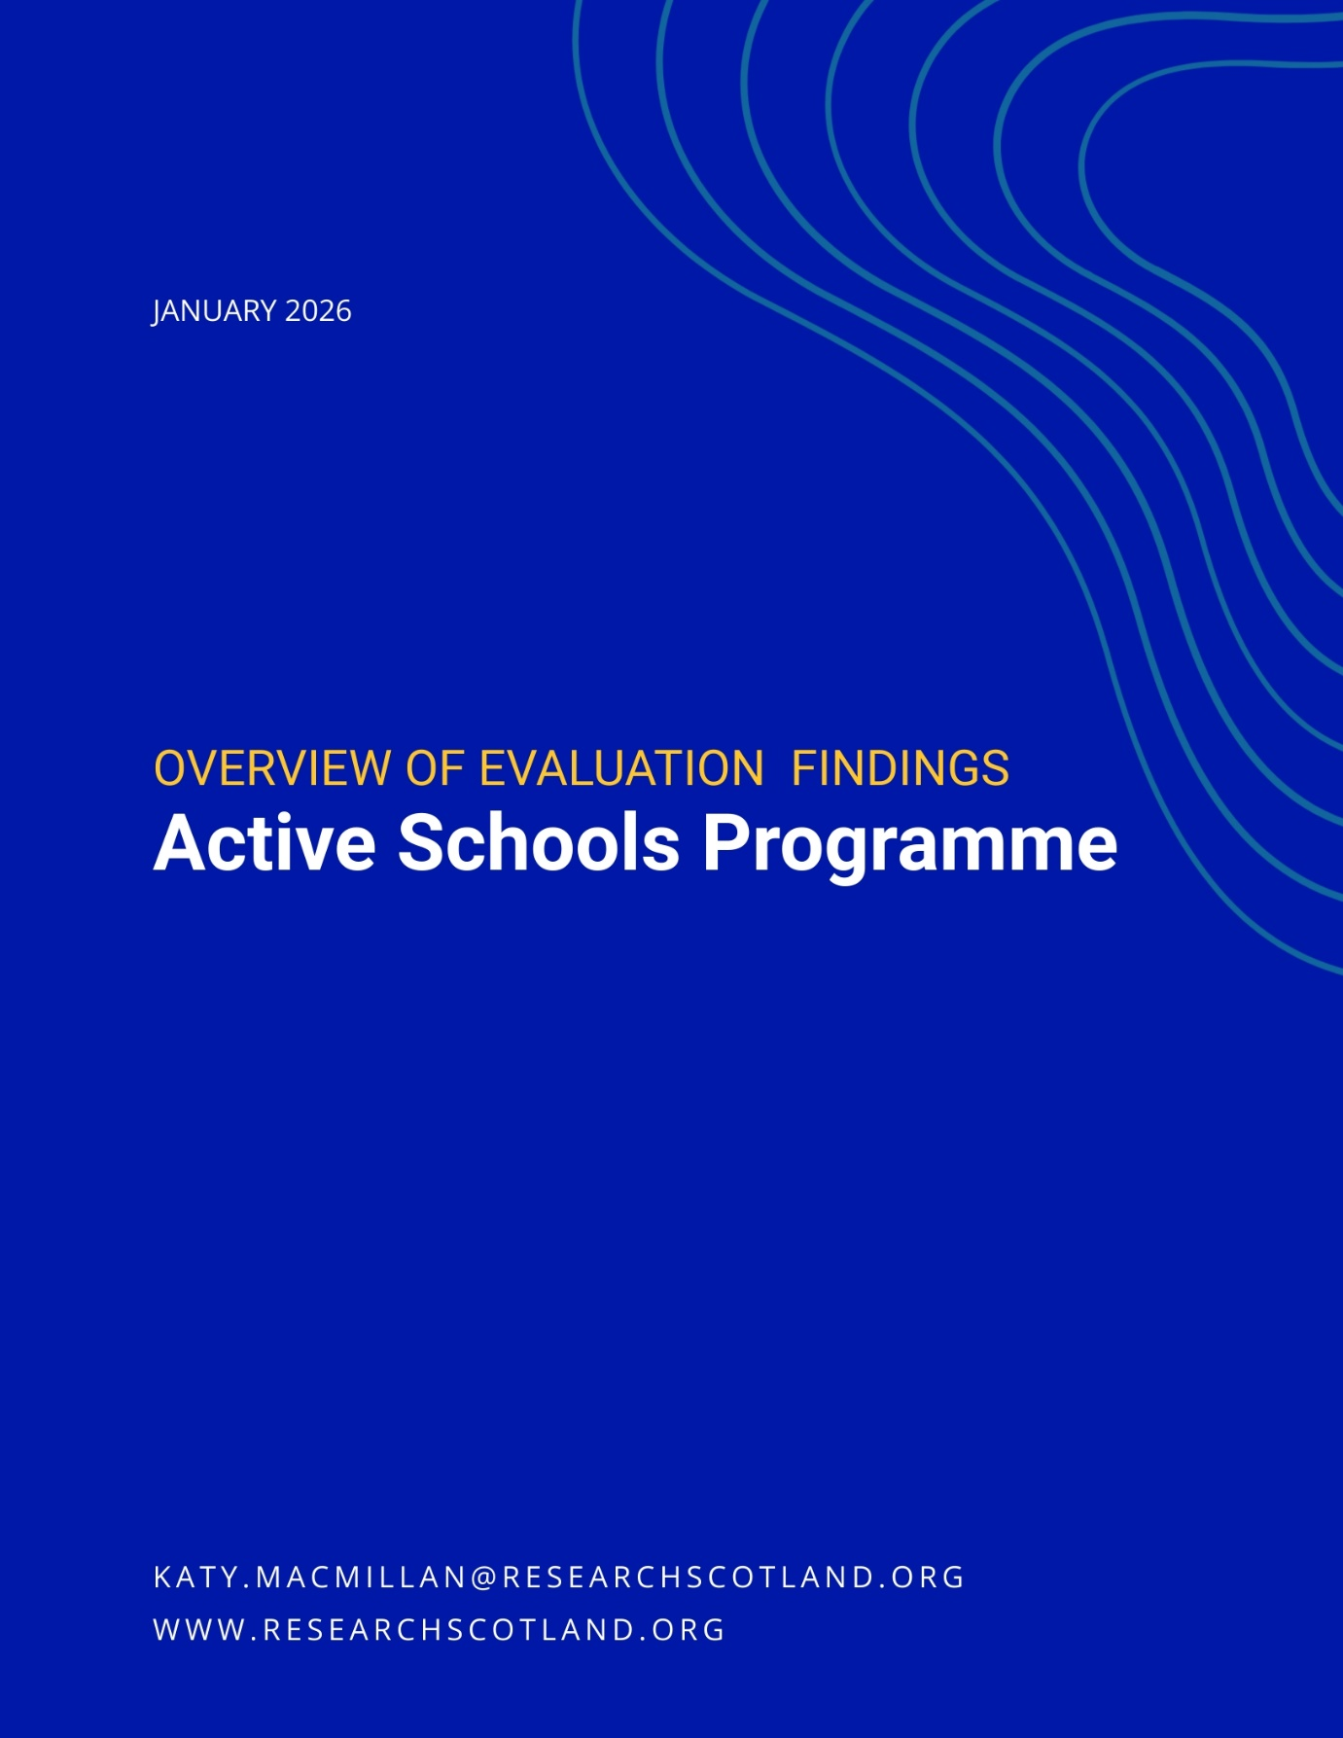

Contents

1. Introduction 1
2. Active Schools impact 3
3. Active Schools model 12
4. Future considerations 20

Introduction

1.1 About this report

This report sets out findings from an evaluation of the Active Schools programme, undertaken by Research Scotland for sportscotland in autumn 2025. The overarching aim of this evaluation report is to explore:

What are the impacts and challenges of the current Active Schools programme?

This evaluation, alongside a wider horizon scanning piece of research which explores key drivers for change, will inform exploration of the future focus of and models for Active Schools beyond 2027.

1.2 Method

This evaluation report involved:

- a desktop review and online surveys – with responses from 1,313 school staff, 37 Active Schools Managers [ASMs], 256 Active Schools Coordinators [ASCs], 276 deliverers and 20 sportscotland staff
- 25 evaluation interviews, 25 horizon scanning interviews and discussions with the Young People’s Sport Panel and equalities organisations.

1.3 About Active Schools

The Active Schools programme aims to:

- create more and higher quality opportunities to participate in sports before school, during lunchtime and after school
- develop effective pathways between schools and clubs in the local community.

Active Schools is part funded by Scottish Government through sportscotland. Over £12 million is invested by Scottish Government and over £4 million by partners. Partnership agreements are in place with all 32 local authorities to March 2027.

Active Schools has five priority areas that are consistent across all 32 local authority teams. Active Schools:

- provides high quality opportunities for all young people to take part in sport & physical activity before school, at lunchtime and after school
- develops, leads and supports effective pathways to connect schools, clubs and communities
- provides inclusive opportunities by using targeted approaches to remove barriers to participation
- develops a network of volunteers to deliver activity sessions
- develops and supports leadership opportunities for young people.

The network consists of over 400 managers and coordinators. Locally, Active Schools teams have their own priorities within the overarching aims of the programme.

Active Schools impact

2.1 Impact on physical activity levels

Participation in physical activity through Active Schools
In 2024/25, Active Schools:

- engaged 280,000 children and young people in physical activity
- involved 40% of the total school roll in Scotland 2024/25.

Participation levels have been increasing in recovery from the pandemic since 2020, before levelling out in 2023-2025 – in part due to a stronger focus on engaging those who need the most support to be active.

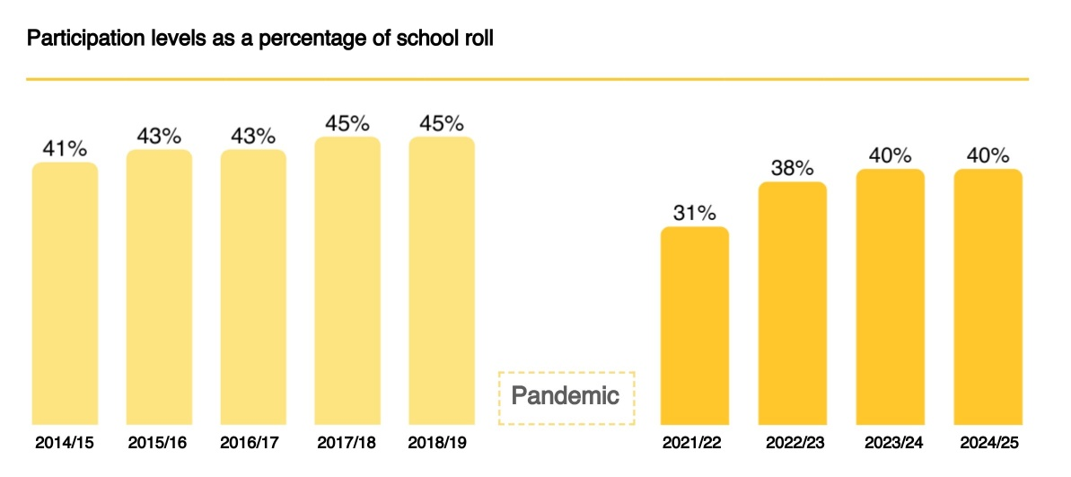

In 2024/25, the percentage of the school roll engaged in Active Schools differed between local authorities, ranging from 24% to 59%. In 2024/25, more than half of primary school pupils took part in Active Schools, compared with a quarter of secondary school pupils and less than a third of pupils at ASN schools.

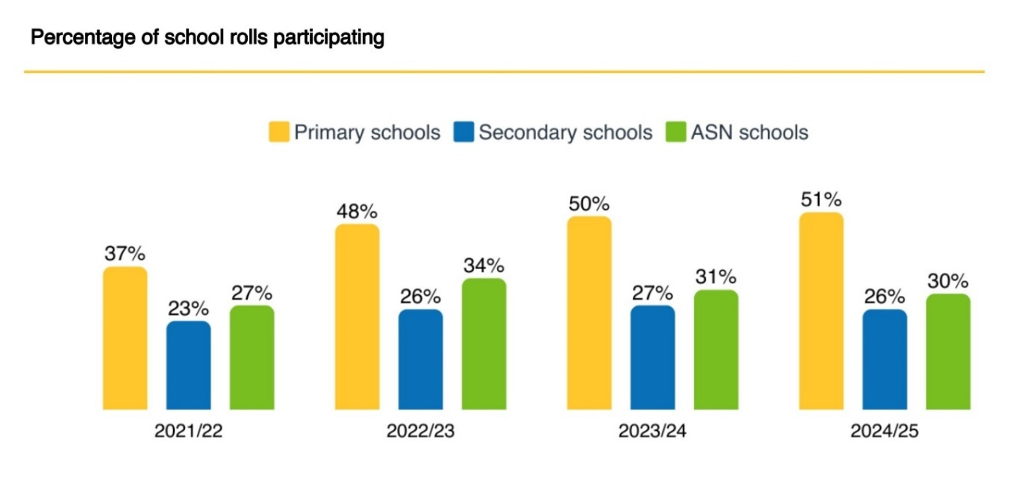

Impact on physical activity levels
In 2019/20, sportscotland undertook a major survey of Active Schools participants to explore the impact of taking part.

44% of pupils said that they would be less active without their Active Schools activity – with the remainder saying they would find another way to be active. Pupils from the most deprived areas and secondary pupils were most likely to say they would be less active without Active Schools.

67% of pupils said Active Schools helped them to be more active outside of school. This is lower for those in the most deprived areas, and for secondary school pupils.

94% of pupils said Active Schools made them want to keep being active as they grew up.

49% of pupils said Active Schools helped them get interested in other sports and clubs. This was lower for pupils in the most deprived areas, and for secondary pupils.

Figures from the 2019/20 survey suggest that Active Schools activity itself supported more participants to meet physical activity guidelines. The biggest change in inactivity was for pupils in the 20% most deprived areas and for females.

Stakeholder views
Schools and the Active Schools network were positive about the impact Active Schools has on young people’s physical activity levels. Most schools were very clear that Active Schools helped to support physical activity levels among their pupils. Some said that without Active Schools there would be little or no sport or physical activity extra-curricular activities at their school.

“
There’s no way we’d have anything close to the number of kids we’ve got engaged in extra-curricular sport if it wasn’t for Active Schools.” Secondary school

“
Without free after school clubs in our school – the majority of our children would not participate /try out any new sports or take part in physical activity.” Primary school

Active Schools teams also highlighted that the programme supported young people to be active in a way that suited them, in an inclusive, fun, safe and supportive environment. This helped increase physical activity levels and reduce inactivity.

“
Without Active Schools activities, the cluster inactivity levels would be huge.” Active Schools team member

Some Active Schools teams said activity was planned purposefully to get young people active, focusing on engaging those less likely to take part or who were not already involved. Many of the examples given of impact on physical activity levels for inactive young people related to targeted, small scale and in-depth work, rather than universal activity. Wider stakeholders also felt that Active Schools played an important role in building physical activity rates, and contributing to physical health.

Example: Supporting engagement with physical activity
In one area, Active Schools undertook specialist work which involved in-depth bespoke support to young people with care experience and young carers. A cohort of 10 to 15 young people was selected and received one to one support, and new social sessions with peer games were also introduced. Some of the young people taking part received a free leisure membership. Through the project, young people have achieved qualifications, started volunteering and achieved awards, found new passions and improved their wellbeing.

“I think its awesome I get to play sports cause I never did that before.” Young person

Example: Building physical activity habits
In one area, targeted inclusion work through the Active Schools team supported 56% of participants to transition into regular physical activity. The team prioritises support for those who have taken part in this programme, helping them to maintain consistent engagement with physical activity. Building strong, trusting relationships with young people is a crucial aspect of the approach.

2.2 Impact on health and wellbeing

National evidence
sportscotland’s national survey in 2019/20 found that Active Schools made a significant difference to young people’s health and wellbeing.

- 97% said taking part in sport and physical activity helped them feel healthy
- 89% said it helped them feel confident
- 88% said it helped them feel happy.

There is very clear evidence and strong research that demonstrates that physical activity and sport can bring about positive change to people’s health and wellbeing.

There is a range of research which highlights the positive relationships between physical activity and various aspects of health. Across the life cycle, it can prevent premature death and chronic diseases; reduce blood pressure, osteoporosis, obesity and risk of stroke, colon cancer and cardiovascular disease; and improve psychological wellbeing, coronary blood flow and protect against post-menopausal breast cancer.

The UK Chief Medical Officer has highlighted that there are clear benefits of physical activity for children, for which there is moderate to strong evidence. These include improving bone health, cognitive function, cardiovascular fitness, muscle fitness, weight status and depression. Research has also found that children and young people taking part in sport have fewer mental health, emotional, behavioural and peer-relationship problems and demonstrate more positive social behaviours.

Evaluation evidence

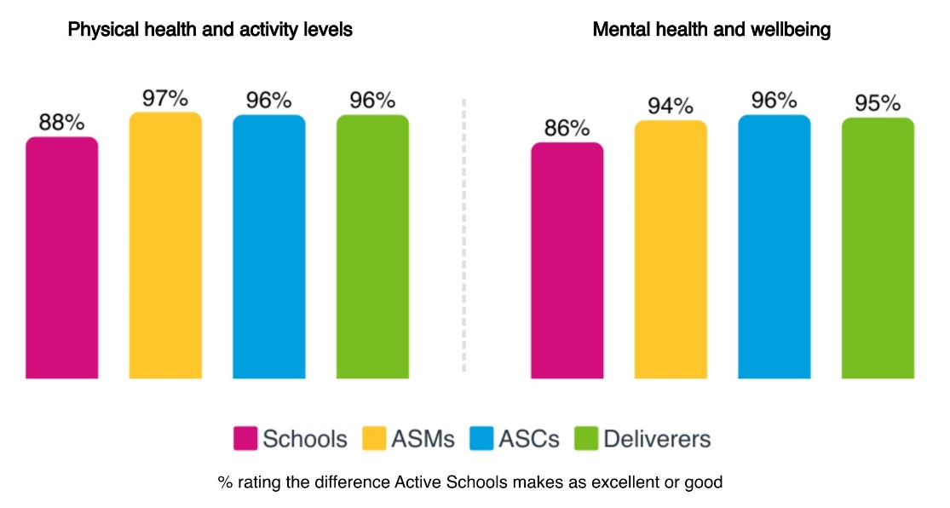

Schools felt that Active Schools supported physical and mental health, built positive relationships, supported emotional regulation, boosted positive mindsets, helped young people learn about healthy lifestyles, and built confidence and resilience. Schools also highlighted that being active helped young people with their mood, mindset and confidence. Schools in the 15% most deprived areas rated impact more highly and ASN schools rated impact more poorly.

“
Young people's physical, mental health and wellbeing is enhanced; their confidence and wellbeing is raised.” Secondary school

Active Schools teams highlighted that being active would have a significant impact on young people’s physical and mental wellbeing. This includes increased fitness, strength and coordination; reduced stress and anxiety; emotional regulation and feelings of being able to cope; and increased energy.

Some young people talked about how Active Schools supports their mental health and emotional wellbeing, through doing activity or talking about emotions due to strong, trusting relationships developed as part of targeted work.

“
I feel calmer and more relaxed after my sessions.”
Young person

Example: Active Schools support for pupils with ASN
In one area, Active Schools delivered inclusive community and school dance sessions for parents, carers and young people with additional support needs. Active Schools also supported pupils with additional support needs from enhanced learning resource classes to take part in other sessions within schools and the community. The team found that almost all participants improved their mental health, confidence, physical health and overall wellbeing. Some young people also saw improvements in their coordination, balance, flexibility, endurance and strength.

“I feel relaxed.” Young person

Example: Supporting mental health
In one area, Active Schools worked to empower young women aged 12 to 18 who were experiencing mild to moderate mental health challenges such as stress, anxiety or depression. Over six weeks, participants attended sessions combining movement and education. A physical activity segment was designed to be enjoyable and engaging, followed by a class based segment on coping strategies and life skills. Overall 100% of participants felt healthier, 100% expressed greater confidence to exercise and 66% reported increased energy.

“Felt like a break from school but still learning and trying new things. A lot more flexible and relaxed than learning in school.” Young person

2.3 Impact on education and learning

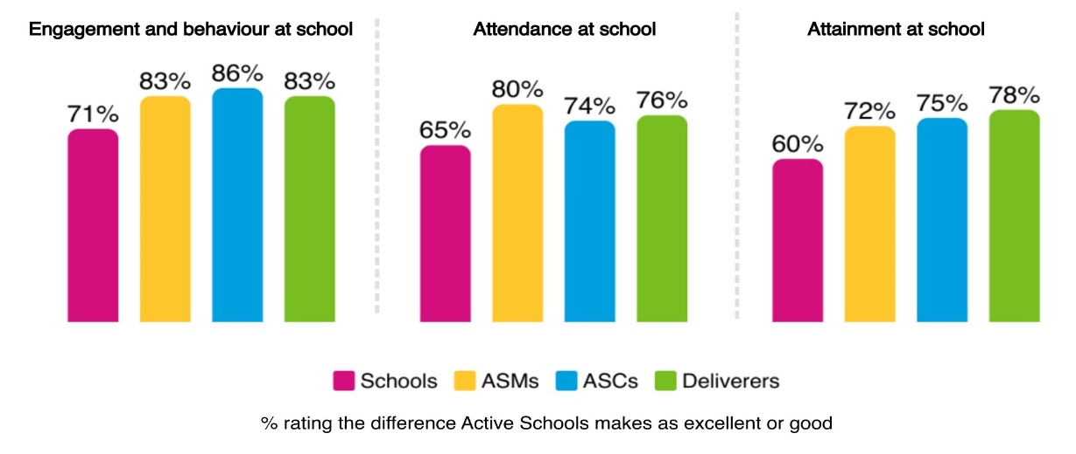

Schools were positive about the impact of Active Schools on engagement, behaviour, attendance and attainment. In addition, most schools said that Active Schools aligned a lot with education outcomes (75%) and contributed a lot to school culture and ethos (78%).

Schools indicated that Active Schools contributed to the experiences and outcomes in Curriculum for Excellence and aligned well with Getting it Right for Every Child, the United Nations Convention on the Rights of the Child and Pupil Equity Fund priorities. When talking about the difference that Active Schools made to their school, school staff often used words like ‘value’, ‘rely’ and ‘depend’.

“
They are a vital part of our school community.”
Primary school

“
They are involved in many aspects of the school life.”
Secondary school

Engagement, behaviour and attendance
Schools were very clear that that Active Schools was supporting:

- engagement with learning and positive behaviour – through movement and physical activity building concentration levels and mental wellbeing
- attendance at school – encouraging children and young people to come to school on days that Active Schools sessions are on.

“
Pupils involved in Active Schools activities often show better attendance, as participation fosters a stronger connection to school life.” Secondary school

“
Without Active Schools support some of our children would struggle to maintain attendance at school; they would be more disengaged whilst in school.” Primary school

Young people agreed that sport and physical activity could encourage them to attend school.

“
I’ve not been going to school as often recently, but knowing this is on a Friday makes me want to come in – I don’t want to miss it.” Young person

Example: Engaging disengaged Pupils
In one area, Active Schools engaged with a group of S2 and S3 pupils at one school for six weeks, working with them for two periods each week. The programme aimed to build relationships, boost motivation and guide students towards positive outcomes through physical activity, team building and role models.

By the end of the programme, several students showed marked improvements in attendance and engagement with school. One student moved into the local authority Leadership Academy, resulting in further increases in attendance and academic performance. Young people also felt more motivated and confident about their future.

Attainment, skills and achievement opportunities
Schools felt that Active Schools had an impact on the learning environment through:

- offering opportunities for children to achieve in different aspects of school life
- developing new skills appropriate for learning – including confidence, resilience, teamwork, leadership, motivation, perseverance and self-discipline
- gaining qualifications and accreditations and building a sense of responsibility
- supporting attainment – through developing skills for effective learning and offering further learning and qualification opportunities.

“
It has improved relationships between pupils and also given pupils an opportunity to achieve and feel successful outside the classroom setting.” Primary school

Schools felt that these skills and qualifications contributed to pupil attainment, with the skills learned being transferrable into other areas of the curriculum. School staff emphasised that Active Schools was part of a wider effort to support learning and attainment, and while it contributed, it was not the only or main driver.

Example: Supporting literacy
In one area, Active Schools supported four pupils who were not engaging in literacy and reading tasks, and were below target for reading ages and literacy attainment. Active Schools staff held weekly quiet reading sessions, working 1-1 with each pupil, followed by 30 minutes of football activity, building teamwork and communication skills. This linked with wider school based activities. All four pupils saw an improvement in their reading age, with one increasing their reading age by nearly four years. All went from saying they didn’t enjoy reading, to saying that they do.

Young people were clear that they gained skills and qualifications through taking part in Active Schools. Many talked about how important these skills were for the future, gaining both transferrable and sports specific skills for future learning and careers.

I am gaining valuable leadership experience as I want to work in sport in the future.”

I feel more confident that the skills and knowledge gained will continue to help me throughout college and for future job opportunities.” Young people

Example: Positive destinations
In one area, the Active Schools team supported an initiative with young people at risk of leaving schools with few qualifications and who are physically inactive. The project uses sport to engage pupils, with activities and workshops providing knowledge around career paths in sports. During the programme, young people said they gained skills in leadership, confidence, problem solving, resilience and team work. Young people also went on to take part in Active Schools provision.

“I enjoyed learning about what jobs I can get that involve sport.”

“I have started volunteering at a sport session.”

An Active Schools leadership journey
Evan* started volunteering with Active Schools in S1 following an I Can Lead training event. He regularly volunteered at holiday camps, after schools and supporting PE classes. In S5 he undertook more leadership training including Active Schools Play Leader Mentor Training.

Evan dedicated more than 40 hours annually to Active Schools. To recognise his volunteering efforts, he received a funded space on a National Pool Lifeguarding Qualification course, and passed. He went on to secure a full time job in the leisure and sport field. He also continues to volunteer at holiday programmes.

2.4 Impact on inclusion and networks

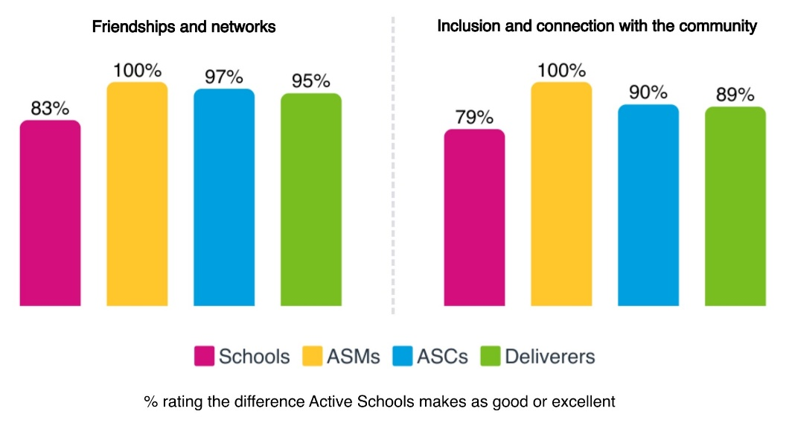

Schools were positive about the impact Active Schools has on young people’s friendships, networks and inclusion within the community. The sportscotland Active Schools survey from 2019/20 also found that participants said taking part in sport and physical activity helped them to make friends (82%) and feel included (82%).

Friendships and networks
School staff said that Active Schools:

- supports connections, friendships and networks across stages and ages
- creates a sense of fun in the school environment
- builds safer and more inclusive play at break and lunch for primary pupils
- supported transitions and connections between primary and secondary.

“
The young play leaders have definitely helped to make playtimes (with no PSA or adult support) much more enjoyable and safe.” Primary school

Young people agreed that they made friends and talked to people through Active Schools.

“
I made new friendships, and feel more safe and happy after being anxious about coming.” Young person
Example: Transition support
Active Schools often supports transitions from primary to secondary school. In one area, a P7 targeted transition club was designed for pupils who needed additional support when moving from primary to secondary. The activity involved sports, fitness, gender violence input and wider activities like science.

Participants gained new skills around making new friends, team work and confidence. Young people reported clear benefits in feeling more excited and less nervous, scared and worried about transition. In addition, more pupils became interested in joining extra-curricular clubs, and became more interested in the chance to learn different subjects at high school.

Inclusion and community connection
School staff said that Active Schools:

- fosters a sense of belonging and nurture
- provides positive role models and builds trusting relationships
- empowers young people and provides opportunities for pupil voice
- helps young people work together and deal with conflict
- promotes inclusion and equity in the school
- provides opportunities that people would not otherwise have access to.

“
I think it gives the children a sense of belonging in school.”
Primary school

ASN schools rated impact on friendships and networks and inclusion within the community lower than other schools.

Young people agreed that Active Schools helped them feel included and connected.

“
I made new friendships, and feel more safe and happy after being anxious about coming.” Young person

Active Schools model

3.1 Introduction

This chapter explores the current Active Schools model, in relation to the five priority areas which are consistent across all 32 local authorities in Scotland.

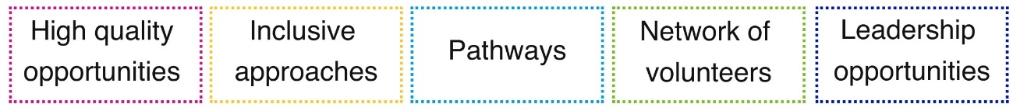

3.2 High quality opportunities

Active Schools aims to provide high quality opportunities for all young people to take part in sport and physical activity – before school, at lunchtime and after school. In 2024/25, there were just under 265,000 Active Schools sessions. Of these more than a quarter were football, with other common activities including multi-sports, netball, dance, basketball and rugby.

Overall, schools rated the quality and range of Active Schools activities highly.

- 85% of schools rated quality as good or excellent.
- Secondary schools and schools in the most deprived areas were most likely to rate the quality and range of activities as excellent.
- ASN school staff rated the quality and range the lowest.
- Those within the Active Schools network also rated quality highly.

Schools valued Active Schools teams, their skills and knowledge. Many valued the relationship-based approach, focusing on strong connections and communication with schools and young people. For the future, some schools and Active Schools teams suggested considering:

- the capacity and remit of Active Schools teams to support schools
- the impact of the volunteer model on quality and range of activity, including the increasing reliance on young people as volunteers
- qualification levels among deliverers – which are reducing
- the budgets available to pay skilled deliverers
- the range of activities – beyond traditional activities
- particular barriers to quality and range in rural areas and for pupils with ASN
- balancing quantity of activity with quality.

Some suggested that although there were variations in quality due to volunteer deliverers, it didn’t impact on outcomes for young people – who got active, gained new skills and made friendships. A few said they now focused on creating a fun and safe environment. Others talked of a different approach, where they had reduced the number of experiences, focusing on high quality experiences reaching the most disadvantaged or excluded young people. This meant that the number of participants had reduced, but the quality of experience had increased.

3.3 Inclusive opportunities

Active Schools aims to provide inclusive approaches using targeted methods to remove barriers to participation.

Participation of under-represented groups

In 2024/25:

 | Active Schools % | School Roll %
In the 20% most deprived areas | 22% | 23%
From diverse ethnic communities | 14% | 12%
Pupils with ASN | 27% | 35%
Girls and young women | 47% | 49%

These trends show the national picture for Active Schools, and will vary between local authorities.

Pupils from the most deprived areas and diverse ethnic communities are reasonably well represented in Active Schools participation.

Pupils with ASN are under-represented in Active Schools participation. In 2024/25, although more than a third of school pupils had ASN, the proportion of Active Schools participants with ASN was lower, at just over a quarter. However, this proportion has increased from 20% since 2021/22.

Fewer females than males take part in Active Schools at all ages, with this trend being seen since 2014/15. Males also make more frequent visits to Active Schools - in 2024/25, 56% of visits were by males, and 44% by females. The imbalance is particularly clear at secondary school, increasing in older year groups. Nationally, fewer girls than boys meet physical activity guidelines – with the biggest difference in the 13-15 age band.

Detailed analysis shows that some local authority areas have a 50/50 split between males and females, or are close to this. Most of these areas have multi-sports making up a high proportion of sessions. Some of the areas with the lowest engagement of females have a very high percentage of visits to football sessions. It is worth noting that the availability of volunteers skilled in relevant sports, to deliver sessions, will impact on this pattern.

Views on inclusion
Schools generally felt that Active Schools was been good including a wide range of young people, that Active Schools sessions were generally inclusive, and that activities were adapted to suit a range of needs.

Schools were particularly positive about involvement of girls and young women and young people from areas of socio-economic deprivation. Approximately a third of schools felt that Active Schools had been fair, poor or very poor at engaging young people with low levels of physical activity and young people with ASN.

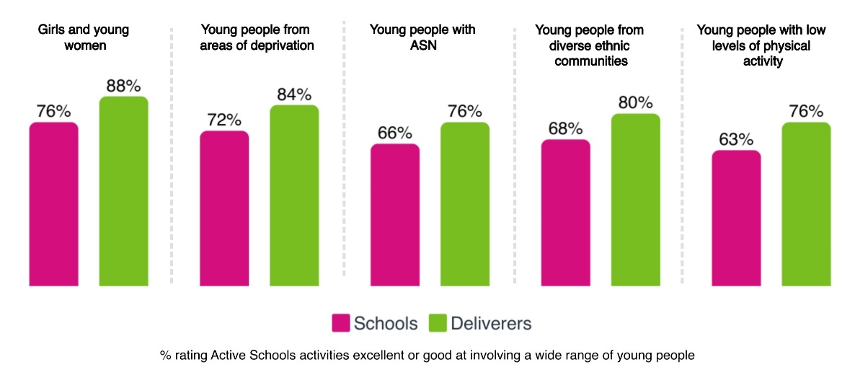

Reflecting on what works well, schools felt that:

- Active Schools was responsive to the needs of young people and worked closely with schools and pupils to explore needs.
- A lot of thought went into inclusion in Active Schools - with Active Schools tracking engagement, identifying gaps, discussing targeted activities, considering needs and then developing activity in line with this.
- It was positive that Active Schools activities were free to pupils. Schools felt this supported initiatives around cost of the school day and tackling poverty.

“
We love the ethos of our Active Schools team – so inclusive and strive to accommodate for as wide a range of children as possible.” Primary school

Although some schools were positive about work to include young people with ASN, some said that there was not always a range of Active Schools activities to meet different needs. A few said that at times activity was not inclusive and was geared towards able bodied participation. Schools recognised this was challenging as deliverers were volunteers and may not have the skills to deliver or may require extra adults supporting inclusive delivery.

A few schools said that they felt that Active Schools engaged those who were already sporty. Some schools suggested that there should be more targeted activity prioritising inclusion, and engaging pupils less likely to take part in physical activity. Secondary schools suggested more targeted work with girls and young women, and many suggested more focus on support for pupils with ASN.

“
Something more specifically tailored to encourage children with low levels of physical activity to take part in sport would be really good.” Primary school

Some schools pointed to intersectionality compounding challenges and barriers – for example people in areas of social deprivation, from diverse ethnic communities, with low physical activity levels.

Many Active Schools teams said that there had been a real focus on inclusion in recent years, and that targeted activity now formed a key part of their work – but with potential for further development. In sportscotland’s survey of ASMs, many identified inclusion, equality and diversity as a key focus for the upcoming year – including focusing on girls and young women, low income families, young people with care experience, rural schools, young people with ASN and inactive young people. Many were working to enhance their understanding of needs, identifying inactive pupils, profiling and exploring needs, working to develop opportunities and interrogating health and wellbeing data to drive activities in schools.

Example: Tracking and targeting
One team talked about undertaking detailed tracking of participation – including identifying people who are inactive, and differences in participation between different groups. This helps the Active Schools team explore where additional or different inputs could make a difference. The approach integrates well with local authority data systems and enables data sharing and collaboration.

Example: Understanding physical activity levels
One Active Schools team explained that it was gathering enhanced data collection to better inform planning and decision making. It has begun to collect data on physical activity participation outside Active Schools programmes and the school day. This provides a more comprehensive view of activity levels and helps identify which young people are inactive.

3.4 School, club and community pathways

Active Schools aims to develop, lead and support effective pathways to connect schools, clubs and communities. In 2024/25:

- More than 1,000 schools had at least one school to club link
- Two thirds of school to club links related to football or rugby
- 9% of Active Schools sessions were delivered by clubs (compared with 10% the two previous years, and 11% in 2021/22).

It is important to note that the links that can be made from schools to clubs depends on the infrastructure of clubs available locally.

Views on pathways
School staff generally felt that Active Schools connected schools well to wider clubs in the community. Overall, most school staff rated the connections excellent or good. ASN school staff rated connections much more poorly than other types of school.

“
Active Schools are very proactive in offering opportunities and promoting pathways.” Secondary school

“
Links with sports clubs in the community have been beneficial for pupils and provide regular high-quality input from rugby, tennis and golf clubs.” Primary school

Active Schools teams generally rated pathways to clubs and communities highly. Active Schools was felt to be a key programme connecting schools and clubs, and strengthening the participation pathway.

School staff, Active Schools teams and wider stakeholders also identified challenges with pathways, including:

- gaps in links to clubs and pathways for young people with ASN
- taster sessions not leading to a pathway into sport or activity locally
- challenges in rural areas and communities where there are few or no clubs
- reducing capacity and resources in club and community sport, sport development, local authorities and leisure trusts
- clubs not always being inclusive or accessible
- issues with the cost of club activity, proving a barrier to moving from Active Schools to club based activity
- challenges asking local clubs to volunteer in Active Schools delivery
- a need for better coordination between Active Schools, Community Sports Hubs and Governing Bodies for Sport.

3.5 Network of volunteers

Active Schools aims to develop a network of volunteers to deliver activity sessions. In 2024/25, there were almost 20,000 people delivering Active Schools activities.

- The highest proportions of deliverers were secondary school pupils (31%) and teachers or school staff (31%).
- The proportion of deliverers who are voluntary has been increasing – to 92% in 2024/25.
- At the same time, the proportion of deliverers who hold relevant qualifications has been decreasing (to 39% in 2024/25).

Stakeholder views
Deliverers rated the support they had been provided with as an Active Schools deliverer highly. Most (67%) said the support was excellent.

Most school staff highly valued the leadership opportunities that delivering Active Schools offered for their pupils. However, they highlighted that adult volunteers were also required. A few school staff highlighted that Active Schools placed significant additional workloads on teachers which may not be sustainable in the context of wider workload pressures.

A few school staff questioned whether the volunteer model for delivering Active Schools worked. There were concerns about:

- the quality of sessions delivered by volunteer young people or parents
- challenges attracting parent volunteers
- the skills of volunteer deliverers in relation to both managing behaviour and inclusion, particularly supporting young people with ASN
- relying on goodwill of teachers to give up their time to supervise sessions
- the capacity of club coaches to volunteer their time for free
- limited pools of volunteers available in small schools and rural areas.

Some schools felt that the model of volunteers should be reconsidered, and that Active Schools teams should deliver activity directly, be more present in schools and be part of the school community. Schools with ACSs or other team members based in their school for part or all of the week highly valued this.

Broadly Active Schools teams were positive about delivery through a network of volunteers. Approaches that worked well included:

- student placements through work with further and higher education institutions
- working with newly qualified teachers
- primary pupils leading play sessions at break and lunchtime
- secondary school pupils leading activities, developing leadership skills and gaining qualifications and recognition.

“
We simply wouldn't have a programme without our volunteers.” Active Schools team member

Challenges mirrored those identified by schools, including:

- capacity and burnout among teachers as volunteers
- young leaders require an adult presence and mentoring opportunities, which can be increasingly difficult to identify
- undertaking inclusive and targeted work using volunteers
- access for training for volunteers, including through SGB qualifications.

Some Active Schools teams and wider stakeholders suggested that while volunteers were important, and provided locally based people to run activities, relying solely on volunteers to deliver the whole Active Schools programme may not be sustainable – particularly with a need for skilled and trained volunteers to support inclusion.

3.6 Leadership opportunities

Active Schools aims to develop and support leadership opportunities for young people. A total of almost 27,000 young people were involved in local authority leadership programmes in 2024/25. This an increase from just over 24,000 involved in 2023/24 (when monitoring began for this indicator). In 2024/25, more young women (52%) than young men took part – higher than broader Active Schools participation.

Almost all local authorities (94%) offer an Active Schools pathway or programme for young people as leaders. This includes developing young people as volunteers, coaches and deliverers of Active Schools, programmes such as Young Ambassadors or Event Organisers, and young people being panel or committee members. Local authorities run these opportunities in a range of ways including Coaching Academies, Leadership Academies and other leadership pathways.

Young people are supported to gain qualifications through leadership programmes, including SGB sports specific awards, Sports Leaders UK, local Sports Leaders qualifications, first aid, safeguarding, Dynamic Youth Awards, Saltire Awards and others such as disability awareness.

Views on leadership opportunities
Schools generally rated the Active Schools leadership opportunities highly – with 74% rating them as excellent or good. Secondary schools rated leadership opportunities the highest and ASN schools rated leadership opportunities the lowest.

Schools valued:

- the opportunities for young people in primary and secondary school to develop their skills – including resilience, initiative, planning, supporting others, and working as a team
- the linked pathways in leadership from primary into secondary school
- the opportunities to gain qualifications through leadership programmes
- the chance for primary pupils to train as play leaders, and support play at break and lunch times.

“
This was transformative to our P6s last year and allowed learners the chance to both keep active, develop teamwork and also enhance their leadership skills.” Primary school

Active Schools teams felt that leadership was a core aspect of Active Schools, and that the leadership element of the programme worked well, built skills and were particularly effective for senior pupils when connected with qualifications.

Active Schools teams noted that leadership opportunities provided a route into careers – including as lifeguards, gym instructors, hall keepers, Modern Apprenticeship opportunities, Active Schools Assistants and ASCs. Some felt that this fit well with school priorities, developing skills for life, and wider trends of more pupils being interested in vocational pathways.

“
We have many success stories of pupils and young people progressing through our pathways into full-time work in sport and beyond.” Active Schools team member

Some Active Schools teams highlighted how their leadership work supported their inclusion priorities, including:

- Some sports leadership programmes are developed to help with attendance, behaviour and attainment – working closely with schools.
- In some areas there is a deliberate focus on engaging a wide range of people in leadership – for example young people with care experience – so they can go on to coach or mentor young people with similar lived experience.
- Fit for Girls was felt to work well, encouraging senior girls to lead sport.

Few challenges to leadership work were highlighted. A few felt that because so many deliverers are volunteers, it could be hard to place young people in high quality mentoring environments. And a few mentioned that leadership can be quite a busy landscape, with other PE and sports leadership courses taking place in schools.

Example: Building leadership skills
In one area a Sports Leadership Academy initiative offers pupils aged 14+ a week long holiday camp of certificated and non-certificated leadership courses spread between different venues. This is developed in partnership with governing bodies for sport, and has been well supported by secondary schools, some of whom have paid pupil fees or arranged transport.

Example: Targeted leadership approaches
One area launched a new leadership programme for S5/6 pupils, targeting those less likely to be going on to university. This focuses on football, basketball and netball. Young leaders get their entry level first qualifications for free in exchange for 25 hours volunteering, either with Active Schools in school or through local community clubs.

Wider stakeholders also rated leadership opportunities highly, feeling that most local areas had well established leadership programmes which built skills, connected with Curriculum for Excellence and Scotland’s national outcomes, and provided young people the opportunity to gain qualifications.

However, a few stakeholders were concerned that young leaders were being used as substitutes for adult volunteers. A few felt that approaches to leadership programmes should be more inclusive, supporting young people beyond those who are the most sporty and active, and offering meaningful opportunities for young people with ASN. Some wider stakeholders also felt that more standardisation in leadership programmes would be helpful.

Future considerations

4.1 Key findings

Active Schools is getting young people more active. 280,000 young people were involved in 2024/25, and almost half (44%) said they would be less active without Active Schools. The health and wider benefits of being active are well researched and evidenced. However, Active Schools is not reaching everyone to the same extent – with under-representation and differing outcomes for girls and young women and young people with ASN. These groups are known to be less likely to be active.

Active Schools is contributing significantly to education and learning outcomes, including supporting attendance and engagement at school. This is highly valued by school staff, and is often happening through targeted activity with the least engaged pupils. Active Schools also supports inclusion, a sense of community, friendship and connections. Leadership activity is also having a significant impact on young people’s skills, qualifications, aspirations and opportunities. ASN schools are less positive about impact and Active Schools model than other schools.

4.2 Developing the model

The Active Schools model is highly valued and respected. When schools were asked about priorities for the future for Active Schools, there were many mentions of ‘continue’, ‘more’ and ‘expand’. Schools, Active Schools teams, wider stakeholders, and those involved in the broader horizon scanning exercise, felt that Active Schools was an established, well respected and strongly supported programme which was highly regarded. Stakeholders felt that there were real opportunities to build on strengths in the Active Schools model around inclusion; leadership opportunities; supporting physical activity health and wellbeing; supporting learning outcomes; and community connection and reach.

To help Active Schools refine its model, stakeholders suggested:

- greater clarity of expectations around whether Active Schools is a universal offer for all children and young people, or whether support should be targeted at those most in need, most disengaged or most inactive
- considering development of the volunteer model to incorporate more direct delivery by paid, skilled staff (to support quality, range and inclusion); more training; and national support for engaging volunteers;
- building on highly valued leadership activity to clearly link it with skills development, recognised qualifications, inclusion, work experience and pathways to employment;
- better demonstrating the difference that Active Schools makes – moving from measuring participation and activity numbers, to outcomes; and
- sharing practice and ideas between Active Schools teams beyond Manager level, sharing ideas, training and recognising the success of teams, volunteers and participants at national level.

https://www.scotpho.org.uk/risk-factors/physical-activity/data/children/
Prescribing Exercise as Preventive Therapy, Warburton DER, Nicol CW and Bredin SSD, Canadian Medical Association Journal, vol. 174, issue 7, 2006
The Social Benefits of Sport, sportscotland, 2010 and Prescribing Exercise as Preventive Therapy, Warburton DER, Nicol CW and Bredin SSD (2006), Canadian Medical Association Journal, vol. 174
UK Chief Medical Officers’ Physical Activity Guidelines, 2019
A Review of the Social Impacts of Culture and Sport, Sheffield Hallam Sport Industry Research Centre, 2015
Scottish Health Survey 2024: Volume 1: Main Report, Scottish Government, October 2025
Overall, 8% of schools rated connections poor or very poor. This increased to 39% for ASN schools.

