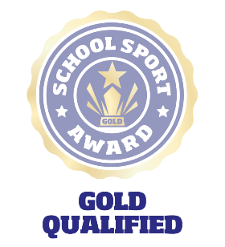Gold Questions Template **School Sport Award**   
**A framework for school sport**

**School Details**

**School name:**

**School roll:**

**School lead name:**

**Active Schools Coordinator:**

**Social media links:**

**School Context – tell us anything else about your school (e.g. geography, size, ethos, etc.)...**

**5 Steps to Gold**

This is an opportunity for your School Sport Committee to reflect on their role over the last year and share their story with us.

* **Step 1**: **School information** – Complete the “School Details” above.
* **Step 2**: **Action Plan** – There should be a least 1 new or ‘in-progress’ action across 4 of the 8 areas of the award that have a due date within the current academic year.
* **Step 3**: **The Questions** – The 3 questions below should be answered through the pupil voice. This can be through video (max 1 minute per video) PowerPoint, sway, Word, YouTube or any other method that works for you and your committee. Be creative – this is about telling your story!
* **Step 4**: **Evidence** – Upload your additional information, or if linking to external content, copy the links into this document and upload to your awards page. Evidence should be minimal and reflect the information requested in point 2. You are more than welcome to attach evidence you have already put together as part of the schools exisiting reporting, however we do not need or expect to see high amounts of additional evidence submitted.
* **Step 5**: **Submit** **for Gold!**

**Questions to answer**

1. **What makes your school gold?**
2. **What is something you have changed, and how?**
3. **What is the best thing about sport in your school?**