
SPORTS PARTICIPATION:
golf FACT SHEET

Context
This fact sheet provides a summary of information on participation in golf from 2003-06. It is based on data from the Scottish Omnibus Survey, which covers a wide range of sports and physical recreations from angling to yoga.
This fact sheet also supplements a detailed report on sports participation in Scotland and is one of a series which profile participation in selected sports, geographic areas and by specific population groups (see http://www.sportscotland.org.uk).

Adults
Golf had an overall participation rate of 8% and its participation profile showed a strong bias towards men.
Less than one in ten adults (8%) participated in golf at least once in four weeks. There were, however, small variations by both gender and age (see Figures 1 and 2) with, for example, a slight peak for 16-24 year olds (9%).
Participation by gender
Figure 1: Comparative participation by gender and age
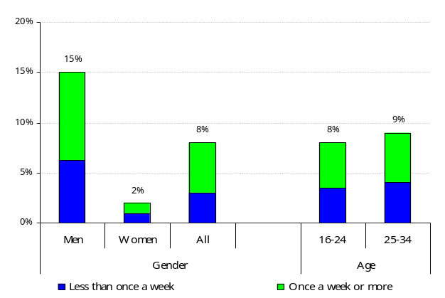

Whilst 15% of men participated in golf during a four-week period, this compares to a rate of only 2% for women.
Golf participation tended to be typified by regular participation, with over half of all participants (57%) playing once a week or more.

NOTE: In all figures referring to participation ‘less than once a week’ denotes participation less than once a week but at least once in the past four weeks.

Participation by age

Figure 2: Comparative participation by age
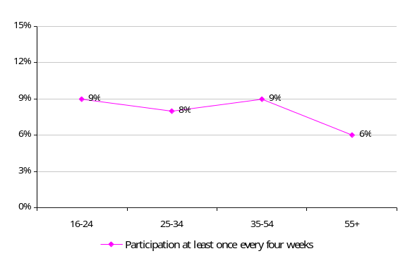

Golf participation is relatively consistent across all age groups. However, only a sixth (17%) of adult participation was by those aged 16-34 years, whilst this group represented 32% of the total population.
Additional factors affecting participation
Participation rates for those taking part in golf at least once in a four-week period varied according to personal circumstances, with the participation rates shown below:
Economic status
- in full time employment – 13%;
- in part time employment – 4%;
- not in employment – 5%; and
- students – 9%.
Social class
- upper/middle class (AB) – 13%;
- lower middle class (C1) – 9%;
- skilled manual workers (C2) – 8%; and
- semi/unskilled workers and those not in employment (DE) – 3%.
Deprivation – participation rates for persons living in the country’s more deprived areas were 3% whilst rates for outside deprived areas were 9%.
Limiting long-term illness or disability (LLTI)
- with an LLTI – 3%; and
- without an LLTI – 9%.
Car ownership/access to a car
- no car – 2%;
- one car – 8%; and
- two or more cars – 14%.

Local authority grouping
- East – 7%;
- Glasgow – 6%;
- Midland – 9%;
- North – 10%;
- South – 8%; and
- West – 7%.
Club membership (participants only)
More than half (58%) of participants (those who participated in golf at least once every four weeks) were club members.
Four-fifths (78%) of club members played golf once a week or more, compared to only three in ten (29%) non-club members.
Frequency, duration and nature of participation (participants only)
Figure 3: Frequency of participation
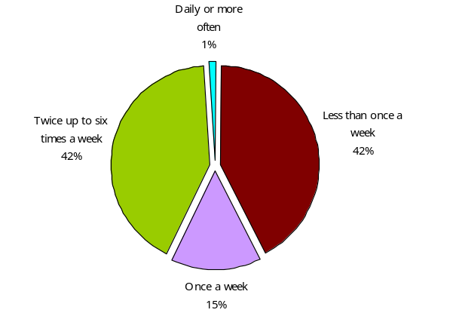
Frequency of participation – almost half (42%) of participants took part in golf less than once a week; with virtually the same number (43%) taking part twice a week or more.
Figure 4: Duration of participation
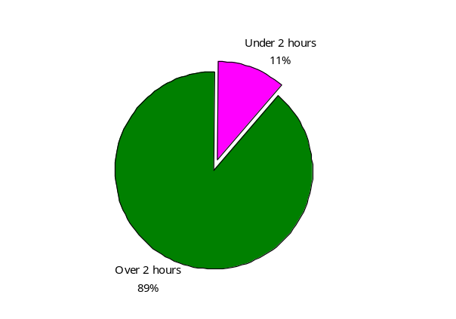
Duration of participation – 89% of participation in golf, over the four weeks prior to the survey, was for more than two hours.

Figure 5: Nature of participation
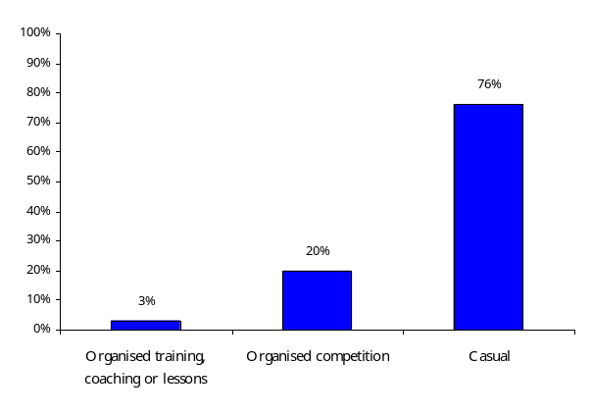

Nature of participation – over the four weeks prior to the survey, three-quarters (76%) of the participation in golf was on a casual basis while 20% of sessions involved organised competitions.

Children (aged 8-15)
Figure 6: Participation in golf, by gender and age (excluding PE lessons)
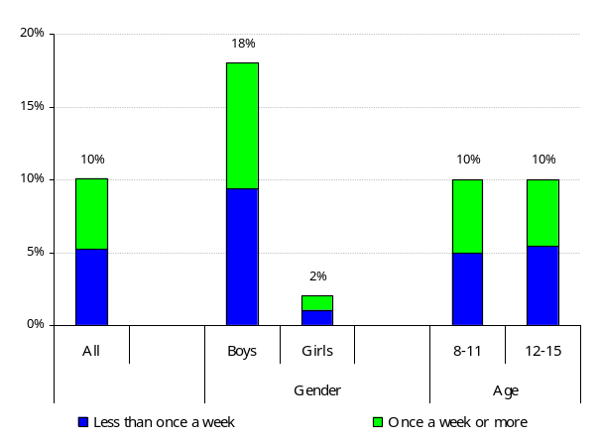
Whilst only 2% of girls participated in golf during a four-week period, this compares to a rate of 18% for boys.
Participation rates were the same for 8-11 year olds and 12-15 year olds, with the both age groups likely to participate regularly.

NOTE: Figures for the nature of participation are based on a count of casual, training and competitive sessions for each participant during a four weeks period.
Additional factors affecting participation
Like adults, participation rates for children taking part in golf, at least once in a four-week period, varied relative to personal and familial circumstances.

Social class
- children from AB households – 14%;
- children from C1 households – 11%;
- children from C2 households –12%; and
- children from DE households – 7%.
Urban and rural areas
- children from urban areas – 10%; and
- children from rural areas – 11%.

Deprivation (Scottish Index of Multiple Deprivation areas)
- children living inside SIMD areas – 8%; and
- children living outside SIMD areas – 11%.
Local authority grouping
- East – 8%;
- Glasgow – 8%;
- Midland – 11%;
- North – 11%;
- South – 12%; and
- West – 10%.
Club membership (participants only)
No gender split – overall club membership only please
The rate for regular participation (once a week or more) was higher for club members (64%), than it was for those children who were not club members (41%).

Frequency of participation
The measure of frequency of participation is in the national strategy for sport in Scotland (‘Reaching Higher’) and is participation in sport and physical recreations at least once a week. However, in order to minimise sampling error, the main indicator used in this fact sheet is participation at least once in the last four weeks.

Participation

Participation – is the process of taking part, however informally, as opposed to spectating or helping to organise the sport. Participation data is based on upon peak season data, which shows the most popular four months of data and more accurately reflects the seasonal nature of much sports participation. It avoids any dilution due to the data being looked at as if the sporting activity took place over a full twelve-month period, when in fact it may only occur for half of the year.

Social class definitions by group
AB Upper middle class – higher managerial, administrative or professional.
Middle class – intermediate managerial, administrative or professional.
C1 Lower middle class – supervisor or clerical and junior managerial, administrative or professional.
C2 Skilled working class – skilled manual workers.
DE Working class – semi and unskilled manual workers.
Those at lowest levels of subsistence – state pensioners etc with no other earnings.

Data notes
1. As a result of the sample sizes involved in the survey the figures quoted will, on average, have an estimated error margin of +/-2%. Consequently a rate of 18% for an individual activity has the potential to be as high as 20% or as low as 16%. Nonetheless, the picture provided by the data remains relevant and is a reasonable guide to the overall rates and their patterns.
2. Data are based on a 2003-06 survey by TNS of participation in sports and physical recreations.
3. Further information, including a methodological overview, is available on the sportscotland website: http://www.sportscotland.org.uk


For survey information, data and policy implications contact: research@sportscotland.org.uk
Fact sheets and reports produced by Knight, Kavanagh and Page: http://www.kkp.co.uk

