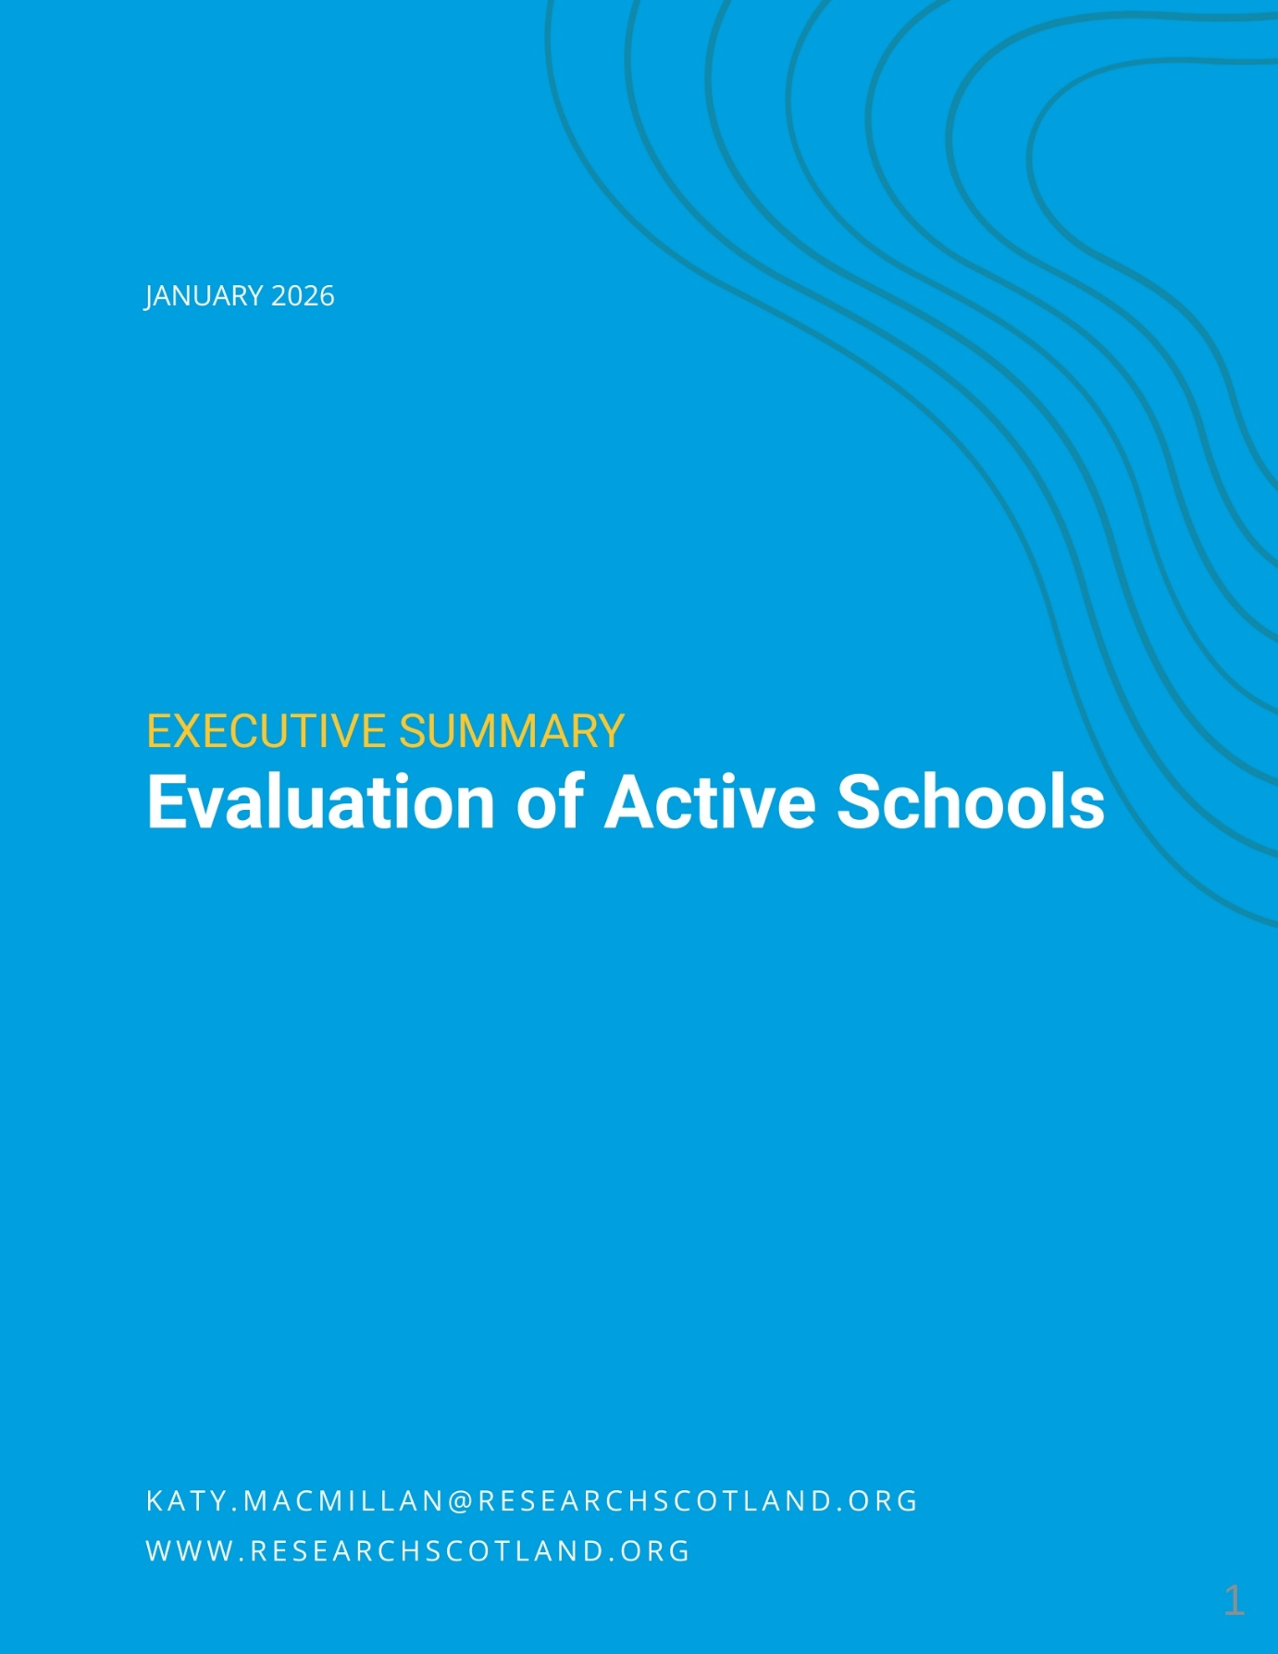

Active Schools Evaluation - Summary

About this report

This report sets out findings from an evaluation of the Active Schools programme, undertaken by Research Scotland for sportscotland in autumn 2025. The overarching aim of this evaluation report is to explore:

What are the impacts and challenges of the current Active Schools programme?

This evaluation, alongside a wider horizon scanning piece of research which explores key drivers for change, will inform exploration of the future focus of and models for Active Schools beyond 2027.

The evaluation report involved:

- a desktop review and online surveys – with responses from 1,313 school staff, 37 Active Schools Managers [ASMs], 256 Active Schools Coordinators [ASCs], 276 deliverers and 20 sportscotland staff
- 25 evaluation interviews, 25 horizon scanning interviews and discussions with the Young People’s Sport Panel and equalities organisations.

About Active Schools

The Active Schools programme aims to:

- create more and higher quality opportunities to participate in sports before school, during lunchtime and after school
- develop effective pathways between schools and clubs in the local community.

Active Schools is part funded by Scottish Government through sportscotland. Over £12 million is invested by Scottish Government and over £4 million by partners. Partnership agreements are in place with all 32 local authorities to March 2027.

Active Schools has five priority areas that are consistent across all 32 local authority teams. Active Schools:

- provides high quality opportunities for all young people to take part in sport and physical activity before school, at lunchtime and after school
- develops, leads and supports effective pathways to connect schools, clubs and communities
- provides inclusive opportunities by using targeted approaches to remove barriers to participation
- develops a network of volunteers to deliver activity sessions
- develops and supports leadership opportunities for young people.

The network consists of over 400 managers and coordinators. Locally, Active Schools teams have their own priorities within the overarching aims of the programme.

Key findings

Active Schools is getting young people more active. 280,000 young people were involved in 2024/25, and almost half of Active Schools participants say they would be less active without Active Schools. The health and wider benefits of being active are well researched and evidenced. However, Active Schools is not reaching everyone to the same extent – with under-representation and differing outcomes for girls and young women and young people with additional support needs (ASN). These groups are known to be less likely to be active.

Active Schools is contributing significantly to education and learning outcomes, including supporting attendance and engagement at school. This is highly valued by school staff, and is often happening through targeted activity with the least engaged pupils. Active Schools also supports inclusion, a sense of community, friendships and connections. Leadership activity is also having a significant impact on young people’s skills, qualifications, aspirations and opportunities. ASN schools are less positive about impact and Active Schools model than other schools.

Developing the model in the future

The Active Schools model is highly valued and respected. When schools were asked about priorities for the future for Active Schools, there were many mentions of ‘continue’, ‘more’ and ‘expand’. Stakeholders felt that there were real opportunities to build on strengths in the Active Schools model around inclusion; leadership opportunities; supporting physical activity health and wellbeing; supporting learning outcomes; and community connection and reach.

To help Active Schools refine its model, stakeholders suggested:

- greater clarity of expectations around whether Active Schools is a universal offer for all children and young people, or whether support should be targeted at those most in need, most disengaged or most inactive
- considering development of the volunteer model to incorporate more direct delivery by paid, skilled staff (to support quality, range and inclusion); more training; and national support for engaging volunteers;
- building on highly valued leadership activity to clearly link it with skills development, recognised qualifications, inclusion, work experience and pathways to employment;
- better demonstrating the difference that Active Schools makes – moving from measuring participation and activity numbers, to outcomes;
- sharing practice and ideas between Active Schools teams beyond Manager level, sharing ideas, training and recognising the success of teams, volunteers and participants at national level.

Impact of Active Schools

Getting young people active
In 2024/25, Active Schools engaged 280,000 children and young people in physical activity. This is 40% of the total school roll in Scotland 2024/25. More than half of primary school pupils took part in Active Schools, compared with a quarter of secondary school pupils and less than a third of pupils at ASN schools.

In 2019/20, sportscotland undertook a major survey of Active Schools participants to explore the impact of taking part.

94% of pupils said Active Schools made them want to keep being active as they grew up.

67% of pupils said Active Schools helped them to be more active outside of school. This is lower for those in the most deprived areas, and for secondary school pupils.

49% of pupils said Active Schools helped them get interested in other sports and clubs. This was lower for pupils in the most deprived areas, and for secondary pupils.

44% of pupils said that they would be less active without their Active Schools activity. Pupils from the most deprived areas and secondary pupils were most likely to say they would be less active without Active Schools.

Figures from the 2019/20 survey suggest that Active Schools activity itself supported more participants to meet physical activity guidelines – reducing inactivity and increasing the proportion of young people who are active. The biggest change in inactivity was for pupils in the 20% most deprived areas and for females.

Schools, those in the Active Schools network and wider stakeholders were positive about the impact Active Schools has on young people’s physical activity levels. Most schools were very clear that Active Schools helped to support physical activity levels among their pupils. Some said that without Active Schools there would be little or no sport or physical activity extra-curricular activities at their school.

“
There’s no way we’d have anything close to the number of kids we’ve got engaged in extra-curricular sport if it wasn’t for Active Schools.” Secondary school

Some Active Schools teams said activity was planned purposefully to get young people active, focusing on engaging those less likely to take part or who were not already involved. Many of the examples given of impact for inactive young people related to targeted, small scale and in-depth work, rather than universal activity.

Supporting health and wellbeing
sportscotland’s national survey in 2019/20 found that Active Schools made a significant difference to young people’s health and wellbeing.
- 97% said taking part in sport and physical activity helped them feel healthy
- 89% said it helped them feel confident
- 88% said it helped them feel happy.

There is very clear evidence and strong research that demonstrates that physical activity and sport can bring about positive change to people’s health and wellbeing. The UK Chief Medical Officer has highlighted that there are clear benefits of physical activity for children, for which there is moderate to strong evidence. These include improving bone health, cognitive function, cardiovascular fitness, muscle fitness, weight status and depression. Research has also found that children and young people taking part in sport have fewer mental health, emotional, behavioural and peer-relationship problems and demonstrate more positive social behaviours.

Schools felt that Active Schools supported physical and mental health – with most rating its contribution as good or excellent (88% for physical health, 86% for mental health). Schools and other stakeholders also felt that Active Schools built fitness, strength and coordination, supported positive relationships and emotional regulation, boosted positive mindsets and energy, reduced stress and anxiety, helped young people learn about healthy lifestyles, and built confidence and resilience.

“
I feel calmer and more relaxed after my sessions.”
Young person

Schools in the 15% most deprived areas rated impact more highly and ASN schools rated impact more poorly.

Supporting learning, attendance and attainment
Most schools said that Active Schools aligned a lot with education outcomes (75%) and contributed a lot to school culture and ethos (78%).

Schools indicated that Active Schools contributed to the experiences and outcomes in Curriculum for Excellence and aligned well with Getting it Right for Every Child, the United Nations Convention on the Rights of the Child and Pupil Equity Fund priorities. When talking about the difference that Active Schools made to their school, school staff often used words like ‘value’, ‘rely’ and ‘depend’.

“
They are a vital part of our school community.”
Primary school

Schools were positive about the impact of Active Schools on engagement, behaviour, attendance and attainment. Schools were very clear that Active Schools was:

- supporting engagement with learning and positive behaviour – through physical activity building concentration levels and mental wellbeing
- boosting attendance at school – encouraging children and young people to come to school on days that Active Schools sessions are on
- offering opportunities for children to achieve in different aspects of school life
- supporting attainment – through developing new skills for learning – including confidence, resilience, teamwork, leadership, motivation, perseverance and self-discipline – and offering further learning and qualification opportunities.

Schools felt that these skills and qualifications contributed to pupil attainment, with the skills learned being transferrable into other areas of the curriculum. School staff emphasised that Active Schools was part of a wider effort to support learning and attainment, and while it contributed, it was not the only or main driver.

Young people were clear that they gained skills and qualifications through taking part in Active Schools. Many talked about how important these skills were for the future, gaining both transferrable and sports specific skills for future learning and careers.

Inclusion and networks
Schools were positive about the impact Active Schools has on friendships and networks (83% rating impact as excellent or good) and inclusion and community connection (79%). ASN schools rated impact on friendships and networks and inclusion within the community lower than other schools. The sportscotland Active Schools survey from 2019/20 also found that participants said taking part in sport and physical activity helped them to make friends (82%) and feel included (82%).

“
I made new friendships, and feel more safe and happy after being anxious about coming.” Young person

School staff said that Active Schools:

- supports connections, friendships and networks across stages and ages
- creates a sense of fun in the school environment
- builds safer and more inclusive play at break and lunch for primary pupils
- supports transitions and connections between primary and secondary
- fosters a sense of belonging and nurture
- provides positive role models and builds trusting relationships
- empowers young people and provides opportunities for pupil voice
- helps young people work together and deal with conflict
- promotes inclusion and equity in the school
- provides opportunities that people would not otherwise have access to.

“
I think it gives the children a sense of belonging in school.”
Primary school

The Active Schools model

There are five priority areas of the current Active Schools model which are consistent across all 32 local authorities in Scotland.

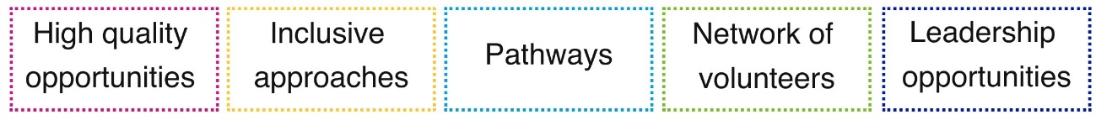

High quality opportunities
Active Schools provided more than 265,000 sessions in 2024/25. Of these more than a quarter were football, with other common activities including multi-sports, netball, dance, basketball and rugby.

Overall, schools rated the quality and range of Active Schools activities highly – with 85% rating quality as good or excellent.

- Secondary schools and schools in the most deprived areas were most likely to rate the quality and range of activities as excellent.
- ASN school staff rated the quality and range the lowest.
- Schools valued Active Schools teams, their skills and knowledge. Many valued the relationship-based approach, focusing on strong connections and communication with schools and young people.

For the future, some schools and Active Schools teams suggested considering the impact of the volunteer model on quality and range of activity; the range of activities available (beyond traditional activities); particular barriers to quality and range in rural and remote areas; and how best to balance quantity and quality of activity.

Inclusive opportunities
Active Schools aims to provide inclusive approaches using targeted methods to remove barriers to participation. Nationally:

- Pupils from the most deprived areas and diverse ethnic communities are well represented in Active Schools participation.
- Fewer females than males take part (particularly at secondary school, increasing in older age groups).
- Pupils with ASN are under-represented.
- The balance of participation varies between local authorities.

Schools generally felt that Active Schools sessions were inclusive, that activities were adapted to suit a range of needs and that activity was targeted to meet needs. Schools valued that Active Schools activities were free to pupils, feeling this supported initiatives around the cost of the school day and tackling poverty.

Approximately a third of schools felt that Active Schools had been fair, poor or very poor at engaging young people with low levels of physical activity and young people with ASN.
For young people with ASN, schools felt that activities didn’t always meet needs, and volunteer deliverers may not have the skills to support people with ASN, or may require extra adults to support inclusive delivery.

Some schools pointed to intersectionality compounding challenges and barriers – for example people in areas of social deprivation, from diverse ethnic communities, with low physical activity levels.

Pathways
Active Schools aims to develop, lead and support effective pathways to connect schools, clubs and communities. In 2024/25:

- More than 1,000 schools had at least one school to club link.
- Two thirds of school to club links related to football or rugby.
- 9% of Active Schools sessions were delivered by clubs (compared with 10% the two previous years, and 11% in 2021/22).

It is important to note that the links that can be made from schools to clubs depends on the infrastructure of clubs available locally.

School staff generally felt that Active Schools connected schools well to wider clubs in the community, with most rating connections excellent or good. ASN school staff rated connections much more poorly than other types of school.

School staff, Active Schools teams and wider stakeholders also identified challenges with pathways, including:

- gaps in links to clubs and pathways for young people with ASN
- challenges in rural areas and communities where there are few or no clubs
- reducing capacity and resources in club and community sport, sport development, local authorities and leisure trusts
- clubs not always being inclusive or accessible
- challenges asking local clubs to volunteer in Active Schools delivery.

Network of volunteers
Active Schools aims to develop a network of volunteers to deliver activity sessions. In 2024/25, there were almost 20,000 people delivering Active Schools activities.

- The highest proportions of deliverers were secondary school pupils (31%) and teachers or school staff (31%).
- The proportion of deliverers who are voluntary has been increasing – to 92% in 2024/25.
- At the same time, the proportion of deliverers who hold relevant qualifications has been decreasing (to 39% in 2024/25).

Most school staff highly valued the leadership opportunities that delivering Active Schools offered for their pupils. However, they highlighted that adult volunteers were also required, and that pressures on school staff were increasing.

A few school staff questioned whether the volunteer model for delivering Active Schools worked. There were concerns about the quality of sessions, the skills of volunteers, and the capacity of parents, teachers and club coaches to volunteer their time. Some schools felt that Active Schools teams should deliver activity directly.

Some Active Schools teams and wider stakeholders suggested that while volunteers were important, and provided locally based people to run activities, relying solely on volunteers to deliver the whole Active Schools programme may not be sustainable – particularly with a need for skilled and trained volunteers to support inclusion.

Leadership opportunities
Active Schools aims to develop and support leadership opportunities for young people. A total of almost 27,000 young people were involved in local authority leadership programmes in 2024/25. More young women (52%) than young men took part in leadership activities.

Schools generally rated the Active Schools leadership opportunities highly – with 74% rating them as excellent or good. Secondary schools rated leadership opportunities the highest and ASN schools rated leadership opportunities the lowest.

Schools valued the opportunities for skills development, gaining qualifications and connecting primary and secondary schools through leadership activity. Active Schools teams noted that leadership opportunities provided a route into careers – including into the Active Schools network. Some Active Schools teams also highlighted how their leadership work supported their inclusion priorities – for example supporting attendance and attainment; engaging disadvantaged young people in leadership activity; and engaging girls and young women in leading sport.

Few challenges to leadership work were highlighted. A few felt that because so many deliverers are volunteers, it could be hard to place young people in high quality mentoring environments.

https://www.scotpho.org.uk/risk-factors/physical-activity/data/children/
UK Chief Medical Officers’ Physical Activity Guidelines, 2019
A Review of the Social Impacts of Culture and Sport, Sheffield Hallam Sport Industry Research Centre, 2015
Overall, 8% of schools rated connections poor or very poor. This increased to 39% for ASN schools.

