
SPORTS PARTICIPATION:
Dance FACT SHEET

Context
This fact sheet provides a summary of information on participation in dance from 2003-06. It is based on data from the Scottish Omnibus Survey, which covers a wide range of sports and physical recreations from angling to yoga.
This fact sheet also supplements a detailed report on sports participation in Scotland and is one of a series which profile participation in selected sports, geographic areas and by specific population groups (see http://www.sportscotland.org.uk).

Adults
Dance had an overall participation rate of 6% and its participation profile showed a bias towards women.
One in twenty adults (5%) participated in dance at least once in four weeks. There were, however, variations by both gender and age (see Figures 1 and 2) with, for example, a peak for 16-24 year olds (11%).
Participation by gender
Figure 1 Comparative participation by gender
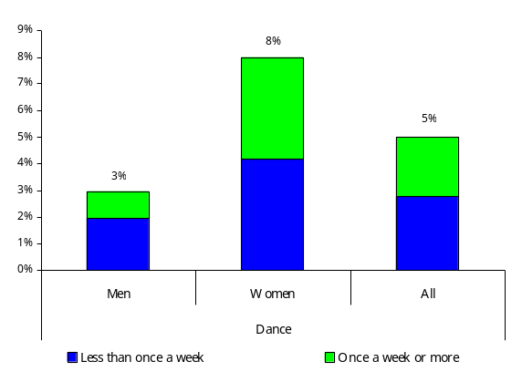

Whilst 8% of women participated in dance of one form or another over a four-week period, this compares to a rate of 3% for men.
Dance participation tended to be typified by less regular participation, with two-thirds of male dancers (65%) and more than half of female dancers (52%) participating less than once a week.

NOTE: In all figures referring to participation ‘less than once a week’ denotes participation less than once a week but at least once in the past four weeks.

Participation by age

Figure 2: Decline in participation by age
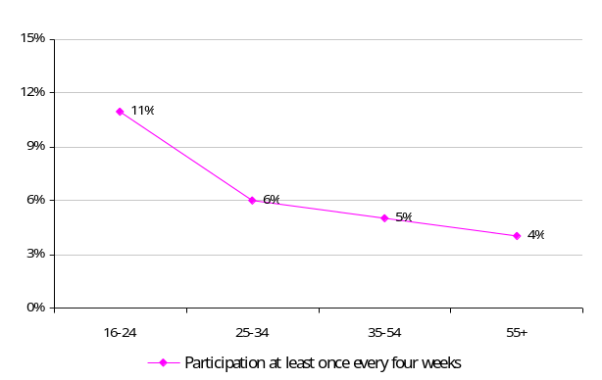

Dance participation was age related, with 11% of 16-24 year olds having participated in dance, whilst only 4% of those aged 55+ years participated.
A sixth (17%) of adult participation was by those aged between 16-34, whilst this group represented 32% of the total population.
Additional factors affecting participation
Participation rates for those taking part in dance at least once in a four-week period varied according to personal circumstances, with the participation rates shown below:
Economic status
- in full time employment – 5%;
- in part time employment – 9%;
- not in employment – 4%; and
- students – 15%.
Social class
- upper/middle class (AB) – 7%;
- lower middle class (C1) – 6%;
- skilled manual workers (C2) – 5%; and
- semi/unskilled workers and those not in employment (DE) – 4%.
Deprivation – participation rates for persons living in the country’s more deprived areas were 4%, whilst rates for outside deprived areas were 6%.
Limiting long-term illness or disability (LLTI)
- with an LLTI – 3%; and
- without an LLTI – 6%.
Car ownership/access to a car
- no car – 4%;
- one car – 5%; and
- two or more cars – 7%.

Local authority grouping
- East – 5%;
- Glasgow – 4%;
- Midland – 7%;
- North – 7%;
- South – 5%; and
- West – 4%.
Club membership (participants only)
Just over a fifth (21%) of participants (those who participated in dance at least once every four weeks) were club members.
There was a significant difference in the frequency of participation for club and non-club members, with three-quarters (74%) of club members taking part in dance once a week or more, compared to only 37% of non-club members.
Frequency, duration and nature of participation (participants only)
Figure 3: Frequency of participation
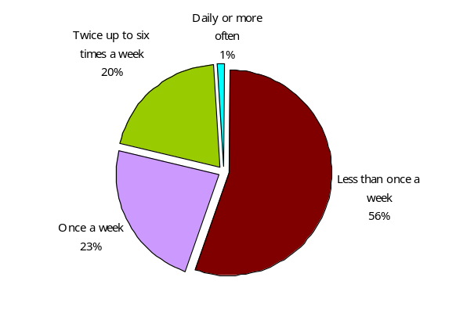
Frequency of participation – over half (56%) of participants took part in dance less than once a week; whilst almost a fifth (21%) did so twice a week or more.
Figure 4: Duration of participation
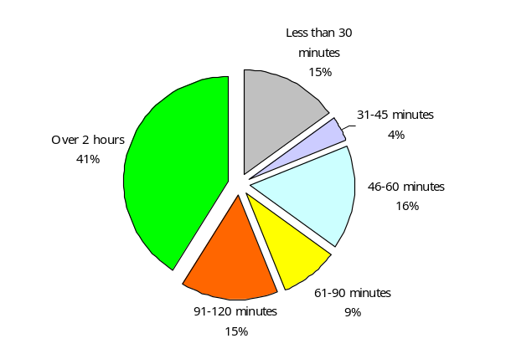
Duration of participation – 41% of participation in dance, over the four weeks prior to the survey, was for more than two hours.

Figure 5: Nature of participation
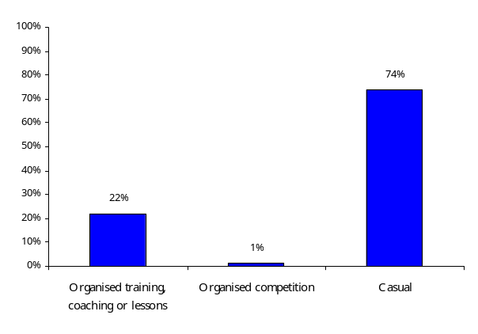

Nature of participation – over the four weeks prior to the survey, three-quarters (74%) of participation was on a casual basis whilst 22% involved organised training, coaching or lessons.

Children (aged 8-15)
Figure 6: Participation in dance, by gender and age (excluding PE lessons)
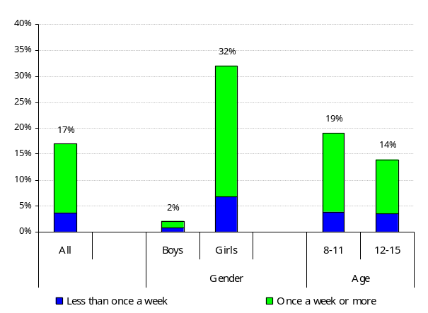
A quarter (24%) of young people participated in dance over a four-week period (including during PE lessons), whilst when PE lessons were excluded, participation rates were 17%.
Note: Participation in environments other than a school PE lesson have been selected as the focus for the remainder of the fact sheet as it shows independent levels of participation in dance.
Whilst only 2% of boys participated in dance during a four-week period, this compares to a much higher rate of 32% for girls.
Participation rates were higher for 8-11 year olds (19%), than for 12-15 year olds (14%) over a four-week period. Both age groups were characterised by having higher levels of participation once a week or more.
Additional factors affecting participation
Like adults, participation rates for children taking part in dance, at least once in a four-week period, varied relative to personal and familial circumstances.

Social class
- children from AB households – 20%;
- children from C1 households – 15%;
- children from C2 households –15%; and
- children from DE households – 18%.
Urban and rural areas
- children from urban areas – 17%; and
- children from rural areas – 15%.

Deprivation (Scottish Index of Multiple Deprivation areas)
- children living inside SIMD areas – 18%; and
- children living outside SIMD areas – 17%.
Local authority grouping
- East – 17%;
- Glasgow – 16%;
- Midland – 17%;
- North – 18%;
- South – 16%; and
- West – 16%.
Club membership (participants only)
Almost half (43%) of young people who participated were club members.
The rate for regular participation (once a week or more) was much higher for club members (91%), than it was for those children who were not club members (66%).

Frequency of participation
The measure of frequency of participation is in the national strategy for sport in Scotland (‘Reaching Higher’) and is participation in sport and physical recreations at least once a week. However, in order to minimise sampling error, the main indicator used in this fact sheet is participation at least once in the last four weeks.

Participation

Participation – is the process of taking part, however informally, as opposed to spectating or helping to organise the sport. Participation data is based on upon peak season data, which shows the most popular four months of data and more accurately reflects the seasonal nature of much sports participation. It avoids any dilution due to the data being looked at as if the sporting activity took place over a full twelve-month period, when in fact it may only occur for half of the year.

Social class definitions by group
AB Upper middle class – higher managerial, administrative or professional.
Middle class – intermediate managerial, administrative or professional.
C1 Lower middle class – supervisor or clerical and junior managerial, administrative or professional.
C2 Skilled working class – skilled manual workers.
DE Working class – semi and unskilled manual workers.
Those at lowest levels of subsistence – state pensioners etc with no other earnings.

Data notes
1. As a result of the sample sizes involved in the survey the figures quoted will, on average, have an estimated error margin of +/-2%. Consequently a rate of 18% for an individual activity has the potential to be as high as 20% or as low as 16%. Nonetheless, the picture provided by the data remains relevant and is a reasonable guide to the overall rates and their patterns.
2. Data are based on a 2003-06 survey by TNS of participation in sports and physical recreations.
3. Further information, including a methodological overview, is available on the sportscotland website: http://www.sportscotland.org.uk


For survey information, data and policy implications contact: research@sportscotland.org.uk
Fact sheets and reports produced by Knight, Kavanagh and Page: http://www.kkp.co.uk

NOTE: Figures for the nature of participation are based on a count of casual, training and competitive sessions for each participant during a four weeks period.

