
SPORTS PARTICIPATION:
athletics and running/jogging FACT SHEET

Context
This fact sheet provides a summary of information on participation in athletics and running/jogging from 2003-06. It is based on data from the Scottish Omnibus Survey, which covers a wide range of sports and physical recreations from angling to yoga.
This fact sheet also supplements a detailed report on sports participation in Scotland and is one of a series which profile participation in selected sports, geographic areas and by specific population groups (see http://www.sportscotland.org.uk).

Athletics and running/jogging
Athletics and running/jogging participation can be broken down by:
- Running/jogging; and
- Athletics.
As the same individuals may have participated in more than one form of athletics and running/jogging, the figures avoid double counting when arriving at an overall total. It is not possible to, for example, simply add the numbers taking part in athletics to those who participated in running/jogging to get an overall total, as many people will have done both.

Adults
Athletics and running/jogging had an overall participation rate of 5% and its participation profile showed a slight bias towards men.
One in twenty adults (5%) participated in athletics and running/jogging at least once in four weeks, with rates for different formats ranging from 1% for athletics to 4% for running/jogging. There were, however, variations by both gender and age (see Figures 1 to 3) with, for example, a peak for 16-24 year olds (11%).
Participation by gender
Whilst 6% of men participated in athletics and running/jogging of one form or another during a four-week period, this compares to a rate of only 3% for women.

NOTE: In all figures referring to participation ‘less than once a week’ denotes participation less than once a week but at least once in the past four weeks.

Figure 1: Comparative participation by gender
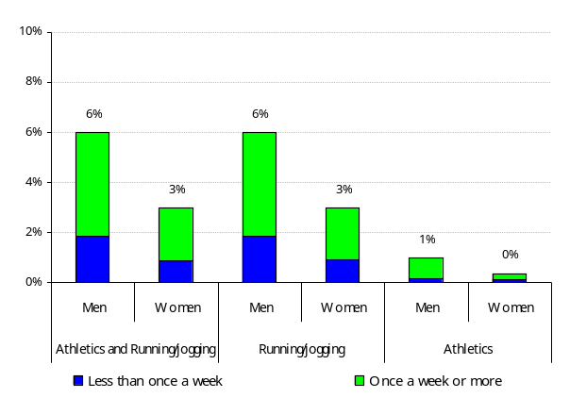
* In all instances, where graphs show 0%, this means that participation levels for that category were below 0.5%.
Athletics and running/jogging participation tended to be typified by regular participation, with more than two-thirds (69%) of male athletes participating once a week or more.
Running/jogging was the sport’s most popular format with men’s rates at 6%, compared to 1% for athletics. Running/jogging was also the most popular format of participation (1%) for women.
Participation by age

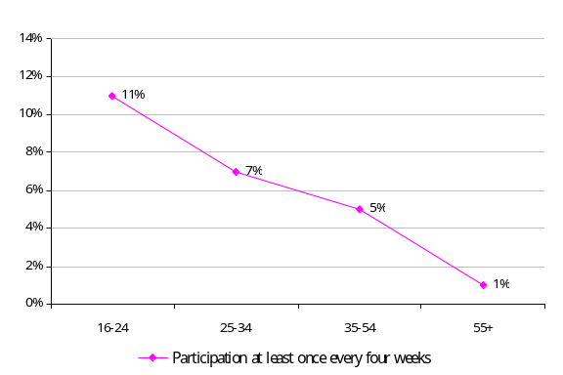
Figure 2: Decline in participation by age

Athletics and running/jogging participation was strongly age related, with 11% of 16-24 year olds having participated, compared to only 1% of those aged 55 years and over.
Figure 3 examines the different types of athletics and running/jogging participation for the two main groups of adults that participated. Almost a fifth (18%) of adult participation was by those aged 16-34, whilst this group represented 32% of the total population.

Figure 3: Types of participation by age
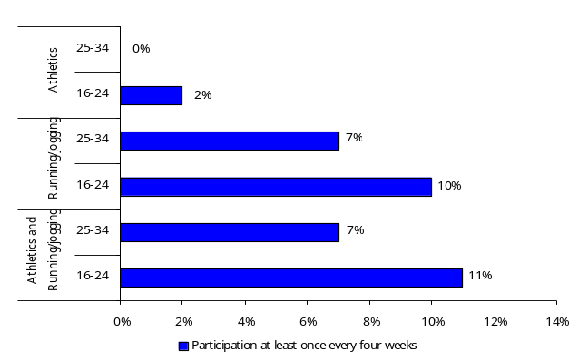

The most noticeable difference between the two age groups was participation in athletics, with virtually no participants aged 25-34 years.
Additional factors affecting participation
Participation rates for those taking part in athletics and running/jogging at least once in a four-week period varied according to personal circumstances, with the participation rates shown below; one of the most noticeable figures is the high student participation.
Economic status
- in full time employment – 7%;
- in part time employment – 5%;
- not in employment – 2%; and
- students – 16%.
Social class
- upper/middle class (AB) – 7%;
- lower middle class (C1) – 6%;
- skilled manual workers (C2) – 4%; and
- semi/unskilled workers and those not in employment (DE) – 2%.
Deprivation – compared to other sports it is notable that there was little difference in the participation rates for people living in the country’s more deprived areas.
Limiting long-term illness or disability (LLTI)
- with an LLTI – 1%; and
- without an LLTI – 6%.
Car ownership/access to a car
- no car – 2%;
- one car – 5%; and
- two or more cars – 8%.
Urban and rural areas
- live in urban areas – 5%; and
- live in rural areas – 6%.
Local authority grouping
- East – 5%;
- Glasgow – 5%;
- Midland – 4%;
- North – 6%;
- South – 3%; and
- West – 5%.
Club membership (participants only)
One in ten (10%) male participants (those who participated in athletics and running/jogging at least once every four weeks) were club members, compared to one in eight (12%) women.
Frequency, duration and nature of participation (participants only)
Frequency of participation – three in ten (31%) participants took part in athletics and running/jogging less than once a week; whilst more than half (55%) did so twice a week or more.
Figure 4: Frequency of participation
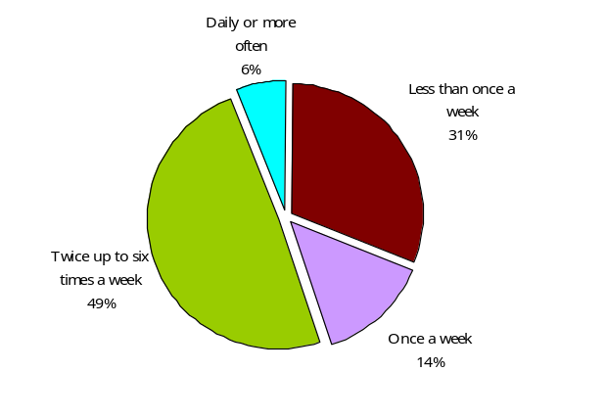
Duration of participation – 39% of participation in running and jogging, over the four weeks prior to the survey, was for between three-quarters of an hour and an hour and a half.
Figure 5: Duration of participation
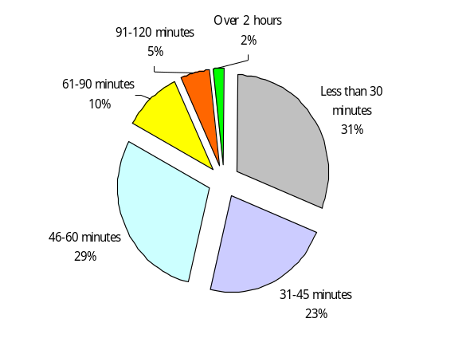

Nature of participation – over the four weeks prior to the survey, more than three-quarters (78%) of the participation in athletics and running/jogging was on a casual basis, 19% was organised training, coaching or lessons and only 2% of sessions involved organised competitions.

NOTE: Figures for the nature of participation are based on a count of casual, training and competitive sessions for each participant during a four weeks period.
Figure 6: Nature of participation
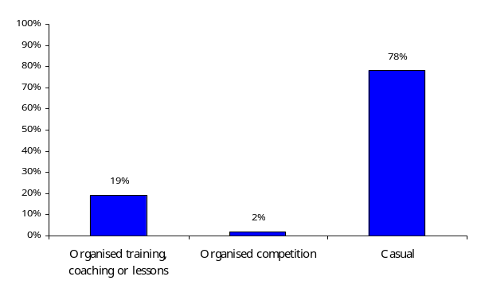

Children (aged 8-15)
Figure 7: Participation by type of athletics and running/jogging (excluding PE lessons)
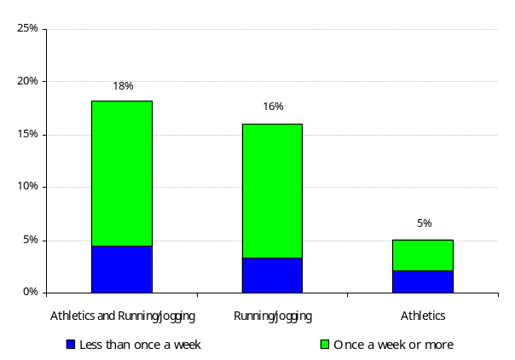
Over a third (36%) of young people participated in athletics and running/jogging of one form or another over a four-week period (including during PE lessons), compared with 18% excluding PE lessons.
Note: Participation excluding PE lessons has been selected as the focus for the remainder of this fact sheet as it shows independent levels of participation in athletics and running/jogging.
The participation rates for different formats ranged from 5% for athletics to 16% for running/jogging.
Frequency of participation (participants only)
Frequency of participation – girls were as likely to have participated in some form of athletics or running/jogging as frequently as boys, although there was in fact a slightly higher proportion of girls (65%) participating, compared to 63% of boys.

Figure 8: Frequency of participation (at least once in four weeks)
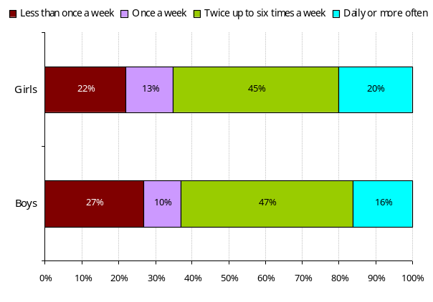

Additional factors affecting participation
Like adults, participation rates for children taking part in athletics and running/jogging, at least once in a four-week period, varied relative to personal and familial circumstances.
Social class
- children from AB households – 21%;
- children from C1 households – 20%;
- children from C2 households – 16%; and
- children from DE households – 18%.
Urban and rural areas
- children from urban areas – 16%; and
- children from rural areas – 18%.
Deprivation (Scottish Index of Multiple Deprivation areas)
- children living inside SIMD areas – 13%; and
- children living outside SIMD areas – 19%.
Local authority grouping
- East – 8%;
- Glasgow – 20%;
- Midland – 18%;
- North – 17%;
- South – 14%; and
- West – 17%.
Club membership (participants only)
Overall – rather than gender split
The rate for regular participation (once a week or more) was the same for both club and non-club members for athletics and running/jogging.

Frequency of participation

The measure of frequency of participation is in the national strategy for sport in Scotland (‘Reaching Higher’) and is participation in sport and physical recreations at least once a week. However, in order to minimise sampling error, the main indicator used in this fact sheet is participation at least once in the last four weeks.

Participation

Participation – is the process of taking part, however informally, as opposed to spectating or helping to organise the sport. Participation data is based on upon peak season data, which shows the most popular four months of data and more accurately reflects the seasonal nature of much sports participation. It avoids any dilution due to the data being looked at as if the sporting activity took place over a full twelve-month period, when in fact it may only occur for half of the year.

Social class definitions by group

AB Upper middle class – higher managerial, administrative or professional.
Middle class – intermediate managerial, administrative or professional.
C1 Lower middle class – supervisor or clerical and junior managerial, administrative or professional.
C2 Skilled working class – skilled manual workers.
DE Working class – semi and unskilled manual workers.
Those at lowest levels of subsistence – state pensioners etc with no other earnings.
Note that this category includes the highest proportion of pension-aged people (the lowest participating group of all four social groupings used in the fact sheet).

Data notes

1. As a result of the sample sizes involved in the survey the figures quoted will, on average, have an estimated error margin of +/-2%. Consequently a rate of 18% for an individual activity has the potential to be as high as 20% or as low as 16%. Nonetheless, the picture provided by the data remains relevant and is a reasonable guide to the overall rates and their patterns.
2. Data are based on a 2003-06 survey by TNS of participation in sports and physical recreations.
3. Further information, including a methodological overview, is available on the sportscotland website: http://www.sportscotland.org.uk


For survey information, data and policy implications contact: research@sportscotland.org.uk
Fact sheets and reports produced by Knight, Kavanagh and Page: http://www.kkp.co.uk

