Interim evaluation of the Changing Lives Fund

The Changing Lives through Sport and Physical Activity Fund is a £1 million Fund supporting 17 partnerships over two years. It aims to enable sport and community organisations to intentionally change lives through sport and physical activity.

This summary highlights the lessons learned from the first year of the Fund – from January 2019 to January 2020.

Participants

Overall, the focus of the Changing Lives Fund was on quality and outcomes, rather than quantity and numbers. Participants were split into two groups:

- Level 1 participants - low level, mass participation or introductory activity
- Level 2 participants – sustained activity of approximately six sessions over three months.

Funded projects were well on track to achieve the overall target of almost 3,300 level 2 participants. The Level 2 target group was important, as this was the group that projects expected to see positive change come about for.

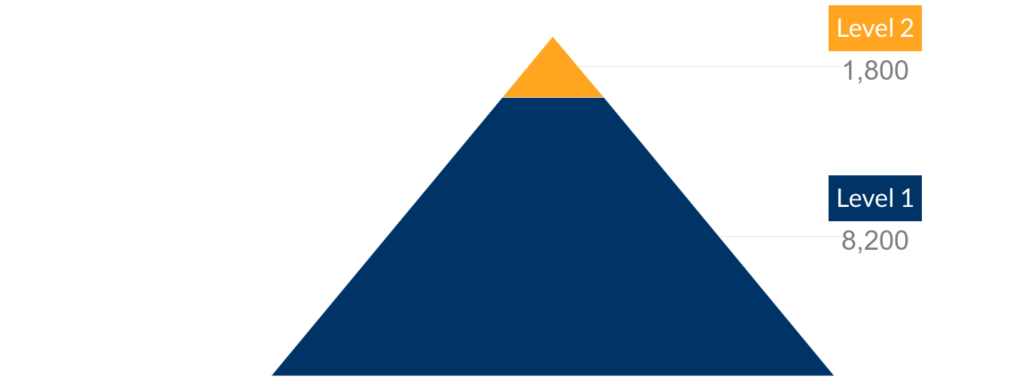

It was expected that many participants would move from level 1 to level 2 over the second year of the Fund.

In the first year of the Changing Lives Fund, almost 200 volunteers have supported delivery. Most (117) have been trained volunteers, helping in a sustained way and likely to have achieved qualifications.

Participant profile

Most projects reported engaging successfully with their target groups. The profile of participants was mixed in terms of age and ethnic origin. However, some projects targeting both males and females attracted more males than females. This meant the fund had a higher proportion of male participants than expected.

Target group | Year 1 participation | Project targets | Comparison
Female | 48% | 60% | -
Male | 52% | 40% | +

The profile of participants and volunteers shows that work needs to take place to:

- ensure equal participation where activity is available to both sexes
- support projects to address challenges in gathering disability monitoring information
- engage a higher proportion of female volunteers and disabled volunteers.

Increasing physical activity levels

Eight projects aimed to achieve outcomes around increasing physical activity levels. The available evidence is positive:

Physical activity level | Inactive | Some activity | Active | Total number
Baseline | 27% | 38% | 35% | N = 78
End year 1 | 10% | 39% | 51% | N = 70

This shows a clear shift away from participants being inactive, through to having some activity and being active. There have also been a range of small shifts in increasing physical activity levels. For example, in one project, 97% of participants said they took part in more sport and physical activity now than they did a year ago. In another, the average number of days that people were physically active increased from 2.8 to 4.3 days.

Example: Active Families
The project worked with a family over a period of time. Initially the mother rarely left the house due to her physical health and anxiety. This had a big impact on the young person in the family who did not attend school. The project worked, among other things, to increase the mother’s physical activity and physical wellbeing. The mother began to walk regularly and her confidence increased to the extent that she would leave the house alone to attend various activities in the community.

Inclusion

Most projects (12) had outcomes relating to inclusion beyond physical activity levels. There was a strong focus on inclusion within the fund, and it was mandatory for projects to focus on inclusion in some way, including increasing physical activity levels. The evidence, from a small sample of those involved in a sustained way in the Fund, highlights that the Changing Lives Fund has had a clear impact on how included and close to other people the project participants feel.

Has the project helped you feel…? | Yes | Sometimes | No
Included* | 82% | 17% | 1%
Closer to people** | 79% | 17% | 4%
*n=153 **n=151

There was good evidence that participants felt:

- more connected to other people
- more included within sport and physical activity
- more able to access sport and physical activity
- able to take part in planning activities.

Example: Walking Netball – more than a game
A 28 year old woman with Autistic Spectrum Disorder has been attending the Walking Netball sessions for one year. To begin with she was anxious and was not sure if she would be able to participate. She was concerned about the environment, meeting new people and her co-ordination skills. To ease her anxiety she attended the first session with her mother, who stayed close by throughout. Since attending the sessions, she feels she has improved her sense of direction, her coordination and her teamwork skills. She’s made new friends, and she feels that taking part in a team sport has helped her to improve her sense of touch.

“I’ve overcome people touching me and I’m coping better in crowds with lots of noise. I’m making new friends and feel included as part of the team.” Participant

Example: Youth Works Through Sport
This project supported youth workers to develop their skills around creating an inclusive environment. Participants reported that they were more aware of the relevant issues and how to address them. And those delivering the project also saw improvements in the participant’s knowledge and capacity to create an inclusive environment.
“I identified what barriers young people faced to take part, and we overcame some of these barriers to enable them to take part and engage… I will follow this up and follow through with removing barriers.” Participant

Sport for health and wellbeing

Almost all projects (16/17) aimed to achieve outcomes relating to health and wellbeing. The evidence, from a small sample of those involved in a sustained way, highlights that the projects have helped most people to feel healthy, useful, relaxed and optimistic.

Has the project helped you feel…? | Yes | Sometimes | No
Healthy | 81% | 16% | 3%
Relaxed | 82% | 15% | 3%
Useful | 83% | 14% | 2%
Optimistic | 75% | 23% | 2%
*n=159, **n=126, ***n=126, ****n=161

Projects working with young people submitted evidence showing that participants:

- felt physically healthier, fitter or faster
- felt less anxious and calmer
- better understood the link between physical and mental health
- were making healthier eating choices and sleeping better
- were building their strength and balance.

Example: Inspiring Cadder!
At this project, 95% of participants felt better about themselves because they had been involved in the project and 97% felt healthier or fitter than they did a year ago. As an example, one shy P6 pupil got involved in this project. He was overweight, struggled with his confidence and participated in no sport or physical activity. He now attends four evening sessions a week, has lost a significant amount of weight and has improved his confidence.

“I love the clubs… I feel really good and love coming every night. I feel better and I have got much faster.” Participant

Example: Shining a Light on Mental Health
The Shining a Light on Mental Health project developed the skills of young people to lead discussions about mental health with their peers, and with adults. Feedback from the young ambassadors strongly highlighted the development of skills and capacity around mental health. Within this project 100% of the ambassadors said that they understood the benefits of physical activity for their mental health.

Sport for skills

Some projects (6) selected outcomes relating to skills. However, almost all projects (16) were asked to gather standard information from participants to explore whether the project helped them to feel included and closer to people.

The evidence, from a small sample of those involved in a sustained way in the Fund, indicates that over half felt the project had consistently helped with their ability to make their mind up, think clearly and deal with problems well. A third felt it sometimes helped. More widely, projects reported improvements in confidence, aspiration, leadership, team work, independence and positive life decisions.

Has the project helped you feel…? | Yes | Sometimes | No
Able to make your mind up* | 63% | 32% | 4%
Able to think clearly** | 58% | 37% | 5%
Able to deal with problems well*** | 58% | 33% | 9%
*n=123 ** n=127 *** n=126

Example: Care 2B Active
There was evidence that the project supported some care experienced young people to become more motivated to achieve at school. One young person also developed an interest in working in healthcare after taking part in a First Aid course and felt more motivated to succeed in their prelim exams in order to pursue their career.

Example: Positive Change through Football: Inside and Out
Project evaluation found that participants developed their confidence, esteem, teamwork, patience, attitude, anger management, communication, listening and problem solving skills, as well as understanding normality and developing friendships. The project also fostered better relationships between prisoners and staff, and between participants and the other prisoners. The project has helped participants to develop better conflict management and problem solving skills, and the confidence to interact and negotiate with other people.

Example: Champions for Change
In this project participants were supported to complete training courses, gain accreditation and move into positive destinations. Participants have progressed to volunteering with Active Schools, volunteering in community sports clubs and have become more work-ready.

Sport for communities

Some projects (6) selected outcomes relating to strengthening communities. Almost all projects (16) were asked to gather standard information from participants to explore whether the project helped them to feel involved in their communities.

The evidence, from a small sample of those involved in a sustained way in the Fund, indicates that around two thirds felt that the project helped them to become more involved in their community.

Has the project helped you feel…? | Yes | Sometimes | No
Involved in your community | 68% | 25% | 6%
n=120

There was some wider evidence from project monitoring forms that projects had strengthened the capacity of community organisations through building a pool of volunteers, and engaging volunteers who are more diverse and representative of the community. Two projects have built connections between younger and older generations, helping older people feel more connected to their local community.
Example: Wicketz
In this project, a range of people, including young people, parents and community volunteers have been brought together through leadership opportunities. Young people were trained as sports leaders, giving them ownership of the activity. The increased ownership has facilitated a sense of belonging and pride in the club. The project has also engaged parents, some of whom have qualified as assistant coaches.

The coaches delivering the activity noted that the project is now well known within the communities they work in. People living and working in the community, in shops and restaurants are familiar with the project and are proud to say that they or their children attend the club.

“It’s a massive part of the community now…it’s really taken an active part of people’s everyday lives.” Staff
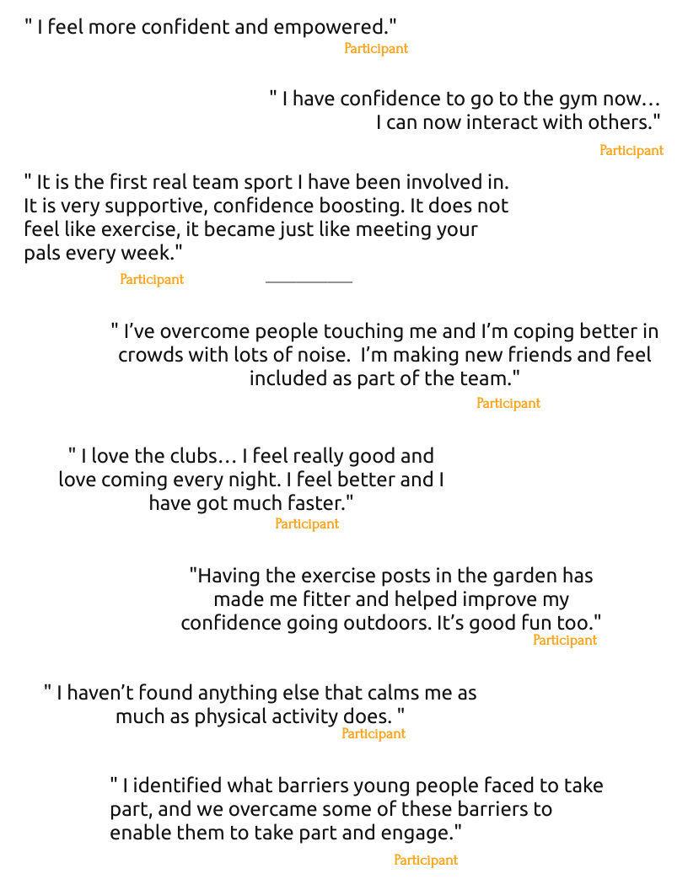

Lessons learned

What works

Projects have worked well when they have:

- combined social and physical activity
- taken a flexible and person centred approach
- worked closely with other partners
- focused strongly on outcomes and intended change.

Lessons learned

- Self-evaluation: Projects have taken responsibility for self-evaluation and gathered some very good evidence about the difference they have made. Quotes, case studies and some simple standard measures across the Fund have gathered strong evidence about the difference these projects are making.

- Measuring health and wellbeing: The standard health and wellbeing measures used within the Fund provide strong, consistent evidence in a way which is relatively simple to gather and analyse. However the measures did need adapted for different client groups, so some flexibility is needed.

- Measuring physical activity: Analysis of evidence about physical activity is complex, particularly if focusing on whether people have moved from being inactive to active. Projects have all gathered and presented data in the way which is most useful to their project – and all are reasonable and appropriate. However collating this information between projects at Fund level does create some interesting challenges.

- Involving women and girls: Projects engaging with both men and women have often found that more men are taking part than women. This has made the Fund below target in terms of the proportion of girls and women taking part. The proportion of female volunteers is also relatively low. Concentrated work is needed in this area, perhaps learning from those projects targeting women and girls.

- Involving disabled people: Some projects have experienced challenges in gathering information on participant profile in terms of disability. Projects also report no disabled volunteers being involved in delivery. Concentrated work is needed in this area, again perhaps learning from projects targeting disabled people.

One project was not asked to gather this information as this was not the focus of the project. This project had 563 level two participants in year one.
One project was not asked to gather this information as this was not the focus of the project. This project had 563 level two participants in year one.

