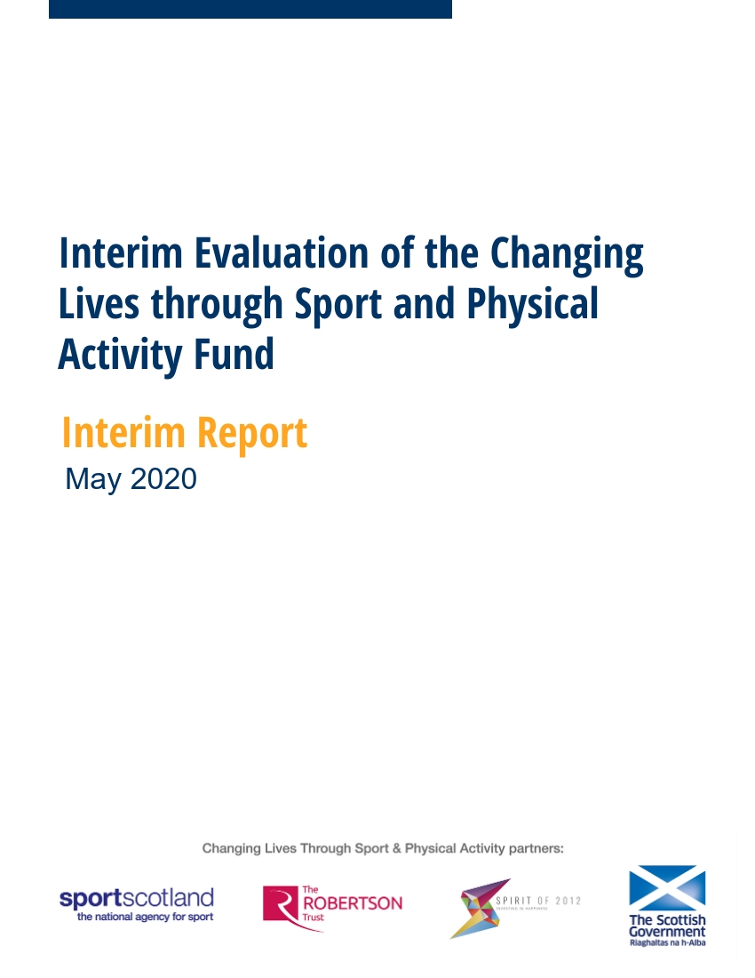

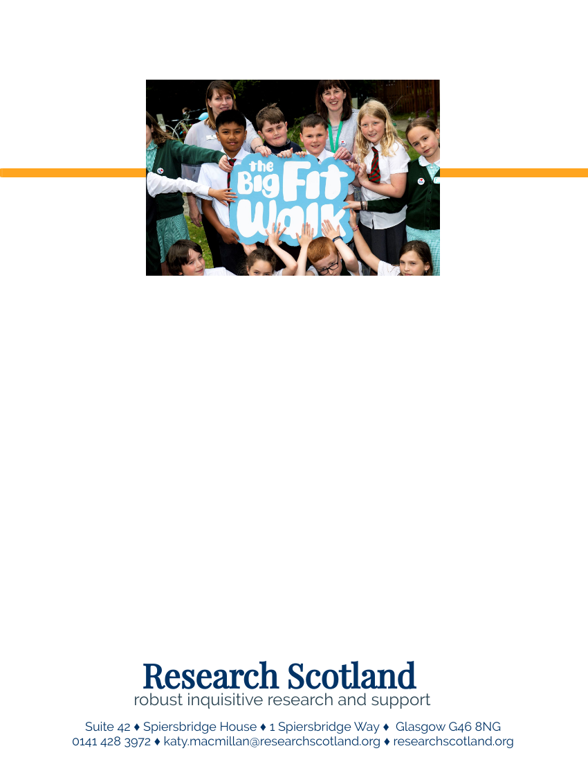

Contents

Summary i
1. Introduction 1
2. Changing Lives delivery 9
3. Changing Lives participants 17
4. Are we changing lives? 27
5. Lessons learned 52

Appendix One: Evaluation matrix for the Changing Lives Fund 60
Appendix Two: Standard measures for evaluation of the Changing Lives Fund 63
Appendix Three: Top 10 Lessons Learned 64

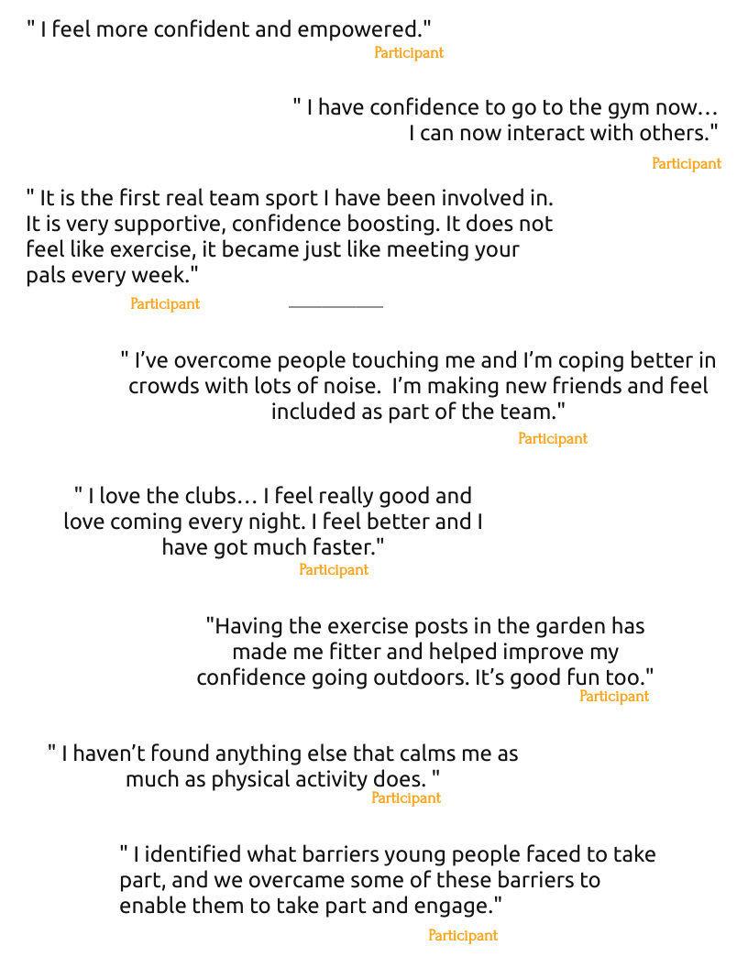

Summary

This report sets out findings from an interim evaluation of the Changing Lives through Sport and Physical Activity Fund. This is a £1 million Fund supported by the Changing Lives through Sport and Physical Activity Programme partners: Robertson Trust, Scottish Government, sportscotland and Spirit of 2012. Spirit of 2012 manages the Fund on behalf of partners. The Fund supported 17 partnerships, providing short term additional resource over two years to enable sport and community organisations to intentionally change lives through sport and physical activity.

This interim evaluation focuses on the first year of the Fund, broadly January/ February 2019 through to December/ January 2020. For many projects, the first six months focused on project set up, with delivery commencing mid-2019.

Participants

The projects involved approximately 10,000 people in year one. Of these, 8,200 took part in low level, mass participation, taster or introductory activity (classed at Level 1 for this Fund). Approximately 1,800 took part in more sustained activity of approximately six sessions over three months (classed at Level 2 for this Fund). The Level 2 target group was important, as this was the group that projects expected to see positive change come about for.

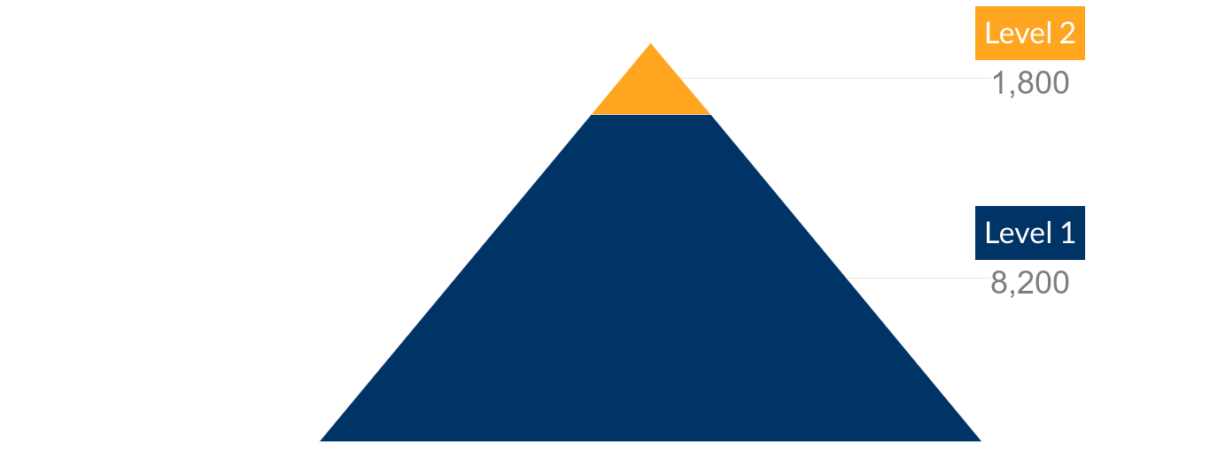

Overall, funded projects were well on track to achieve the overall target of almost 3,300 level 2 participants. In year one, projects achieved 55% of this target. Projects had already involved more level 1 participants than they aimed to engage across the two years (target of 5,300 over two years). However, it was expected that many participants would move from level 1 to level 2 over the second year of the Fund.

Individually each project appeared well on track to achieve anticipated numbers. However, all projects are likely to be affected by the global public health situation. In particular two projects due to ramp up school based activity in 2020/21 are likely to be significantly affected.

Overall, projects were reassured that generally the focus of the Changing Lives Fund was on quality and outcomes, rather than quantity and numbers.

The profile of participants was mixed in terms of age and ethnic origin. Most projects reported engaging successfully with their target groups. However, five projects targeting both males and females had attracted more boys and men than girls and women, meaning overall the Fund had involved a higher proportion of male participants than expected. Concentrated work therefore needs to take place to ensure that girls and women are effectively engaged in the Fund. Where activity is available to both sexes, more work needs to be done to ensure equal participation.

Target group | Year 1 participation | Project targets | Comparison
Female | 48% | 60% | -
Male | 52% | 40% | +

There were some challenges around gathering participant profile in terms of disability, with some projects unsure when and how to best ask for this information and some gaps in the information provided. It will be important to work with projects to strengthen this reporting for year two.

In the first year of the Changing Lives Fund, almost 200 volunteers have supported delivery. Most (117) have been trained volunteers, helping in a sustained way and likely to have achieved qualifications. While the mix in terms of age and ethnic origin is good, it may be useful to work with projects to explore ways to engage a higher proportion of female volunteers and disabled volunteers.

Increasing physical activity levels

Eight projects aimed to achieve outcomes around increasing physical activity levels. The available evidence is positive:

Physical activity level | Inactive | Some activity | Active | Total number
Baseline | 27% | 38% | 35% | N = 78
End year 1 | 10% | 39% | 51% | N = 70

This shows a clear shift away from participants being inactive, through to having some activity and being active. There have also been a range of small shifts in increasing physical activity levels. In one project, 97% of participants said they took part in more sport and physical activity now than they did a year ago. In another, the average number of days that people were physically active increased from 4.2 days to 5.7 days per week, and in another the number of days increased from 2.8 to 4.3 days.

Example: Active Families
The project worked with a family over a period of time. Initially the mother rarely left the house due to her physical health and anxiety. This had a big impact on the young person in the family who did not attend school. The project worked, among other things, to increase the mother’s physical activity and physical wellbeing. The mother began to walk regularly and her confidence increased to the extent that she would leave the house alone to attend various activities in the community.

Inclusion

Most projects (12) had outcomes relating to inclusion beyond physical activity levels. There was a strong focus on inclusion within the fund, and it was mandatory for projects to focus on inclusion in some way, including increasing physical activity levels. The evidence, from a small sample of those involved in a sustained way in the Fund, highlights that the Changing Lives Fund has had a clear impact on how included and close to other people the project participants feel. Almost all felt the project helped them feel more included and closer to people, to some extent.

Has the project helped you feel…? | Yes | Sometimes | No
Included* | 82% | 17% | 1%
Closer to people** | 79% | 17% | 4%
*n=153 **n=151

It is important to note that within these projects there were approximately 1,200 participants at this level during year one, so this feedback reflects a sample of those involved.

As well as participants feeling more connected to other people, there was also good evidence that participants were beginning to feel more included within sport and physical activity and more able to access it. Participants indicated that projects provided an inclusive atmosphere and reported feeling more able to take part in planning and participating in activities. Participants reported that they enjoyed coming to the activities and that it helped them feel more included. Some projects also specifically involved building the skills of deliverers to create inclusive environments for participation in sport and physical activity.

Example: Walking Netball – more than a game
A 28 year old woman with Autistic Spectrum Disorder has been attending the Walking Netball sessions for one year. To begin with she was anxious and was not sure if she would be able to participate. She was concerned about the environment, meeting new people and her co-ordination skills. To ease her anxiety she attended the first session with her mother, who stayed close by throughout. Since attending the sessions, she feels she has improved her sense of direction, her coordination and her teamwork skills. She’s made new friends, and she feels that taking part in a team sport has helped her to improve her sense of touch.

“I’ve overcome people touching me and I’m coping better in crowds with lots of noise. I’m making new friends and feel included as part of the team.” Participant

Example: Youth Works Through Sport
This project supported youth workers to develop their skills around creating an inclusive environment. Participants reported that they were more aware of the relevant issues and how to address them. And those delivering the project also saw improvements in the participant’s knowledge and capacity to create an inclusive environment.
“I identified what barriers young people faced to take part, and we overcame some of these barriers to enable them to take part and engage… I will follow this up and follow through with removing barriers.” Participant

Sport for health and wellbeing

Almost all projects (16/17) aimed to achieve outcomes relating to health and wellbeing. The evidence, from a small sample of those involved in a sustained way in the Fund, highlights that the projects have helped most people to feel healthy, useful, relaxed and optimistic.

Has the project helped you feel…? | Yes | Sometimes | No
Healthy | 81% | 16% | 3%
Relaxed | 82% | 15% | 3%
Useful | 83% | 14% | 2%
Optimistic | 75% | 23% | 2%
*n=159, **n=126, ***n=126, ****n=161

Projects working with young people submitted evidence showing that participants were feeling physically healthier, fitter, faster, making healthier eating choices or sleeping better. There was good evidence that older participants were improving or sustaining aspects of their physical health – for example through building their grip strength, balance and strength.

Example: Inspiring Cadder!
At this project, 95% of participants felt better about themselves because they had been involved in the project and 97% felt healthier or fitter than they did a year ago.
As an example, one shy P6 pupil got involved in this project. He was overweight, struggled with his confidence and participated in no sport or physical activity. He now attends four evening sessions a week, has lost a significant amount of weight and has improved his confidence.

“I love the clubs… I feel really good and love coming every night. I feel better and I have got much faster.” Participant

People involved in Changing Lives projects reported that physical activity provided a range of benefits relating to their wellbeing and mental health. Some reported increased awareness of the link between mental health and physical activity and greater understanding of wellbeing, self care and positive self talk. Participants also reported finding that physical activity helped with anxiety, got rid of negative thoughts and was calming. In presenting this evidence, projects made clear that it was important to recognise that mental health fluctuated and did not always improve in a linear way. Mental health moves back and forth and varies day by day.

Example: Shining a Light on Mental Health
The Shining a Light on Mental Health project developed the skills of young people to lead discussions about mental health with their peers, and with adults. Feedback from the young ambassadors strongly highlighted the development of skills and capacity around mental health. In particular, ambassadors pointed to the importance of treating mental health as a general state, something which everyone has, rather than a specific illness.

Within this project 100% of the ambassadors said that they understood the benefits of physical activity for their mental health.

“I have a lot more knowledge on adult and young people’s perception of mental wellbeing. I am able to relate because I have heard many different experiences and can relate that back to people of different ages.” Participant

Sport for skills

Some projects (6) selected outcomes relating to skills. However, almost all projects (16) were asked to gather standard information from participants to explore whether the project helped them to feel included and closer to people.

The evidence, from a small sample of those involved in a sustained way in the Fund, indicates that over half felt the project had consistently helped with their ability to make their mind up, think clearly and deal with problems well. A third felt it sometimes helped.

Has the project helped you feel…? | Yes | Sometimes | No
Able to make your mind up* | 63% | 32% | 4%
Able to think clearly** | 58% | 37% | 5%
Able to deal with problems well*** | 58% | 33% | 9%
*n=123 ** n=127 *** n=126

More widely, projects reported improvements in confidence, aspiration, leadership, team work, independence and positive life decisions.

Example: Care 2B Active
Through this project there was evidence that some care experienced young people became more motivated to achieve at school, after taking part in the activity. One young person also developed an interest in working in healthcare after taking part in a First Aid course, and felt more motivated to succeed in their prelim exams in order to pursue a career in this field.

Example: Positive Change through Football: Inside and Out
In this project, evaluation found that participants developed their confidence, esteem, teamwork, patience, attitude, anger management, communication, listening and problem solving skills, as well as understanding normality and developing friendships. The project also fostered better relationships between prisoners and staff, and between participants and the other prisoners. The project has helped participants to develop better conflict management and problem solving skills, and the confidence to interact and negotiate with other people.

“Improved confidence and new found respect for staff.”
“Being able to approach them (officers) and having the confidence to do so.” Participants

Participants also developed skills in relation to learning and employment, including first aid training, CPR training and chid protection training.

Example: Champions for Change
In this project participants were supported to complete training courses, gain accreditation and move into positive destinations. Participants have progressed to volunteering with Active Schools, volunteering in community sports clubs and have become more work-ready.

Sport for communities

Some projects (6) selected outcomes relating to strengthening communities. Almost all projects (16) were asked to gather standard information from participants to explore whether the project helped them to feel involved in their communities.

The evidence, from a small sample of those involved in a sustained way in the Fund, indicates that around two thirds felt that the project helped them to become more involved in their community.

Has the project helped you feel…? | Yes | Sometimes | No
Involved in your community | 68% | 25% | 6%
n=120

There was some wider evidence from project monitoring forms that participants had become more involved in their community as a result of participation. For example, in two projects, the group of volunteers has strengthened the capacity of community organisations, and has also built a pool of volunteers who are more diverse and representative of the community. It is hoped that this will in turn help to build longer term sustainability. One project is seeing evidence of this through an increase in the diversity of participants.

Two projects have built connections between younger and older generations. This helped older people feel more connected to their local community, through connections with primary school pupils and younger people.
Example: Wicketz
In this project, a range of people, including young people, parents and community volunteers have been brought together through leadership opportunities. Young people were trained as sports leaders, giving them ownership of the activity. The increased ownership has facilitated a sense of belonging and pride in the club. The project has also engaged parents, some of whom have qualified as assistant coaches.

The coaches delivering the activity noted that the project is now well known within the communities they work in. People living and working in the community, in shops and restaurants are familiar with the project and are proud to say that they or their children attend the club.

“It’s a massive part of the community now…it’s really taken an active part of people’s everyday lives.” Staff
Lessons learned

Projects felt that the social aspect of activity, the flexibility within projects, the partnership approach and involvement of volunteers, and the focus on setting clear outcomes at the outset all contributed to project success. Although partners demonstrated good evidence that they had reached their target participants and brought about change, projects also reported a range of challenges. The range of challenges reported was varied, with a few projects reporting challenges in relation to recruiting volunteers, engaging parents, meeting complex client needs, engaging some participants, and working in partnership.

Focusing on outcomes
Projects very much welcomed the focus on outcomes and change in people’s lives, and the message that it was understandable if outcomes changed along the way.

Action: The message that the focus of the work can change may need more clarity over year two, due to the global health situation. This would include clarity on flexibility around use of funding, timescales and intended outcomes. We understand that partners will already be carefully considering these issues. Ongoing opportunities to share learning between partners should also be explored.

Self-evaluation
Projects have learned a lot about evaluating their own work. A few projects reported challenges gathering feedback.

Action: Research Scotland will pull together a resource of interesting and effective evaluation approaches for sharing with projects, continue to support projects on their own evaluation, and explore ways projects can still share their learning about evaluation over the next year.

Quality of evidence
The quality of evidence from projects on the outcomes they have achieved has largely been very good. The focus for year two should be to move some projects on from simply providing the evidence, to drawing out key messages, telling their story of change, and thinking about what this means for them moving forward, beyond the Changing Lives Fund.

Action: Research Scotland will support projects to further develop their analysis and reporting abilities during year two. Support will be targeted at those organisations for whom it is most useful, in liaison with Spirit of 2012.

Health and wellbeing measures
The standard health and wellbeing measures work well for demonstrating outcomes across health and wellbeing outcomes, as well as outcomes around skills development and strengthening communities. One project did not use the measure as they were not asked to, because they did not aim to achieve health and wellbeing outcomes as a core part of their work. However, we suggest liaising with this project to explore whether it would be feasible for this project to also use the health and wellbeing measures over year 2 of the project. It should be noted that this project provided excellent evaluation evidence. This would provide useful additional information around skills development and strengthening communities for that project, and ensure consistency across all 17 projects in terms of reporting on one element of outcomes.

Action: National partners to agree whether this project should be asked to use the health and wellbeing measures (if possible – to complement the evaluation evidence it already gathers, which is very high quality). Research Scotland to explore with the project as needed.

Physical activity measures
The physical activity measures have provided consistency in the way in which information about levels of physical activity is gathered, across projects with increased activity as a clear intended outcome. However, the analysis of this data is complex. Projects have undertaken the analysis of the data in slightly different ways. This is understandable, as the projects have analysed the data in the way which is the most useful to their own project. The way projects have presented the data are all reasonable, good and appropriate – just not entirely consistent between projects.

Action: Research Scotland to provide clear guidance on how standard physical activity measures should be reported, to provide more consistency.

Profile of participants and volunteers
The evaluation highlighted that most projects reported engaging successfully with their target groups. However, overall the Fund is below target in terms of the proportion of girls and women participating in the Fund. There are also some challenges reported in gathering information on the participant profile in terms of disability. The proportion of female volunteers is also relatively low, and the projects report no disabled volunteers being involved in delivery.

Action: Concentrated work needs to take place around engaging women, girls and disabled people as participants and volunteers. Both may be useful topics for a learning event, to help projects to share learning and learn from wider projects as appropriate. Research Scotland should also work with the projects to strengthen reporting on the profile of participants in terms of disability.

Learning and evaluation
The interim report highlights some clear lessons and messages about the potential change that sport and physical activity can bring about, and how this can be done. There is potential to share learning with the wider sector at this stage. The public health situation also creates new and different opportunities and requirements for learning and evaluation at project and Fund level.

Action: Learning from this interim stage should be shared with projects, partners and the wider sector. The evaluation framework for the Fund should be reviewed, to ensure learning and evaluation remains relevant and useful.

Introduction

About this report

This report sets out findings from an interim evaluation of the Changing Lives through Sport and Physical Activity Fund (the Changing Lives Fund). This is a £1 million Fund and is part of the Changing Lives through Sport and Physical Activity Programme, delivered by The Robertson Trust, the Scottish Government, sportscotland and Spirit of 2012.

The interim evaluation focuses on the first year of the two-year Changing Lives Fund. For many projects, the first six months focused on project set up, with delivery commencing mid-2019.

A full evaluation of the Changing Lives Fund will be produced in spring 2021.

About the Changing Lives Fund

The Changing Lives Fund aims to address wider individual and community needs through sport and physical activity and to support people to become and stay active. The focus is on individual or societal change, not on increasing participation or providing pathways to a particular sport.

The Fund provides short term additional resource over two years, to enable sporting and community organisations to intentionally change lives through sport and physical activity and to evidence this.

The Fund has four change themes. The sport for inclusion theme was mandatory. Projects were encouraged to develop and articulate their own intended outcomes within their chosen change themes, but examples were provided as a guide for the types of outcomes area that partners expected to see.

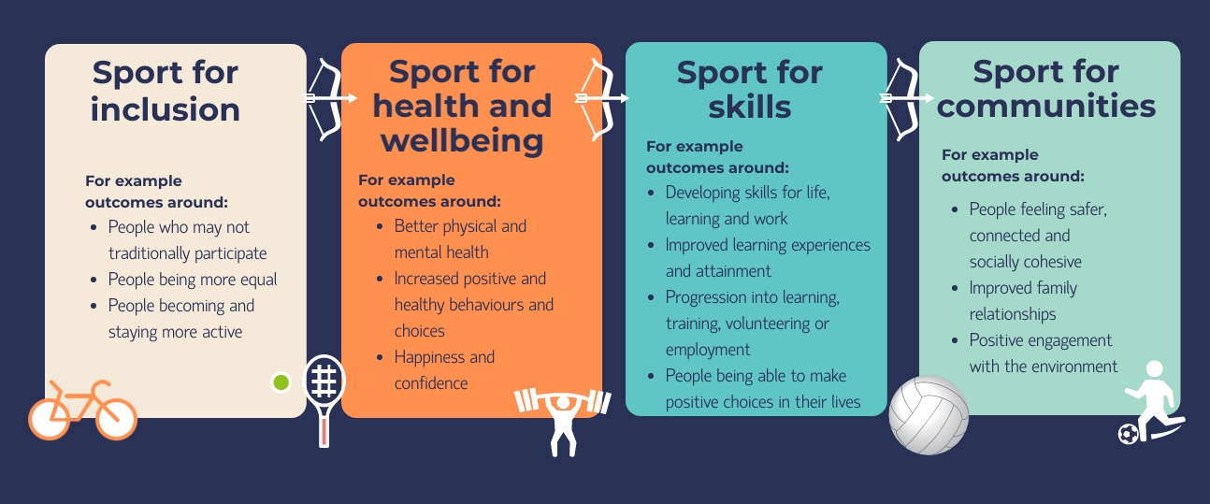

Applications and funded projects

The Fund was open to partnerships between sport and physical activity organisations and community organisations. At least one of the organisations was required to be from the third sector. This was to encourage sporting and community partners to come together to share skills and resources and achieve better impact.

A total of 97 applications were received to the Fund, totalling £5.9 million. The applications were assessed and ranked by Spirit of 2012 and recommendations were made to the Funding Panel (involving Scottish Government, sportscotland and The Robertson Trust). A total of 17 projects were funded, totalling just over £1 million and working across at least 13 local authority areas.

Full details of the funded projects are included in Chapter Two.

Changing Lives context

The Changing Lives Fund sits within the wider Changing Lives through Sport and Physical Activity Programme. The wider programme includes support to enable organisations to use sport and physical activity as a driver to achieve positive individual and community change. This includes clear messaging and leadership roles, networking opportunities and the development of a range of learning and development support to build knowledge, skills and capacity within delivery organisations and those who support them.

Partners have been working to develop clear messages around the important role that sport and physical activity can play in changing lives.

sportscotland’s corporate strategy published in 2019 is entitled ‘Sport for Life’. It sets out a clear vision of building an active Scotland where everyone benefits from sport. It focuses on the role that sport can play in changing lives and supporting people to enjoy as many of the benefits of sport as possible.

The Sport for Life strategy recognises that sport helps to support health, develop skills, strengthen communities, improve activity and boost the economy.

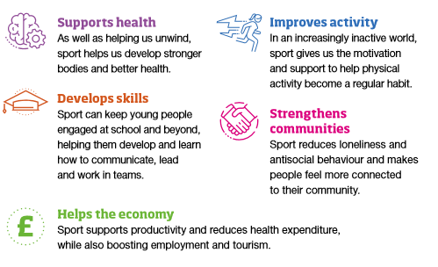
Source: Sport for Life summary, sportscotland

The Sport for Life strategy clearly shows how the outcomes embedded within the Changing Lives Fund around being active, staying active, wellbeing and resilience all link with a world class sporting system in Scotland.

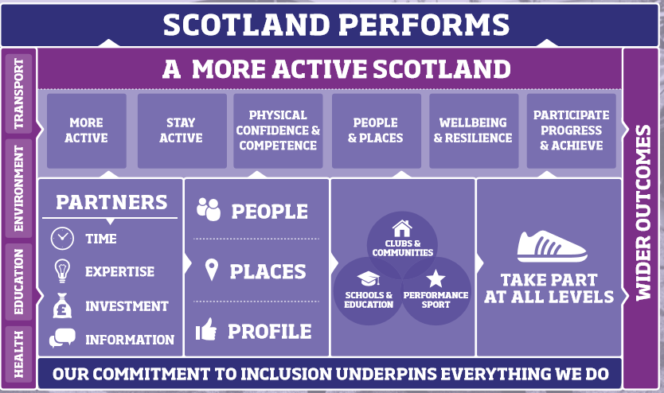

Recognition of the ability of sport and physical activity to change lives is also built into Active Scotland Outcomes Framework, which describes Scotland’s ambitions for sport and physical activity. A clear connection has been made between the Changing Lives approach and outcomes 1, 2 and 5 within the framework.

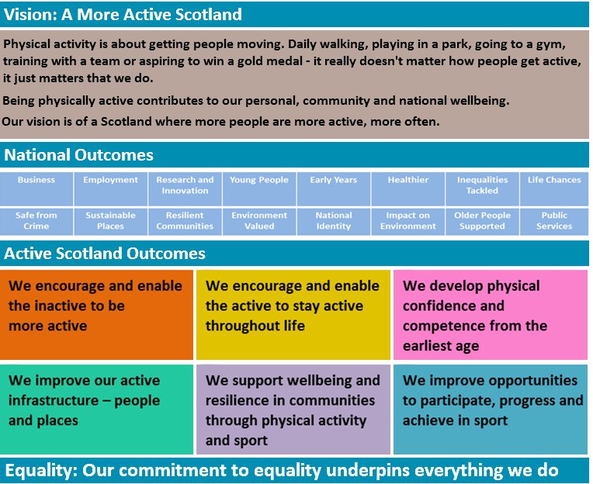
5..
3.
2.
4.
6
1.

Importantly, outcome 5 is about the development of communities through sport and physical activity – rather than developing sport in communities. Through this outcome, the Active Scotland Outcomes Framework recognises and emphasises that sport and physical activity can be a means to develop wider social outcomes in communities – for example around education, employment and safety. This outcome focuses specifically on “harnessing the power of sport and physical activity to improve resilience in communities”.

Evaluation purpose

This evaluation focuses on four main themes:

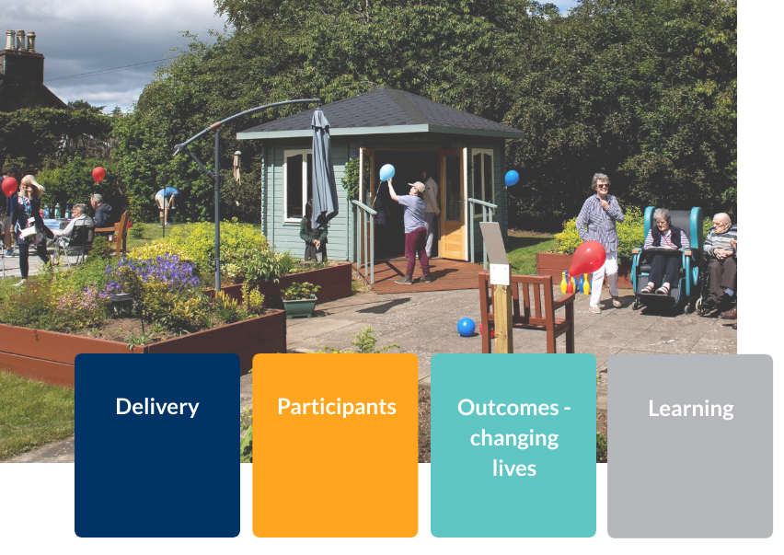

These themes and associated key research questions were developed jointly by Scottish Government, sportscotland, The Robertson Trust and Spirit of 2012. An evaluation framework for the Fund was developed, setting out what would be explored, when, how, why and by whom. The full evaluation framework is attached at Appendix One.

This interim report focuses on:

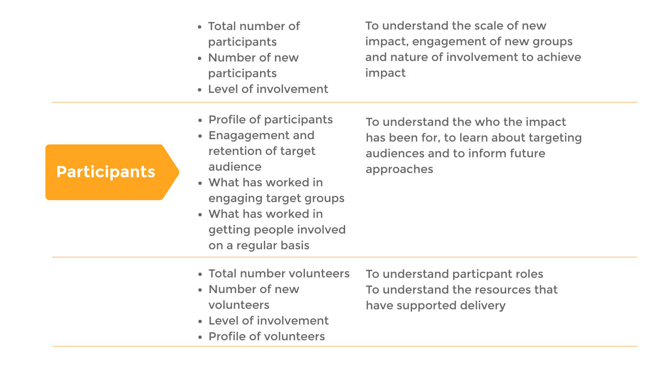
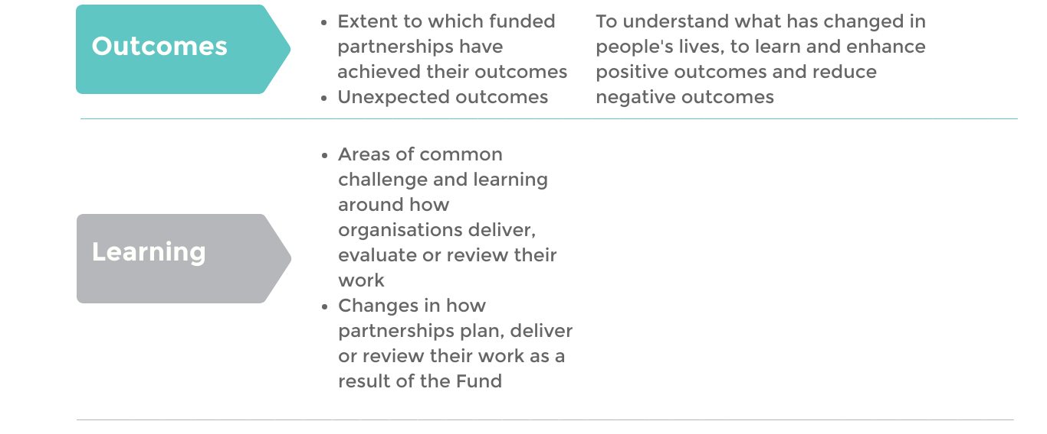
In order to enable a Fund wide report on outcomes, two standard measures were agreed to be applied across funded partnerships.

- Partnerships which aimed to support inactive people to become more active were asked to use a standard definition of what constituted inactive/ some activity/ active – with a different version for under 16s and adults. This was to allow partners to explain what impact the Fund had on supporting people to become more active, in a consistent and collective way.

- Partnerships which aimed to improve participant health and wellbeing were asked to gather data on 10 standard health and wellbeing measures, in a consistent way. The standard health and wellbeing measures and response options are included as Appendix Two.

Interim evaluation method

The interim evaluation draws on two main sources of information.

- Learning Events – Over 2019 there were two Changing Lives Fund learning events. The first event in February 2019 focused mainly on making connections and laying the foundations for embedding learning and evaluation within the programme. The second event in August 2019 included time for reflection and learning. Part of this reflection was not recorded, enabling honest reflection and learning from the challenges experienced over the first six months of each project – in the form of action learning sets. Later in the day, projects were encouraged to identify ‘Top 10’ lessons learned on the themes of partnerships, outcomes and project set up. This reflection and learning was recorded, to inform other similar projects in the future. These ‘Top 10’ lessons are attached as Appendix Three, and key themes are reflected within this report.

- Reporting Forms – Each project is required to submit a six-monthly report on progress in terms of finances, participants, outcomes and communications. In April 2019 each project developed a learning and evaluation plan to ensure that the information submitted within these reports was focused and of a high quality. This evaluation draws on reports submitted in mid and end 2019, at the six month and twelve month stages of each project. It is worth noting that projects started at different times, and reporting was staggered to reflect this. In addition, some projects started delivery earlier in the two year cycle than others. By the time they submitted their end of 2019 report, all projects should have had at least six months of delivery – with some having more than this.

The full evaluation report on the Changing Lives Fund will be produced in spring 2021. It will draw on reflections across all four learning events, reporting forms across the life of the programme, and individual interviews with project partners and national stakeholders.

Research Scotland also delivers a support role to the funded partnerships, providing assistance and advice in ensuring that learning and evaluation is built in from the beginning of each project. This support role is provided by a separate team within Research Scotland. Discussions and reflections made during meetings with Research Scotland in a support capacity are treated confidentially and are not built into the evaluation. Where relevant, projects are encouraged to reflect on interesting lessons learned or findings within their reporting forms – so that key lessons can be included within the evaluation.

Changing Lives delivery

Introduction

This chapter explores the level and nature of funding provided through Changing Lives, and the nature of activities undertaken by funded partnerships. The chapter sets the context and describes the types of activity and funding that have been undertaken in order to change lives through sport and physical activity.

About the funded partnerships

The Changing Lives Fund portfolio is made up of 17 partnerships. A description of each of the partnerships is provided below. The partners include third sector and public sector organisations. Some of the partners, such as sport governing bodies, leisure trusts, sports clubs and community sports hubs have a strong focus on sport and physical activity. Other partners have more of a focus traditionally on equality, education, health, mental health or youth work.

Project | Partners
Active Families | Sport Aberdeen/ Action for Children
Care About Walking | Paths for All/ Perth and Kinross Council
Care 2B Active | Active Communities/ Who Cares? Scotland
Centre Forward | Forth Valley College/ Falkirk Football Community Foundation
Champions for Change | North Ayrshire Leisure/ North Ayrshire Drug and Alcohol Partnership
Community Strides | Scottish Association for Mental Health/ Jog Scotland
Inclusion through Activity | Active Stirling/ Change, Grow, Live
Inspiring Cadder! | Achieve More Scotland/ YOMO
Let’s Give Sport Back to Girls | Inch Park Community Sport Hub/ Youth Scotland
ActivAGE | Greenock Morton Community Trust/ CVS Inverclyde
Positive Change through Football: Inside and Out | Street Soccer Scotland/ Shelter Scotland/ APEX Scotland
Replay Sporting Memories | Sporting Memories Network/ Calderglen Community Sport Hub
Shining a Light on mental health: by young people for young people (BYP4YP) | Scottish Sport Futures/ Scottish Association for Mental Health
T.E.A.M | Big Hearts Community Trust/ Multi Cultural Family Base
Walking Netball – More than a game | Netball Scotland/ Age Scotland/ Breathing Space
Wicketz | Lords Taverners/ Cricket Scotland
Youth Works through Sport | Youth Scotland/ SAPC (St Angela’s Participation Centre) Community Sport Hub

Two of the partnerships saw changes in involvement during 2019. Youth Scotland became involved in the Let’s Give Sport Back to Girls project in mid 2019, and Change, Grow, Live became involved in the Inclusion through Activity project in October 2019. In both cases this was because the original partner was unable to continue its involvement.

About the funded activities

The Changing Lives Fund is strongly focused on outcomes and change. Projects have flexibility to plan their activities to achieve maximum impact, and to flex delivery in line with what works and what project participants need. However, the broad types of activity funded through each Changing Lives project was set out and agreed at the outset. The types of activity are wide ranging, focusing on themes such as:

- supporting people to be more physically active – with a range of specific target groups
- increasing access to physical activity
- supporting mental health and wellbeing
- supporting social inclusion and connections
- supporting skills development
- raising awareness of drug and alcohol misuse and supporting behaviour change
- supporting community integration on release from prison.

Projects aimed to work with a wide range of target groups, including:

- young people
- older people and people in care homes
- care experienced young people
- disabled people
- families with complex needs
- people from minority ethnic communities
- people in areas of socio-economic disadvantage
- people due for release from prison
- people affected by drug and alcohol misuse.

A summary of each project, its broad focus and target group is included below.

Project | Description | Target group
Active Families | Supporting families to be more physically active | 60 people in families with complex needs in Aberdeen
Care About Walking | Encouraging walking for physical activity and social contact | 260 older people across 10 care homes
Care 2B Active | Connecting young people with and without care experience to become more active. | 80 care and non-care experienced young people in Renfrewshire
Centre Forward | 18 month programme to support skills development and SQA qualifications | 24 young people with learning disabilities
Champions for Change | Raising awareness of drug and alcohol misuse, and developing young people as champions to deliver these messages | 640 school pupils involved in sustained activity
Community Strides | Increasing access to jogging activities, recruiting and training jog leaders from minority ethnic communities | 88 people from minority ethnic communities
Inclusion through Activity | A 12 week behaviour change programme extending into a wider 12 month community wide programme | 50 people aged 18 and over affected by alcohol and substance misuse
Inspiring Cadder! | Weekly physical activities and workshops on the benefits of activity. | 300 young people in Cadder, Glasgow
Let’s Give Sport Back to Girls | Weekly physical activity sessions with local school pupils | 50 girls and young women
ActivAGE | Fortnightly intergenerational physical activity in care homes, using young people as volunteers | 160 older people in care homes, young volunteers
Positive Change through Football: Inside and Out | Developing a pathway using football – from within prison to community | 150 people due for release from prison
Replay Sporting Memories | Strength and balance activities for older people at the Sports Hub | 60 older people
Shining a Light on mental health: by young people for young people (BYP4YP) | Developing activity and mental health and wellbeing activity through young champions | 20 young people as wellbeing champions
T.E.A.M | Football and group work to improve wellbeing and social connections | 100 young people from multi-cultural communities in Edinburgh
Walking Netball – More than a game | Taster sessions leading to more regular walking netball activity. | 600 older women involved in sustained activity
Wicketz | Weekly cricket based activity including physical activity, leadership and personal development. | 75 young people from multi-cultural communities in areas of socio-economic deprivation in sustained activity
Youth Works through Sport | Training people to deliver sport and physical activities to people in their community | 75 volunteers and 500 participants in sustained activity

Changing Lives awards

Each partnership was awarded between £42,000 and £70,000 over two years.

Project | Total Fund award | Year 1 Spirit spend | % of total Fund award spent | Match funding attracted
ActivAGE | £57,000 | £14,250 | 25% | -
Care about walking | £50,000 | £25,000 | 50% | £70,939
Care2BActive | £69,985 | £26,993 | 39% | -
Centre Forward | £51,600 | £25,800 | 50% | £17,005
Champions for Change | £69,600 | £23,618 | 34% | £11,640
Community Strides | £69,787 | £34,664 | 50% | -
Inclusion through Activity | £42,151 | £12,036 | 29% | -
Inspiring Cadder | £64,160 | £34,080 | 53% | -
Let’s Give Sport Back to Girls | £66,218 | £30,329 | 46% | -
Positive Change Through Football, Inside and Out | £53,761 | £25,834 | 48% | £8,000
Replay Sporting Memories | £68,872 | £37,771 | 55% | £4,849
Shining a Light on Mental Health: BYP4YP | £61,205 | £27,077 | 44% | £3,235
Sport Aberdeen | £69,782 | £22,874 | 33% | -
T.E.A.M | £47,772 | £28,886 | 60% | £4,350
Walking Netball | £54,003 | £31,762 | 59% | -
Wicketz | £50,000 | £25,000 | 50% | £11,897
Youth Works through Sport | £69,960 | £34,095 | 49% | -
Total | £1,015,856 | £460,069 | 45% | £131,915

Broadly, the Fund runs from January 2019 to January 2021. However, as projects started at different stages, the funding period for each project varies slightly. It is anticipated that most projects will be complete by spring 2021. Each project must involve at least 18 months delivery. Up to six months of year one may have been spent on project set up, co-design and planning.

A few projects underspent in the first 6-month period, compared to the spend profile they had anticipated. This was mostly due to delays in getting the project started. This included:

- delays appointing a full staff team;
- delays delivering training and qualifications for staff; and
- activity moving at a different pace than anticipated – for example being concentrated into school holiday periods.

These projects had a corresponding overspend in the following 6-month period, or anticipated an overspend in the second year which would balance out spending over the funded period.

However, two projects had an underspend due to savings in delivery. One project had budgeted for venues that it was able to access for free, and had delivered some activity through volunteer coaches rather than paid coaches. Another project had made savings due to delivery partners sharing the costs or providing resources.

One project had a significant overspend in the first year due to underestimating staff costs and venue hire costs. It also identified a need to provide fresh fruit and snacks to participants to alleviate the effect of food poverty.

Eight projects attracted match funding, of a total of £131,915 across all projects. Projects attracted between £3,000 and £70,000 in match funding. One project attracted £70,000 in match funding from sources such as the Life Changes Trust, The Robertson Trust and The National Lottery Community Fund.

Intended outcomes

Projects described their intended outcomes when they applied to the Changing Lives Fund. The outcomes were to be set by the project, but should fit within four broad themes:

- sport for inclusion (a mandatory theme);
- sport for health and wellbeing;
- sport for skills; and
- sport for communities.

Successful projects were then supported by Research Scotland to refine their outcomes. Each project was encouraged to focus on a small number of outcomes, where they could bring about real change within the funded project. Projects were encouraged to select up to a maximum of five outcomes. Alongside the development of the intended outcomes, projects were supported to consider how they would monitor progress and gather evidence to demonstrate achievement of the outcomes.

Inclusion
All projects selected outcomes relating to inclusion, as this was a mandatory theme. Projects developed outcomes relating to:

- improved ownership of activities
- increased opportunities for leadership roles
- activity reaching a broader range of participants
- increased opportunities for physical activity
- people moving from inactive to active
- people maintaining higher levels of physical activity.

Health and wellbeing
Almost all (16 of the 17) projects selected outcomes relating to health and wellbeing. Projects developed outcomes relating to:

- increased levels of physical activity
- improved wellbeing
- increased confidence
- improved physical health
- improved mental health / emotional wellbeing
- increased understanding of the benefits of health and wellbeing
- improved lifestyles and healthier, more positive choices.

Skills
Some projects (6) selected outcomes relating to skills. Projects developed outcomes relating to:

- increased aspirations
- improved employability skills
- improved leadership
- increased skills amongst people delivering activity.

Community
Some projects (6) selected outcomes relating to community. Projects developed outcomes relating to:

- improved connections between people in the community
- stronger, more sustainable communities
- more inclusive communities
- improved sense of belonging within the community
- improved community engagement.

Broad types of activity

Across the projects, activity fell broadly into the following categories:

- regular physical activity;
- ad hoc/drop-in physical activity;
- social activity;
- educational activity relating to physical, social, emotional and nutritional wellbeing; and
- coaching/leadership training.

Within these categories, there was a wide variation in activity on the ground, varying by the:

- setting and location;
- size of groups;
- demographics of the people taking part;
- demographics of the people delivering activity;
- intensity of activity; and
- intended outcomes.

Some of the projects – particularly those focused on skills development and leadership -involved working with the same individuals intensively, over an 18 month period. Other projects involved working with participants over blocks of activity, with participants changing over time. Some involved working with a core group of ‘champions’ consistently over the project to develop skills, and using these leaders to then engage with larger numbers of participants around physical activity or health messages. Below we provide a selection of examples to highlight a flavour of the types of activities that took place during Year One.

Example: Youth Works through Sport
The Youth Works through Sport project delivers a range of accredited qualifications for young people looking to develop leadership skills or a career in youth work. The project offers awards at different levels, including Hi5 at SCQF level 2, Ready for Youth work at SCQF level 3 up to the Professional Development Award at SCQF level 6.

Example: Care 2B Active – engaging care experienced young people
This project set up a Care 2B Active Steering Group which meets every second week. This group developed a six week taster session. Each activity was suggested by young people, who felt there were barriers to them accessing these opportunities. The selected activities were clubbercise, parkour, netball, bowling, Highland dance and basketball. The project has also organised trips, visits and activities which enable people to visit new areas, have fun, test their boundaries and move out of their comfort zone.

Example: Replay Sporting Memories – activities for older people
The Replay Sporting Memories project supported older people with long term conditions like dementia, Parkinson’s Disease, depression and those experiencing loneliness and social isolation. The project commissioned a set of strength and balance activities and a training video, and these activities were incorporated into existing Sporting Memories clubs within the Calderglen area. New Hub events, liked to the Calderglen Outdoor Sports Hub, were also introduced. The Hub events focused on activities like cricket, tennis, dance, bowls and table tennis.

Example: T.E.A.M
This project (T.E.A.M) involves weekly support through after school activities for young people experiencing social isolation – with a specific focus on young people from a range of cultural backgrounds. The sessions involve 45 minutes of football or other physical activity, then 45 minutes of group work in a dedicated nurture space.

Example: Inspiring Cadder!
The Inspiring Cadder! project has focused on providing activities and opportunities for young people living in an area of high socio-economic disadvantage. The project delivers breakfast, lunch, after school and evening clubs each week throughout the year. There are a range of physical activities, as well as inputs relating to healthy choices around eating, health and contributing to your community.

Example: Champions for Change
The Champions for Change project supported a core group of young adults to develop their employability, leadership and health and wellbeing skills during the first year of the project, with the aim of this group delivering sessions with health and wellbeing messages in schools during 2020/21.

Changing Lives participants

Introduction

This chapter explores the total number of participants in the Changing Lives Fund, and the profile of these participants. It also sets out volunteer numbers and profile.

Total participants

In the first year of the Changing Lives Fund, a total of approximately 10,000 people took part. Of these, 8,200 took part in low level, mass participation, taster or introductory activity (classed as Level 1 for this Fund). A total of 1,800 took part in more sustained activity of approximately six sessions over three months (classed as Level 2 for this Fund). Projects determined for themselves when participants were deemed to have shifted from Level 1 to Level 2 participation, based on the structure of their programme.

Overall, funded projects were well on track to achieve participant numbers in terms of ongoing, sustained involvement. Across the Fund, over two years, projects aimed to achieve 5,300 Level 1 participants and almost 3,300 Level 2 participants.

 | 2 year target | Year 1 numbers
Level 1 | 5,300 | 8,200
Level 2 | 3,292 | 1,836

Projects were well on track to reach the projected number of Level 2 participants. This is important as these were the individuals that projects expected to bring about change for. However, the numbers suggest that in order to reach this number of Level 2 participants, projects were having to engage a higher number of Level 1 participants than expected. It is likely, however, that many participants will move from Level 1 to Level 2 over the second year of the Fund.
Individually, each project appeared well on track to achieve anticipated numbers. However, two projects were due to ramp up delivery in schools during 2020/21 which is likely to be significantly affected by the current global public health situation. Two projects had relatively low numbers of Level 2 participants in relation to targets but expected that many Level 1 participants would move up to Level 2 over the next year. Projects were reassured that generally the focus within the Changing Lives Fund was on quality and outcomes, rather than quantity and numbers.

Project | Level 2 participants in year 1 | Target number over 2 years | Target group
Active Families | 16 at Level 2* | 60 | Families with complex needs
Care about walking | 62 at Level 2** | 260 | Older people in care homes
Care 2B Active | 47 at Level 2 | 80 | Care and non-care experienced young people
Centre Forward | 25 at Level 2 | 24 | Young people with learning disabilities
Champions for Change | 30 at Level 2*** | 640 | Unemployed people and school pupils
Community Strides | 64 at Level 2 | 88 | People from minority ethnic communities
Inclusion through Activity | 17 at Level 2 | 50 | Adults affected by alcohol and substance misuse
Inspiring Cadder! | 227 at Level 2 | 300 | Young people in an area of socio-economic deprivation
Let’s Give Sport Back to Girls | 30 at Level 2**** | 50 | Girls and young women
ActivAGE | 154 at Level 2 | 160 | Older people in care homes, young volunteers
Positive Change through Football: Inside and Out | 118 at Level 2 | 150 | People due for release from prison
Replay Sporting Memories | 25 at Level 2 | 60 | Older people
Shining a Light on mental health: BYP4YP | 20 at Level 2 | 20 | Young people (wellbeing champions)
T.E.A.M | 21 at Level 2***** | 100 | Young people from multi-cultural communities
Walking Netball – More than a game | 296 at Level 2 | 600 | Older women
Wicketz | 121 at Level 2 | 75 | Young people from multi-cultural communities in areas of socio-economic deprivation
Youth Works through Sport | 563 at Level 2 | 575 | Young people
*30 at Level 1, expected to move up to Level 2 over time
**165 at Level 1, expected to move up to Level 2 over time
***98 involved in wider work at level 1, with work with school pupils scheduled to start 2020/21
****458 involved in wider co-production, with work with school pupils scheduled to start 2020/21
*****73 at Level 1, expected to move up to Level 2 over time

Profile of participants: Level two

Projects gathered detailed information on the profile of participants involved in ongoing, sustained activity at Level 2.

Age
Information on participant age was available for 1,634 Level 2 participants. This highlighted that there was a strong focus on young people within the Fund.

Target group | Year 1 participation | Project targets | Comparison
0 to 15 | 54% | 39% | +
16 to 24 | 11% | 15% | -
25 to 64 | 27% | 24% | +
65 plus | 7% | 21% | -

In year one, the Fund has attracted higher proportions of young (0 to 15) participants than anticipated. The proportion of young adult and adult participants aged 16 to 64 are slightly lower than anticipated. The proportion of participants aged 65 plus appears significantly lower than anticipated. We suspect this may be due to discrepancies in monitoring information around participant age for two projects which aimed to target this age group, with some gaps in information provision.

Sex
Information on participant sex was available for 1,633 Level 2 participants. This highlighted that there was a broadly equal split, with slightly more male participants than female participants. However, projects originally intended that 60% of participants would be female and 40% would be male.

Target group | Year 1 participation | Project targets | Comparison
Female | 48% | 60% | -
Male | 52% | 40% | +

The projects targeting women and girls only activity were broadly on track in terms of numbers. However, five projects targeting both males and females saw slightly more involvement of boys and men than girls and women. All of these projects worked largely with children and young people. In particular, one project which aimed to target a reasonably large number, split equally between young men and young women, had attracted a considerably higher proportion of young men than young women. Another project had attracted more participants than expected in the first year, but more of these were young men than expected.

Concentrated work therefore needs to take place to ensure that girls and young women are effectively engaged in the Fund.

Disability
Information on participant disability was available for 1,446 Level 2 participants. This highlighted that just over one in ten participants was disabled. Projects were originally aiming for almost two in ten participants to be disabled.

Target group | Year 1 participation | Project targets | Comparison
Disabled | 13% | 19% | -
Not disabled | 87% | 81% | +

There have been some challenges gathering information on participant disability, and some gaps in reporting. Some projects indicate that it can take time to build trust to gather this type of information, and people do not always wish to disclose it. One project which indicated that it intended to target a high number of disabled participants did not provide information on disability in its report. It will be important to work with projects to strengthen reporting on the profile of participants in this regard, particularly where this was a key target group for the project.

Ethnic origin
Information on participant ethnic origin was available for 1,443 Level 2 participants. This highlighted that there was a strong focus on engaging minority ethnic people in the Fund.

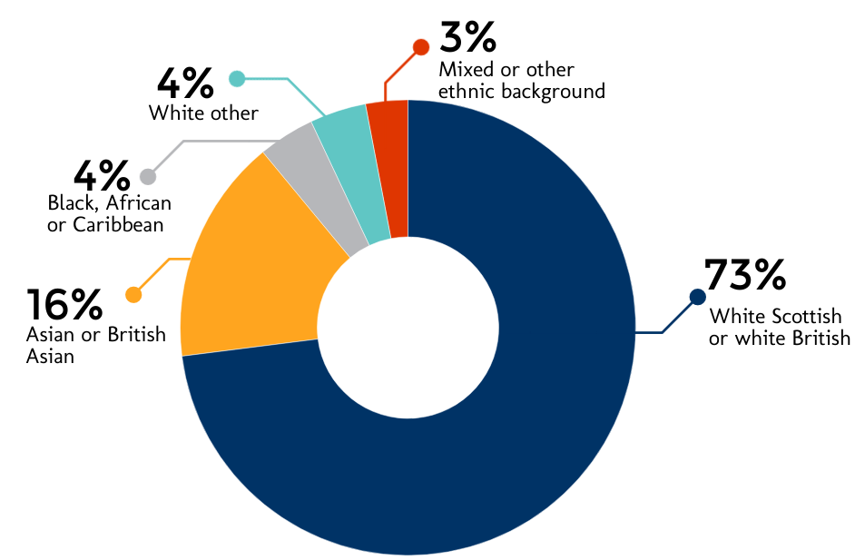

Across both years of the Fund, partners intended that approximately 18% of participants would be minority ethnic. In year one the Fund has therefore performed very well in attracting minority ethnic participants – at 27% of all participants.

Example: Wicketz – engaging minority ethnic participants
The Wicketz project worked closely with local organisations to reach target participants. The project engaged with schools, youth, community and minority inclusion groups working in the local area. The project worked with partners to host 90 taster sessions. The sessions were also advertised through targeted leaflet drops and participation in local festivals. The project found that there was strong partner interest, support and buy in, which greatly helped in connecting with potential participants. Working with partners gave the project a quick, visible, accepted and trusted connection with potential participants. Partners also supported the project through contributing resources and free venues.

Example: Community Strides
In order to maximise engagement with women from monitory ethnic communities, Community Strides Coordinators adopt a face-to-face approach, based on regular contact and relationship building. Community Strides partners with community-based organisations with specific expertise in working with target groups, to build trust and support participants to feel more comfortable. By working with participants to understand more about their backgrounds and needs, project coordinators have established successful groups in three cities across Scotland.

Wider profile
Some projects also targeted specific groups, beyond age, sex, disability and ethnic origin. This included:

- People from areas of deprivation – Six projects targeted this group, and these projects indicated that all or the vast majority of their participants came from areas of concentrated deprivation.
- Care experienced young people – One project targeted care experienced young people, and all of its participants fell into this group. Two projects also indicated that they involved a small number of care experienced young people, despite not specifically targeting this group.
- People not in employment or education – One project specifically targeted unemployed people and people at risk of disengaging from education. Most of its activity leaders came from this group.
- People with experience of substance misuse – One project specifically targeted this group, and all of its participants came from this group.
- People in the care of the Scottish Prison Service – One project specifically targeted this group and most of its participants came from this group.

Example: Care 2B Active – engaging care experienced young people
The project has set up a Care 2B Active steering group, which meets every second week, plans the activity programmes and supports young people to take on leadership roles. It established the group through a period of local engagement and consultation, and a launch event which attracted key partners and influencers. However, the project found it was initially very difficult to engage with young people through their foster carers, social workers or parents. As a result, the project changed its approach and reached out to care experienced young people through Who Cares? Scotland and Active Communities existing groups, local schools, and also visited local private and local authority residential units.

Lessons learned: reaching target participants

Most projects reported engaging successfully with their target groups. These projects were confident that they were reaching intended participants and that engagement and involvement had increased as projects have progressed. Projects used a range of different techniques to reach, engage with and sustain activity with the target group. Approaches which projects indicated worked well included:

- participant led activity
- combining physical activity with social opportunities
- offering opportunities to gain qualifications such as youth work or coaching
- carefully considering the timing of activities – for example providing sessions for parents within school hours
- induction sessions – including getting to know project staff or visiting venues, which were particularly useful for those who live with anxiety
- carefully selecting delivery staff who are integrated with communities, could inspire participants as role models, and/ or have lived experience of issues relevant to participants.

“Visits to venues prior to doing any activity has been very effective, helping to remove the unknown, alleviate anxieties and reduce the fear factor.”
Staff

Example: Wicketz
The Wicketz Development Officer is a natural role model for young participants. He is well known and trusted within the community. He engages parents of participants through an individual, person centred approach, and promotes the project locally using flyers, and taster sessions in schools and community groups. This community focused approach has been very successful in engaging the target group, which includes young people from minority ethnic and refugee communities.
“…we have been keen to engage with and share platforms with local community and other organisations. We have made sure we are both visible, and accessible in the community. At this stage we cannot identify things that have not worked well in engaging target groups.” Staff

A key aspect of reaching target groups effectively was working in partnership. Partners helped with signposting people who may benefit from participation in projects, supporting initial engagement through attendance at partner sessions, and also helped through providing introductions to key staff and networks. For example, one project found that engaging with the Health and Social Care Partnership and Care Home Activity Network had been crucial in connecting the project to existing networks and introducing the project to key staff.

Example: Inspiring Cadder!
In order to successfully engage with their target group in a socio-economically deprived area, Achieve More Scotland and YoMo work with the members of two local youth clubs. Project staff run sessions for youth club members that allow them to come together and socialise, play games, access advice and support and learn about a range of important issues through tailored workshops. Young people are also encouraged to develop their own ideas for activities. This enables the project to more effectively encourage children and young people who would not normally participate in sport to try new activities.
“We have given the young people in the community a lot of autonomy to come up with ideas for clubs and sessions which has resulted in consistently high attendances and positive feedback from all involved.” Staff

Challenges

Although the majority of projects reported successful engagement with their target groups, some highlighted mixed successes in some areas, and others experienced more challenges than others in terms of participant engagement. Key challenges included:

- engaging participants who do not have English as a first language
- sustaining participant engagement through to projects designed to provide follow-on support beyond the project
- travel to and from activities – although projects have delivered activities as locally as possible or provided transport where possible, this is not always realistic.

A few projects reported that engaging older people with dementia could be challenging, because it is difficult to predict how participants would feel from day to day. This presented particular challenges collecting evidence about impact in terms of levels of physical activity and health and wellbeing. In some cases projects found that incorporating social activities into sessions with older people helped to break down some barriers to engagement.

“Many of our members have deteriorated since the onset of the programme and simply couldn’t participate in follow up testing; it was simply beyond their capabilities.”
Staff

One project indicated that it wanted to take further steps to accommodate participants who are physically and visually impaired, and particularly wheelchair users.

A few projects also reported some challenges working with older people and people with support needs where support staff were not fully engaged in the approach. Projects highlighted the pressures support staff were under, with limited continuity of staff, lots of absences and short term employment. A few felt that engaging support staff, such as care home workers, at earlier stages of project development may assist with this challenge.

Example: Shining a Light on Mental Health
Following a request for an activity session for Scottish Disability Sport participants, project Ambassadors recognised that they required to be better prepared to deliver activities to people with physical and visual impairments. In hindsight project staff realised that a greater level of knowledge about the needs of this group is essential, which has resulted in a more tailored approach to delivery when working with new groups with specific support requirements.
“It was clear that there are a range of complex factors surrounding mental health and wellbeing for this particular group which we were not prepared for.” Staff

Volunteers

In the first year of the Changing Lives Fund almost 200 volunteers have supported delivery. Most of these (117) have been trained volunteers, helping in a sustained way and likely to have achieved qualifications. Some (80) have provided one off or semi-regular volunteer support.

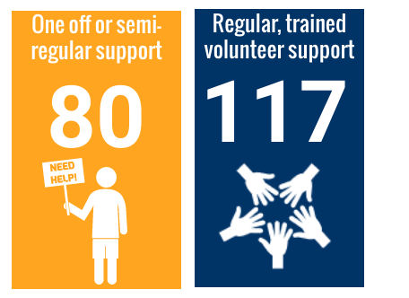

The level of volunteer use to deliver the projects has varied. For some projects, the focus of their activity was delivering volunteers and leaders, while for others this was not a core aspect of their project. Two projects have not involved any volunteers, while one project working with young people has involved 55 volunteers.

Most volunteers have been aged 16 to 24 (39%) or 25 to 64 (44%). Some (15%) were aged under 16, and a small proportion (2%) were 65 or over. More volunteers were male (59%) than female (41%). Given the importance of role models for women in sport and physical activity, and the aim across the Fund of engaging slightly more women and girls than men and boys in activities, it may be useful to review the profile of volunteers with projects and explore how a higher proportion of female volunteers could be attracted to the Fund.

Based on the information provided by projects, none of the volunteers are disabled. It may be worth exploring this further with projects.

Three quarters of volunteers were white Scottish or white British, while a quarter were minority ethnic – largely Asian or white other. This profile indicates that the Fund has successfully attracted a good mix of people with different ethnic origins as volunteers.

Lessons learned: engaging and sustaining volunteers

Some projects have focused on supporting and training volunteers as a core part of their activity. Successful approaches have included:

- encouraging participants to take on a leadership role within the project – delivering activities, making decisions about the project and supporting others
- supporting people to gain qualifications
- encouraging parents and family members to volunteer
- working with local schools, colleges and universities to offer volunteering opportunities.

“Volunteering is really good for me. I like meeting loads of new people and be part of something. I guess it helps with my wellbeing.”
Volunteer

Beyond formal volunteering, many projects are ensuring that their activities are participant led. For example, at T.E.A.M and Let’s Give Sport Back to Girls, young people are involved in decisions about things like activities and snacks, and can lead a sessions if they have a particular interest.

While many projects had successfully engaged volunteers, most recognised that it was challenging. Potential volunteers can have many other life commitments including studying, employment and family life.

Example: Care 2B Active – engaging care experienced young people
Members of the Care 2B Active steering group take on a leadership role within the project. They are supported to gain qualifications and will also be involved in hosting a national sport and physical activity event.

Example: Wicketz – engaging volunteers
The Wicketz project found that parents initially dropped their children off to attend activities. However, gradually partners started to hang around, chat to other parents and watch the session. Over time, the coach has worked with these parents to encourage longer term engagement and involvement in volunteering. Three volunteers joined the project in mid 2019, to support delivery.

Example: Replay Sporting Memories – engaging volunteers
The Replay Sporting Memories project engages volunteers from local colleges, universities and sports clubs. This helped to bring an inter-generational component to the work, which targeted older people. University students have assisted with monitoring and evaluation, including undertaking baseline and follow up strength and balance measures. The project targeted more university and college volunteers as the new term started in autumn 2019.

Are we changing lives?

Introduction

This chapter explores the interim evidence that the funded projects are changing lives through their activities. To set this chapter in context, it is worth remembering that:

- across the Fund there were 1,800 participants in year one who took part in a sustained way, and projects would expect to see real change for over time;
- most projects focused on increasing physical activity levels, inclusion and health and wellbeing, with a smaller number of projects focusing on skills development and community development; and
- year one of the Fund involved up to 6 months of project set up, so this exploration of change is happening at a relatively early stage in the Fund.

Inclusion

All projects selected outcomes relating to inclusion, as this was a mandatory theme. The inclusion theme covered a range of outcomes. For the purposes of reporting, the inclusion theme has been split into:

- increased physical activity – including people moving from inactive to active, and people maintaining higher levels of physical activity; and
- wider inclusion and increased opportunities.

Increasing physical activity levels

Eight partnerships had outcomes relating to increasing physical activity levels. Five of these projects aimed for participants to become more active, while three had specific outcomes around getting inactive people to become more active. For the purposes of evaluation at Fund level, projects were provided with standard measures for assessing whether people were inactive, doing some activity, or active. These are included at Appendix Two.

Four projects provided information on whether participants were inactive, doing some activity or active, based on the standard measures.

Physical activity level | Inactive | Some activity | Active | Total number
Baseline | 27% | 38% | 35% | N = 78
End year 1 | 10% | 39% | 51% | N = 70

This shows a clear shift away from participants being inactive, through to having some activity and being active. The participants remaining inactive were all older people who were particularly frail and with deteriorating conditions and illnesses. For them, undertaking a small amount of activity each day was a reasonable achievement and likely to impact positively on their health.

Example: Centre Forward
All of the students participating in this project increased their weekly participation levels in sport. Before the project, the group of 24 students were participating in around 88 hours of sport per week, increasing to 124 hours per week once on the project. 28% of students transitioned from inactive to some activity, 16% transitioned from some activity to active, and 56% of students sustained an active lifestyle.

Example: Replay Sporting Memories
All 21 older participants increased their time spent on weekly physical activity. Average activity increased from 25 minutes a week to 38 minutes per week. Significantly, 4 participants increased their average activity from under 30 minutes (inactive) to over 30 minutes (some activity). The participants who remained in the inactive category were from day care settings and had the most advanced frail conditions. All are now taking part in ten minutes of strength and balance exercises per week.

Three other projects provided standardised information on the amount of physical activity participants were undertaking, using slightly different measures.

Example: Youth Works through Sport
In this project the average number of days that young people were physically active increased from 4.2 days per week to 5.7 days per week. The project moved two people from being completely inactive every day of the week, to being active at least one day per week. It moved 22 people to being active every day of the week. The average amount of time spent being active each day was 45 to 60 minutes. This means that the average participant was doing approximately 300 minutes (6 x 50 mins) of physical activity a week. This falls into the ‘some activity’ category for young people.

Example: ActivAGE
In this project the average number of days that older participants were physically active increased from 2.8 days per week to 4.3 days per week. Most participants (64%) were active for 30 to 60 minutes on the days they were active. This means that the average participant was doing 180 minutes of physical activity a week (4 x 45 mins). This falls into the ‘active’ category for adults.

Example: Inspiring Cadder!
At this project, 97% of participants said they took part in more sport and physical activity than they did a year ago. As an example, S is 8 years old. Through the project, she now attends dancing every week, and also goes to an after school activity club. Previously she did not do much physical activity.

“She never used to do anything. She would just sit about and watch tv or be her on phone. It’s sad how many kids do that now.” Gran

S started coming along because:

“Dancing is fun and my friends were going along so I wanted to go. This is the first club I have gone to. I also go to the multi-sports club at the school.” Participant

The project asked [S] if anything was different now in her life, or if it had changed:

“I am happy. I love dancing every week. I want to dance every day. My favourite thing is jumping really high.” Participant

Both coaches felt that the difference in S since she attended her first sessions had been remarkable.

“When she first came along she didn’t know how to move or even jump without falling over but now she controls herself much better and is becoming a good dancer.” Staff

One project also explored how active children were on the day their project did not run. Most (57%) undertook between 30 and 60 minutes of activity on the days the group didn’t run. All children ranked themselves highly in terms of how active they were through the project.

Some projects also provided evidence from individual participants about their journey in relation to physical activity levels.

“The football is so much fun and I get to play almost every day. Before (the project) started the football I only got to play in PE class if it was on. Now I get to play a lot more.”
Participant

Example: Active Families
The project worked with a family over a period of time. Initially the mother rarely left the house due to her physical health and anxiety. This had a big impact on the young person in the family who did not attend school. The project worked, among other things, to increase the mother’s physical activity and physical wellbeing. The mother began to walk regularly and her confidence increased to the extent that she would leave the house alone to attend various activities in the community.

Example: Inclusion through Activity
This project asked participants to identify how many hours they spent doing physical activity at the beginning, after 6 weeks and after 12 weeks. The project found that there was an increase in time spent being active at each stage. The project had several participants reporting zero hours exercise at the start of the project, and finishing with three or more hours of exercise a week. This would move participants from inactive to active. Participants also saw wider increases in activities such as walking, housework and gardening.

Wider inclusion

Most projects (12) had intended outcomes which related to inclusion beyond physical activity levels. The focus of these projects varied. Some projects had intended outcomes around inclusion within sport and physical activity:

- people being more interested in and better able to take part in and lead sport and physical activity; and
- participants having a say in how the activities are developed.

Other projects had intended outcomes around inclusion within communities more generally:

- people being more able to relate to peers and better connected to others;
- people socialising more; and
- people in prisons having a better understanding of their rights after liberation.

Standard measures on inclusion
Almost all projects (16) were asked to gather standard information from participants to explore whether the project helped them to feel included and closer to people.

The evidence, from a small sample of those involved in a sustained way in the Fund, highlights that the Changing Lives Fund has had a clear impact on how included and close to other people the project participants feel. Almost all felt the project helped them feel more included and closer to people, to some extent.

Has the project helped you feel…? | Yes | Sometimes | No
Included* | 82% | 17% | 1%
Closer to people** | 79% | 17% | 4%
*n=153 **n=151

It is important to note that within these projects there were approximately 1,200 participants at this level during year one, so this feedback reflects a sample of those involved.

Inclusion in communities
There was good evidence from project monitoring forms that projects were supporting people to meet new people and make friends. There was evidence that these friendships now exist beyond the projects, extending out into community and home life.

“He has made loads of friends with common interest.”
Parent

“…it is so good to see her with her new friends”
Parent

“When I started I only knew a few of the other boys but now we are all mates and everyone gets on well.”
Participant

“…the group helps keep me motivated and meet new people.”
Participant

Four projects specifically brought together people with different life experiences to take part in a shared experience. Sport provided a conduit for people to connect and engage in a positive activity. For example, in one project care experienced and non-care experienced young people were supported to develop awareness of what it means to be a care experienced young person and to reduce the stigma around care experience. Young people with different types of care experience (e.g. residential home and kinship care) started to discuss their experiences. And young people that were not care experienced demonstrated understanding and empathy towards their peers, taking up opportunities to support them through Who Cares? Scotland and at school. In another project, the activity helped some people who were new to Scotland make friends and connections.

“Since we came to this country it hasn’t always been simple but this club helps him make new friends and have fun. He really enjoys it. He is always wanting to go out and play now he also seems more confident and has made some good friends. It has been a huge help for my family. It is also great to know that he is keeping healthy.”
Parent

In another project, prisoners were supported to build relationships within the prison and to consider life on release. This had a major impact on relationships, with most participants (79%) reporting an improvement in their relationships, with improved trust, confidence and anger management.

“Working with people from different halls, different colour, different religion. Different levels of ability, different pace of learning and still all getting along, having patience with each other and having trust in each other.” Participant

“Was great to get mixing with new people. Confidence in playing games I never normally play. Enjoyed team work too.”
Participant
Another project brought together younger and older participants, which helped some older people to reaffirm their interest in sport and physical activity – as well as enjoying the intergenerational aspect of the work.

“I’ve still got it!”
Participant (older person)

Example: Care 2B Active
Sarah* got involved in the Care2B Active project through Active Communities Hearty Lives Project where she is becoming a peer educator within her school. She attends two Care 2B Active groups and has attended national events.

“This has helped me make more friends from different areas but also meet more people who are care experienced and they are just like me. I have also been able to go out my comfort zone and try new things and explore more.” Sarah

From engaging in the project Sarah realised she was care experienced and was able to explore her care identity and sibling separation, and what that means to her. Sarah has now become a family member of Who Cares? Scotland and has been able to take part in multiple national events and WCS groups.

“The groups bring everyone together and you see similarities in each other and that makes you feel less alone.” Sarah

Going forward, Sarah would like to join the project steering group and to take on a leadership role.
*Real name changed to protect identity

Example: Positive Change through Football: Inside and Out
Street Soccer supported Laura* to take part in sport and become included in group activity within a prison setting. When she first joined the sessions, Laura was nervous and avoided making eye contact with staff and other group members. Staff noticed that Laura was taken advantage of because of her vulnerability, being side-lined or “used” by other girls who wanted money or things from her.

Over the course of two sessions a week for just one month she began to come out of her shell, sharing her personality and laughing out aloud – something she said she had not done for a long time. As the weeks progressed, staff heard reports that Laura was no longer excluded. Other women from the project asked her to join them for meals and are now very protective of her stating “she’s our friend, she plays football with us.”
*Real name changed to protect identity

Inclusion within sport and physical activity
From the project reporting forms submitted, there was good evidence to show that participants were beginning to feel more included within sport and physical activity, and more able to access it. Participants indicated that projects provided an inclusive atmosphere and reported feeling more able to take part in planning and participating in activities. Participants reported that they enjoyed coming to the activities and that it helped them feel more included.

“I have confidence to go to the gym now… I can now interact with others.” Participant

“It is the first real team sport I have been involved in. It is very supportive, confidence boosting. It does not feel like exercise, it became just like meeting your pals every week.”
Participant

Example: Community Strides
One participant (M) started out incredibly shy and spent her time on her phone before the class started. However, more recently M has been first there and keen to get started. One week there were only two runners, and the other runner wanted to go home. However, M encouraged the other runner to stay and run together. The project is now supporting M to continue to build confidence during games and drills, over time.

“Since the clocks have gone back an hour, I have noticed that the ladies who observe daily prayers seem to have prayers for a few minutes before the group starts at 12 noon. The ladies go into a wee corner facing in the direction required and I noticed that M had some company last week from the other ladies- it was really lovely to see.” Staff

Example: Walking Netball – More than a game
A 28 year old woman with Autistic Spectrum Disorder has been attending the Walking Netball sessions for one year. To begin with she was anxious and was not sure if she would be able to participate. She was concerned about the environment, meeting new people and her co-ordination skills. To ease her anxiety she attended the first session with her mother, who stayed close by throughout. Since attending the session, she feels she has improved her sense of direction, her coordination and her teamwork skills. She’s made new friends, and she feels that taking part in a team sport has helped her to improve her sense of touch.

“I’ve overcome people touching me and I’m coping better in crowds with lots of noise. I’m making new friends and feel included as part of the team.” Participant

In some projects, the availability of activity locally or with transport support is also reducing financial barriers to participation.

“…I like a lot of people in our area have been finding things a little hard recently financially and just seeing the children having such great fun, when probably a lot of families wouldn’t have the chance to pay for this for their kids, was great.”
Parent

Example: T.E.A.M
The T.E.A.M project at Big Hearts found that around 43% of participants reported that the project was their only means of accessing physical activity outwith school.

“If he didn’t come to the group or do PE he wouldn’t get to play football.” Parent

In one project, prisoners have had better access to sport and physical activity. For example, 64 prisoners serving in high security prisons would typically have had very limited periods of time when they could be out of their cells, mix with other people or gain access to physical exercise.

In a few projects, there was a specific focus on developing the skills of deliverers to create an inclusive environment in which to undertake physical activity and sport. For example, in the Shining a Light on Mental Health project, almost all of the 20 wellbeing ambassadors felt a lot more able to relate to a diverse group of peers, talking about mental health in an open way.

“… I have been able to work with and deliver to a wide mix of people at the tournament and adapt the session to their needs.”
Participant

“I feel that I am a lot more able to relate to everyone as I can understand more what could be going on.”
Participant

Example: Youth Works Through Sport
This project supported youth workers to develop their skills around creating an inclusive environment. Participants reported that they were more aware of the relevant issues and how to address them. And those delivering the project also saw improvements in the participant’s knowledge and capacity to creative an inclusive environment.
“I identified what barriers young people faced to take part, and we overcame some of these barriers to enable them to take part and engage… I will follow this up and follow through with removing barriers.” Participant

Improving health and wellbeing

Sixteen projects selected outcomes relating to health and wellbeing, including:

- improved wellbeing
- increased confidence
- improved physical health
- improved mental health / emotional wellbeing
- increased understanding of the benefits of health and well being
- improved lifestyles and healthier, more positive choices.
Standard measures on health and wellbeing
The 16 projects focusing on health and wellbeing outcomes were asked to gather standard information from participants to explore impact on health and wellbeing.

The evidence, from a small sample of those involved in a sustained way in the Fund, highlights that the projects have helped most people to feel healthy, useful, relaxed and optimistic.

Has the project helped you feel…? | Yes | Sometimes | No
Healthy | 81% | 16% | 3%
Relaxed | 82% | 15% | 3%
Useful | 83% | 14% | 2%
Optimistic | 75% | 23% | 2%
*n=159, **n=126, ***n=126, ****n=161

Physical health and wellbeing
There was good evidence from the reporting forms submitted by projects that the activity was having some impact on physical health.

Projects working with young people submitted evidence showing that participants were feeling physically healthier, fitter, faster, making healthier eating choices or sleeping better.

“My level of fitness has increased, my attitude has changed for the better.” Participant

“I would prefer to eat hunners of blueberries instead of chocolate.”
Participant

“I didn’t know I liked strawberries until I tried them at the group.”
Participant

“I don’t sleep and this is the first time I have slept longer than a couple of hours.”
Participant

“He now says no to pizzas, burgers and fizzy drinks, as he says he needs to be fit to be a fast bowler.”
Parent

“The difference in children is massive… I have seen such an improvement in those children attending. Some are now more confident, some are healthier and more active, some have lost weight and some are just happier.”
Teacher

Example: Inspiring Cadder!
At this project, 95% of participants felt better about themselves because they had been involved in the project and 97% felt healthier or fitter than they did a year ago.
As an example, one shy P6 pupil got involved in this project. He was overweight, struggled with his confidence and participated in no sport or physical activity. He now attends four evening sessions a week, has lost a significant amount of weight and has improved his confidence.

“I love the clubs… I feel really good and love coming every night. I feel better and I have got much faster.” Participant

“The difference is massive. Before there was nothing in the community. The kids had nothing to do so they either cause trouble or lie about and do nothing. (He) used to lie about but now he is running about every night. He is much more like a little boy now and happy. He comes in every night and his face is bright red from running about. It’s great to see. The difference it has made to loads of kids around here is great. The fact that it’s free makes big difference as no one around here has any money.” Family member

There was good evidence that older participants were improving or sustaining aspects of their physical health – for example through building their grip strength, balance and strength. This was measured in a range of different ways, including ability to undertake activities such as sitting to standing or balancing at the beginning and mid point of the project. In some cases, older participants noted that while they felt that they benefited from participation, this was in the context of wider deterioration in their health and wellbeing due to wider factors such as health conditions and ageing.

In many cases, the examples of improved or sustained health were incremental, anecdotal and about the journeys that participants had followed. For example, at one project one participant managed to walk around the grounds of the care home after not being outside for over one year due to various health conditions. Another participant greatly benefited from the strength and balance training. When the project started, she needed a wheelchair to go to the bathroom. Six months later, after participating in strength and balance exercises and being coached to stand up and sit down, she is able to confidently get out of her seat and go to the bathroom independently.

Example: Care About Walking
Paths for All measured grip strength as a reliable measure related to wider health. The projects chose this measure because grip strength generally deteriorates with age, and maintaining a strong hand grip level can enable people to perform day to day tasks more easily. All 9 participants in one group showed an increase in grip strength, after 16 weeks of participation. The project also measured balance using the Berg Balance Scale. Participants are scored on a scale when taking part in 14 activities, including standing to sitting, standing on one leg, and reaching forward with outstretched arms while standing. Five of the six participants that were tested on this measure showed an improvement, while one remained at the same level. One person was originally a high falls risk, and reduced to a medium falls risk after 16 weeks. All of the participants also increased the number of sit to stands they were able to do in 30 seconds, with one doubling from 5 to 10.
“Having the exercise posts in the garden has made me fitter and helped improve my confidence going outdoors. It’s good fun too.” Participant

The project is working with people with deteriorating conditions and illnesses, and so this was broadly in line with project expectations. Many participants indicated that they didn’t really see an impact on their strength and balance, but they still enjoyed the challenge of taking part.

Example: Replay Sporting Memories
Jimmy* is a competitive all round sportsman. His mobility and overall health have changed in the past year due to Parkinson’s disease and dementia. He has attended the Sporting memories club weekly and staff have noticed a marked change in his mobility.

Despite these limitations, Jimmy managed to fully participate in the Sporting Memories Hub activity day – a joint event bringing together children and older people. Staff report that he “came to life” and played for 30 minutes, as well as walking to and from the sports club.

Staff were delighted to see him fully participate in his favourite sports with so much enthusiasm and energy, especially when his health and physical condition had deteriorated so much over the past year.

“Jimmy has managed to maintain a level of physical activity which has defied his health.” Staff

Due to family and health circumstances he now lives in a care setting so is unlikely to attend the hub again. However, he will continue his weekly Sporting Memories involvement at the care home - a true testament to the sporting enthusiast he is.
*Real name changed to protect identity

Mental health
People involved in Changing Lives projects reported that physical activity provided a range of benefits relating to their wellbeing and mental health. Some reported increased awareness of the link between mental health and physical activity and greater understanding of wellbeing, self care and positive self talk.

“I definitely feel more motivated to keep going at sport, but I now know I can do more to improve my mental health.”
Participant

“I use physical activity more to help my mental health.”
Participant

“…even a small among of physical activity can have huge positive results for mental health and wellbeing.”
Participant

Participants also reported finding that physical activity helped with anxiety, got rid of negative thoughts and was calming.

“I haven’t found anything else that calms me as much as physical activity does.”
Participant

“I have been more patient and calm.”
Participant

“I’ve become healthier and have a clearer mind and focus.”
Participant

“I really feel I am taking part in sport now more for my mental health than physical health.”
Participant

Some participants felt that taking part in the project helped build their confidence, manage their emotions, improve their relations with others and made them feel better about themselves.

“I feel more confident and empowered.”
Participant

“I suffer from really bad anxiety so to do something like this was massive for me. Now I am managing to approach people.”
Participant

In presenting this evidence, projects made clear that it was important to recognise that mental health fluctuated and did not always improve in a linear way.

Finally, in some cases, learning and developing skills around mental health were an integral part of the project. Some participants found that the project helped them to deal with wider issues in their lives, which helped improve their mental health.

“Mental health and physical health are totally improved. Can see a future without alcohol.”
Participant

“Before coming to prison, I was in an abusive relationship and this affected my day to day living. This opportunity has helped me look at things with a whole different attitude. My confidence in my whole life has changed for the better.”
Participant

Example: Shining a Light on Mental Health
The Shining a Light on Mental Health project developed the skills of young people to lead discussions about mental health with their peers, and with adults. Feedback from the young ambassadors strongly highlighted the development of skills and capacity around mental health. In particular, ambassadors pointed to the importance of treating mental health as a general state, something which everyone has, rather than a specific illness.

Within this project 100% of the ambassadors said that they understood the benefits of physical activity for their mental health.

“I have a lot more knowledge on adult and young people’s perception of mental wellbeing. I am able to relate because I have heard many different experiences and can relate that back to people of different ages.” Participant

“This project has helped me increase my understanding of mental health and be able to discuss mental health more comfortably with others.” Participant

Staff also felt that the young ambassadors had become more able to adapt and create and inclusive approach, opening up mental health conversations and dealing with things that come up. Staff felt that ambassadors developed trust and belief in their capabilities to deliver the activity, both to young people and adults.

“It has given the confidence to discuss sometimes very sensitive issues and a way to open discussions with young people from different backgrounds.” Staff

Example: Active Families
This project supported families to improve their physical and mental wellbeing. In one family the parent has a number of physical and mental health issues including fibromyalgia which causes pain and significant mental health issues which limit daily activities.

Project staff supported her to develop a daily steps sheet to fill in her step count and record her feelings before and after any walk/activity. This simple but effective intervention resulted in her going for a walk once a week and varying the direction and distance walked. After a relatively short time, she was regularly receiving "nailed it" notifications from her Fitbit, when she achieved her step count target of 4,000 steps. She has now increased this target to 5,000 and is achieving this new target on a regular basis also.

"If it's written down on the plan then I know I have to just get out and do it no matter what the weather is like. I know I will feel so much better afterwards." Participant

These simple tools have proved very effective for her and have had a big impact on her physical and emotional wellbeing.

" ...today looks like a great day, hols booked, sun shining and got my ‘nailed it’….feel so happy.” Participant

" ... I actually walked 13,181 steps yesterday and got my beating personal best achievement." Participant

Building skills for life, learning and work

Six projects intended to achieve outcomes relating to improved skills, positive life choices and positive destinations for participants. Of these, four aimed to build skills through the project, supporting young people to increase their awareness of career opportunities, make positive life decisions and - in the long term - achieve positive destinations. The remaining two aimed to build skills to improve delivery of sport and physical activity.

Standard measures around skills

Almost all projects (16) were asked to gather standard information from participants to explore whether the project helped them to feel included and closer to people.

The evidence, from a small sample of those involved in a sustained way in the Fund, indicates that over half felt the project had consistently helped with their ability to make their mind up, think clearly and deal with problems well. A third felt it sometimes helped.

Has the project helped you feel…? | Yes | Sometimes | No
Able to make your mind up* | 63% | 32% | 4%
Able to think clearly** | 58% | 37% | 5%
Able to deal with problems well*** | 58% | 33% | 9%
*n=123 ** n=127 *** n=126

It is important to note that within these projects there were approximately 1,200 participants at this level during year one, so this feedback reflects a small sample of those involved. The standard measure responses for the four projects specifically focused on skills development for participants were broadly comparable to other projects – although numbers were small.

Building skills for life

Six projects supported participants to develop personal skills including confidence and aspiration, leadership and teamwork and independence and positive life decisions.

- Confidence and aspiration - One of the key areas of personal development was confidence. Some projects aimed to improve confidence amongst participants through the activity itself. And in others, the development of wider skills naturally led to an increase in confidence. Staff delivering activity commented on how they had seen participants’ confidence develop over time. Two projects indicated that they used activities and role models to inspire young people and demonstrate the variety of opportunities in the wider world, encouraging them to be ambitious and aspirational for their own futures.

“Week by week, month by month, I could see the change in the children.”
Coach

“Confidence has boosted, definitely.”
Coach

“[Young person] was a shy boy but he has come out of his shell.”
Parent

“[Young person] is blooming with confidence and always waiting for Friday.”
Parent

“I feel more confident in talking and being in a larger group.”
Participant

“My confidence and self esteem has improved so much and I am able to approach my own personal stuff with more confidence.”
Participant

Example: Wicketz
In this project, participants were asked to think about their goals and ambitions for the future. The project engaged relevant, relatable role models to show young people the range of options available to them. Community partners, such as school staff reported that the project had provided valuable opportunities for young people.

“I think it’s opened up a lot of opportunities for our children.” Teacher

The staff delivering the activity noted that prior to the project, the participants were often seen on the street engaging in anti-social behaviour. Now they take part in positive activity through the project, and are choosing to attend every week. And for some participants, there has been a positive change in behaviour that has led to better focus and engagement at home and at school.

“It’s made me focus more at school.” Participant

“[Young person] has become more responsible and focused ever since they joined the SLUK programme.” Parent

“We have seen a huge change in behaviour in both the children.” Parent

“Through Wicketz [young person] has really improved his English speaking skills and he is so much more confident in talking – it’s made a big difference at school.” Parent

Example: Care 2B Active
Through this project there was evidence that some care experienced young people became more motivated to achieve at school, after taking part in the activity. One young person also developed an interest in working in healthcare after taking part in a First Aid course, and felt more motivated to succeed in their prelim exams in order to pursue a career in this field.

Example: T.E.AM
T.E.A.M supported A, who was referred to the project by the head teacher at his school. A’s first language is not English and he was very shy when he first joined the project. Through football and other activities, he began to make friends and come out of his shell. Over his time with the project he has progressed into a confident, friendly young person. Staff and other participants have enjoyed seeing him develop and sharing in his sense of humour.

“The difference between A’s engagement and confidence when joining the group has been remarkable. From saying very little for the first four or five weeks to happily chatting away to his friends about football and showing off his best dance moves at the end of term party, A has been the perfect example of what we hope to achieve in group by providing the right environment for children to gain in confidence.” Staff

Example: Centre Forward
Young people with learning disabilities have been supported to develop their skills and gain SQA qualifications through this project. Participants are involved in public events where they have the opportunity to develop leadership and communication skills.
One student, Steven is an athlete who recently won the Scottish 200m ambulant championship and is hoping to qualify for the Tokyo 2020 Summer Paralympic Games. He feels that that course has been instrumental in building his skills and confidence to compete at the elite level.
"I am more confident to talk in a group of people and I feel I can read and write things better. I enjoy making new friends and it gets me out of the house, I also enjoy all of the different activities.” Steven
- Leadership and teamwork - Some projects indicated that participants were developing their leadership and teamwork skills naturally, as part of the activity. Young people demonstrated positive behaviours towards each other, such as encouragement and support during challenging situations. This has also led to the participants forming positive relationships and making new friends. Young people have been encouraged to lead activities that they are interested in, and take turns taking on leadership roles.

“…it is so good to see her with her new friends.”
Parent

“He has made loads of friends with common interest.”
Parent

“I feel more confident talking and being in a larger group.”
Participant

“I’ve developed my social and communication skills.”
Participant

“My personal and people skills have changed in a way that I have a positive outlook on life and that I’m looking forward to spending time with my family and achieving something else that is positive in my life.”
Participant

Three projects also specifically supported young people to develop their leadership skills, two of which have dedicated leadership programmes. People participating in these programmes have gone on to demonstrate improved leadership through their continued engagement and uptake of volunteering opportunities in the community.

In one project with a dedicated leadership programme (Youth Works Through Sport), two thirds of participants reported that they had improved their knowledge, confidence and skills to lead sport activity in their community.

Beyond the leadership programmes, activities also offered regular and ad hoc opportunities, for example, in one project (Wicketz) participants take turns in being team captain.

“I never saw myself as a leader but getting involved in sports coaching and doing the iLead leadership programme has changed that.”
Participant

- Independence and positive life decisions – One project indicated that one young person had learned how to travel independently using public transport, and another project had supported young people to make healthier eating choices for themselves. Another project found participants leaving prison developed their sense of responsibility and respect.

“Responsibility and small taste of normality in a place that is far from normal.”
Participant

“New ability to problem solve and speak in larger groups.”
Participant

“Less angry more motivated.”
Participant

“(The project) built a relationship with the young person and over a period of time and after trying various activities enrolled the young person in a dodgeball club where he now plays regularly. The young person in question had previously lived a sedentary lifestyle and frequently self harmed. The increase in physical activity as well as the social side of being involved with others clearly benefitted the young person.”
Project partner

Example: Positive Change through Football: Inside and Out
In this project, evaluation found that participants developed their confidence, esteem, teamwork, patience, attitude, anger management, communication, listening and problem solving skills, as well as understanding normality and developing friendships. The project also fostered better relationships between prisoners and staff, and between participants and the other prisoners. The project has helped participants to develop better conflict management and problem solving skills, and the confidence to interact and negotiate with other people.

“Improved confidence and new found respect for staff.” Participant

“Being able to approach them (officers) and having the confidence to do so.” Participant

Building skills for learning and employment

Four projects supported participants to develop skills specific to learning, volunteering and employment pathways. Participants have engaged in a range of relevant training opportunities, such as:

- First Aid training
- Emergency First Aid at Work
- CPR training
- Resilience training
- Disability Inclusion training
- Child Protection training.

Participants have also gained accreditations, including:

- coaching qualifications (at level one and level two)
- SCQF qualifications (whole course qualifications and SQA units)
- Saltire Awards.

Example: Champions for Change
In this project participants were supported to complete training courses, gain accreditation and move into positive destinations. Participants have progressed to volunteering with Active Schools, volunteering in community sports clubs and have become more work-ready.

Example: Centre Forward

In this project, young people at college with learning disabilities were supported to volunteer at sporting events where they engaged with participants and employers. This has helped participants to develop their skills and confidence, and provided an insight into the responsibilities and skills required for employment. Through evaluation feedback, 100% of young people reported improved employability skills and increased awareness around the world of work. The young people have also amassed 189 qualifications including SQA qualifications, First Aid certifications and coaching qualifications.

“We have met and engaged with the students who have all grown in confidence since starting this journey. It has offered them a purpose and discipline while allowing them to learn life skills… " Community stakeholder
Example: Inspiring Cadder!
C, a 14 year old girl, went from doing no sport and physical activity outwith school, to getting involved in two nights of dancing a week. She now wants to be a dancer or dance coach. She has started to volunteer to help lead sessions, helping the younger kids learn basic steps.

“I love it so much. I have never got to do anything like this before. I go home and practise every night and can’t wait for a competition to show off.” Participant

“She is so much happier. She loves dancing. She dances everyday now in the house, at her grans, on the street….She has made new friends and now wants to be a dance coach… She is still very young, but I like that she is taking part at her age so that she is exercising more.” Parent

Building skills to improve sport and physical activity

Two projects specifically intended to develop the knowledge and skills of people who deliver activities. This has included developing skills to ensure that deliverers can reduce barriers to activity, deliver more inclusive activity and deliver activity appropriate for a particular client group.

Example: Youth Works through Sport
As part of this project, young people were supported to develop skills that would enable them to lead on sport and physical activity in their local community. Young people participating in the project set their own targets around creating a more inclusive environment for sport and physical activity. Some young people specifically noted that they wanted to develop skills around First Aid and Child Protection. After learning new skills, participants reported feeling more confident in delivering sport and physical activity.

“I identified what barriers young people faced to take part, and we overcame some of these barriers to enable them to take part and engage… I will follow this up and follow through with removing barriers.” Participant

“Taking part in this workshop means I can also boost my SQA points, so I get to improve my own, as well as other people’s skills, which is really rewarding.” Participant

“It helped me to be more comfortable in my next coaching session… I can take note of any issues and (know where to) report it to the concerned person…Also in case of emergency I can use my knowledge of basic first aid training.” Participant

Example: Care About Walking
This project supported 20 staff working in care homes to develop their knowledge and skills around walking, and how walking could be used to benefit their residents. Care home residents were supported to participate in activities that got them more active and promoted strength and balance.

“With their support this was a natural progression for us to continue to enable our residents to have the strength, motivation and confidence to achieve goals they did not previously think possible and become more active both within the care home and within their wider local community.” Care home manager

Strengthening communities

Six projects aimed to bring about change in relation to strengthening communities, including:

- improving connections between people in the community
- stronger, more sustainable communities
- more inclusive communities
- improving sense of belonging within the community
- improving community engagement.

Standard measures on strengthening communities
Almost all projects (16) were asked to gather standard information from participants to explore whether the project helped them to feel involved in their communities.

The evidence, from a small sample of those involved in a sustained way in the Fund, indicates that around two thirds felt that the project helped them to become more involved in their community.

Has the project helped you feel…? | Yes | Sometimes | No
Involved in your community | 68% | 25% | 6%
n=120

Six of the projects specifically aimed to bring about changes related to strengthening communities. The standard measures for these projects were broadly comparable to the wider Fund. However, in one of these six projects 100% of participants said the project had helped them feel more involved in their community.

Wider evidence
There was some wider evidence from project monitoring forms that participants had become more involved in their community as a result of participation.

For example, in two projects, the group of volunteers has strengthened the capacity of community organisations, and has also built a pool of volunteers who are more diverse and representative of the community. It is hoped that this will in turn help to build longer term sustainability. One project is seeing evidence of this through an increase in the diversity of participants.

Two projects have built connections between younger and older generations. This helped older people feel more connected to their local community, through connections with primary school pupils and younger people.

“I loved the energy from the kids. It reminded me of playing with my grandkids in the garden.”
Older participant
Participants involved in leadership activity have gone on to take part in wider activity – such as presenting at the 2019 SOLACE conference, taking on the role of an #iwill Ambassador, being elected as a member of the Scottish Youth Parliament and becoming connected to local groups and committees, such as a local disability committee.

Social connections and networking with communities has improved in some areas, with participants and their families making connections and becoming friends outwith the project. In some cases, projects have provided young people with consistency and a sense of connection with a community during times of transition in their lives, such as moving house or moving school.

Example: Wicketz
In this project, a range of people, including young people, parents and community volunteers have been brought together through leadership opportunities. Young people were trained as sports leaders, giving them ownership of the activity. The increased ownership has facilitated a sense of belonging and pride in the club. The project has also engaged parents, some of whom have qualified as assistant coaches

“Some of the parents are involved now, too. They used to just drop the kids off to have some free time, but now they stay for 15-20 minutes at the start to see what their kids are doing. We have two parent volunteers who want to be involved in cricket and I am telling them how to get qualifications like UKCC Level 1 coaching.”

“It took about two or three months…they really found their feet...they really belonged in that environment, and I think most importantly, they believed that the club was theirs, that it was a part of them and vice versa, they were a part of the club.” Staff

The coaches delivering the activity noted that the project is now well known within the communities they work in. People living and working in the community, in shops and restaurants are familiar with the project and are proud to say that they or their children attend the club.

“It’s a massive part of the community now…it’s really taken an active part of people’s everyday lives.” Staff

In one project, participants have supported others to make positive changes to their lives.

Example: Inclusion through activity
One project has supported people in drug and alcohol recovery to engage in physical activity, and in doing so, to re-engage with their local community. As well as supporting their recovery journey, the project has inspired some people to proactively encourage others to make positive changes to their lives.

“Clients are now acting as a role model and influencing family/friends to become more active/healthy. They also feel an active part of their community.” Staff

In the Inspiring Cadder! project, participants reported that they liked their community more and that it was better because there were things for them to do.

“If it wasn’t on, I honestly don’t know what I’d be doing. There is nothing on up this way. That’s why everyone loves to go.”
Participant

Finally, the Active Families project supported families to develop better interpersonal relationships through physical activity. The project encouraged families to take part in group activities together and community stakeholders reported that people were less isolated, and more active in their community. Parents involved in the project reported that they felt better equipped to discuss issues without shouting and fighting.

Example: Active Families
A single mum with five children under the age of 12 felt isolated and alone with little support networks around her prior to being referred to the Priority Families Service. She began engaging with the Active Families project and has made significant improvements to her relationship with her children, as well as her own confidence and self-esteem.

The whole family were provided with Sport Aberdeen gym memberships, which enabled them to go swimming. The mum was encouraged to participate in an exercise class, which staff were able to support her in going to for the first few classes. She commented on how much she enjoyed the class and feeling able to go out to do something for herself. She was aware that by focusing on her own wellbeing, this would in turn improve her relationship with her children and others in the community.

Another example from Active Families is a family which has engaged with the project once a week. The family includes five children aged 6 to 16. The parents separated two years ago and children live with the mother in the family home.

The mother’s own childhood was chaotic and in recent years she reports feeling isolated, as well as suffering from a range of physical and mental challenges. The older children have struggled with attendance at school and the family was not engaged in any positive activities outside the home. Although the family is close, there were often arguments between the children, who sometimes demonstrated challenging behaviours and frequently tested boundaries.

Initially, the family struggled to engage, due to the mother’s health issues. Since they became involved, they have been supported to engage in range of family outings based on activities such as swimming and football. The project removed all barriers including providing them with swimming costumes, covering the cost of swimming lessons and providing transport to and from the lessons. The project has also introduced mum to family routines and charts that she will be able to use in the future.

The family’s engagement and commitment to making positive changes has resulted in a great improvement in their relationship with each other. Their home environment is more relaxed and the children are out playing with friends more often and engaging in activities within the community.

“I realise it’s my own wellbeing that needs to improve, and it affects the children. I’m willing to work on that to make the children happier”. Parent

Wider and unexpected outcomes

Projects also reported a range of additional outcomes which were beyond their selected outcomes or were unplanned.

Increased positive activity and access to further opportunities
For some projects, the level of increased physical activity and socialising they have seen was unexpected, but very welcome at this stage of delivery.

Several projects reported that participation in their project had spring boarded people onto other activities in the community, either as participants, spectators or volunteers. In one project (Community Strides) participants have progressed to join the local jogging group – continuing their group physical activity in a sustainable way. The project hopes to build on this and to encourage more participants to transition into sustainable community activities.

One project reported that the experience participants and volunteers gained through the project helped them to access paid employment opportunities, even though this was not necessarily an explicit aim.

In one project 34% of leadership programme participants were from the 20% most disadvantaged areas in Scotland. The project felt that the young people would now bring valuable skills and experience to their disadvantaged communities, and become positive role models. This is something that the project will be looking to evidence over the coming year.

Signposting to wider support
Staff in some project demonstrated a particularly proactive approach in dealing with wider challenges and disadvantages of the client group. In some cases this led to clients accessing more support, for example from statutory services including health, social work and justice, or other community organisations.

Staff development
A few projects reported positive impacts on staff. Working with new and challenging client groups has helped staff to develop new skills and a better understanding of how to support the participants. Similarly, working with new partner organisations has facilitated professional development opportunities for some projects.

“I think we all found this a bit difficult at first but we were honest with another and seen the value in the work we do, recognised our roles and responsibilities, and found that often comparing views/opinions/approaches is essential and so helpful.”
Staff

Organisational development
For one project, the work they have done through the Changing Lives Fund has confirmed that the work they do is unique and useful. They hope to use the project as an example for further work and actively seeking opportunities to realise this.

“We increasingly believe that there could, and should, be a place for this model at the heart of every sporting community.”
Staff

Awards and wider recognition
One project was cited by the Scottish Minister for Mental Health in Parliament as an example of the positive impact physical activity has on mental health. And one project reported that it was sharing best practice with partners in the Netherlands.

Two funded partnerships reported that their projects had been nominated for or won awards.
- jogscotland won the Innovation Award from Scottish Women in Sport for its work around breaking down barriers to participation through its partnership with SAMH and joint project work, which included the Community Strides project.
- Paths for All was nominated for a sportscotland COV Award for the Coaching for an Active Life category. The nomination meant that the project was also automatically shortlisted for the national UK Coaching Awards. Although the project did not win, this was a positive endorsement and recognition of its achievements.

Lessons learned

Introduction

This chapter explores early learning about what has worked well and what has been identified as challenging for the funded partnerships. This was not specifically explored within project monitoring forms, which form the main basis of evidence for this report, although some projects mentioned successes and challenges.

There was some learning around partnerships, setting outcomes and project set up explored at partner learning days, and this is included as Appendix Three. The final report at the end of the Fund will include much more reflection on ways of working, and will be informed by 34 in-depth telephone interviews with the funded projects to explore this.

What has helped to change lives

Projects identified a range of factors which contributed to their success and which helped to improve outcomes for participants. The main themes emerging were:

- the social aspect of activity;
- flexibility;
- wider support from partners and volunteers; and
- setting clear outcomes at the outset.

Social aspect of activity
The social aspect of activity, beyond the core activity itself were very important in some projects. Projects reported that group activity helped individuals to bond with each other and create a sense of belonging. A few projects noted that the informal times in activity, such as car journeys or tea breaks were a catalyst for this. And a few projects noted that providing snacks or a meal at the end of the session helped to bring people together and collectively improve wellbeing.

Flexibility
Generally, projects said that they were being flexible and adapting to client’s interests and needs. In some cases, sessions were designed jointly with participants, and co-produced. In other cases, the timing or length of sessions were adapted to suit participant needs.

Example: Champions for Change – timing of sessions throughout the year
The Champions for Change project found that June was a challenging time to engage unemployed young people. Many had found summer employment or were registered on further education courses. The programme was adjusted to focus on engaging young people between September and October, and then January to March.

Example: Walking Netball – learning from the project data
Data gathered by the project indicated that most participants were doing less than the recommended 150 minutes of physical activity per week and that some participants were demonstrating poor mental health. The project aims to address this through the activity, and by introducing targeted interventions from partners with expertise, such as Breathing Space.

Example: Youth Works through Sport
Early in the first year of delivery, this project identified the need to change to deliver more Ready for Youth Work qualifications (at SCQF level 3) than the originally planned PDA (at SCQF level 6). The project feels that this has been proven to be the right decision as there is more interest and engagement at this level and it is on track to meet its targets.

Partnerships
Partnerships can have a significant impact on project development, both positive and negative. Broadly, projects spoke positively about partners which included public sector organisations, businesses, schools, third sector organisations and others. Working with others has helped projects to:

- deliver more activity;
- deliver in more locations;
- facilitate access to the target group; and
- establish their reputation in communities.

Example: Inclusion through Activity
This project involves partners working closely in delivery. Part of the early activity involves joint meetings between participants, key workers and project staff. These meetings help to remove the barriers for participants as they have a trusted, key worker helping them transition into the project.

Example: Wicketz
Partnerships with other businesses in the community have helped the project become well recognised and trusted. The project was invited to local festivals and has received sponsorship for t-shirts from a local taxi company.

Projects also identified challenges with partnership working, which are explored in detail later in this chapter. The top 10 tips suggested by projects in relation to partnership working are set out in Appendix Three. Key themes include:

- communicate, get to know one another and have a joint vision;
- agree roles and responsibilities and identify a lead partner;
- plan ahead, understand resources;
- be honest and open about challenges and understand the different pressures and perspectives of partners.

Projects working with volunteers felt that this had helped to improve their activity through providing capacity and peer support for participants. However, a range of challenges around working with volunteers were also reported – which are explored in detail later in this chapter.

Setting clear outcomes
Projects welcomed the flexible approach taken by the Changing Lives Fund in relation to agreeing and finalising outcomes in the early stages of their project. Projects had learned that it was important to set a small number of focused, realistic outcomes which are based on needs and expressed in clear and simple language. However, projects also stressed that it was important to be flexible and reflective, open to unintended and unexpected outcomes, and flexible to intended outcomes changing or re-focusing along the way.

The full ‘top 10’ list of advice projects developed on setting outcomes is included at Appendix Three.

Challenges to changing lives

Although partners demonstrated good evidence that they had reached their target participants and brought about change, projects also reported a range of challenges.

Volunteering
A few projects noted that there were challenges and barriers to recruiting people for volunteer roles. For example in two projects some participants were reluctant to volunteer to coach despite leadership training – which they felt may be due to confidence levels. In another project potential volunteers did not want to complete the required paperwork. One project aims to address this issue by offering experienced coaches as buddies, to help volunteers gain confidence delivering activities.

Parental support
Two projects indicated that they had experienced challenges around engaging parents, where activity was targeted at young people. The reasons for this varied, including language barriers, location of the activity and parental working hours. One project quickly learned from this and changed the approach. Instead of termly, formal parent meetings, they will gather more informal but more frequent feedback from parents.

Client needs
A few projects indicated that the needs of the target group were higher, or different to what they had expected. For some, this means that they have had to adapt delivery to ensure it is appropriate.

Example: Inclusion through Activity
Active Stirling is working with clients who have substance misuse issues. This is a new area of work for some staff and it has sometimes been challenging for them to understand the most effective approach for this client group. The partner agency works with extremely vulnerable families, so the support work can involve intensive and intimate work with families in crisis.

Example: Centre Forward
This project has found that participants have a wider range of ability than originally anticipated. This means that they are not all able to complete qualifications at the same level. Delivering courses to a group with a wide range of needs placed additional pressure on staff. However the person-centred approach of the project has allowed them to be flexible. Staff have adapted so that individuals are supported to succeed at the level most appropriate for them.

Engaging participants
A few projects indicated that they have struggled to engage participants. For example, a few projects experienced challenges engaging participants through sheltered housing environments, through Community Sport Hubs and through prisons. Where possible, projects have adapted delivery or sought out a new client group. For example:

- one project shifted engagement from sheltered housing units to a care home, where engagement has been high;
- one project found it challenging to engage people in one locality, and so it is taking its equipment out to more local venues to reduce barriers such as travel, cost and confidence;
- one project is moving its activity to more accessible community settings, due to barriers for older people travelling to Community Sport Hub settings; and
- one project adapted its delivery model to fit with the availability of prison staff.

In other cases, projects have had challenges keeping up with demand.

Example: Wicketz – coping with high numbers of participants
The Wicketz project found that the project grew faster than anticipated. It had reached its target number of Hubs and participants within the first six months. This was positive but did create challenges around the time and capacity of the coach, finding suitable spaces and health and safety with high numbers of participants. At one point, space in the delivery location was limited because of the number of parents waiting to pick up their children. The project used this as an opportunity to develop adult sessions for parents, which are now running successfully. The project has been working to ensure there are volunteers available to support the high level of interest, and three new volunteers were recruited mid way through 2019.

Working in partnership
A few projects found that there were some challenges to working in partnership. In some cases, project partnerships had to change or adapt due to partner capacity. Two projects had an unexpected change in lead delivery partner. For both projects, there were circumstances beyond the control of the individuals managing the project. The projects have adapted well, with the most significant impact being a delay to programme delivery.

In one project, partners have had to be very carefully selected and managed, due to the client group of people in prison and their previous relationships with some of the partners. Some participants have pre-existing negative associations with some of the partner organisations. This has been a barrier to their engagement and progress, but has been addressed by another trusted partner taking on that role for individuals with concerns.
A few projects found where partners do not deliver as expected this can have a negative impact on the project. For example, in one project two of the delivery partners did not deliver their planned sessions, leaving participants disappointed.

Lessons learned for the Changing Lives Fund

This section draws on project reflections in their monitoring forms, reflections at the learning days, and reflections of the Research Scotland team providing evaluation support to the Changing Lives projects. It is based on informal feedback, and will be strengthened by interviews with partners during year two, to explore lessons learned further.

Focus on outcomes
Projects very much welcomed the focus on real change in people’s lives, rather than numbers or activities. Projects fed back at learning days that they were very pleased with the message, as articulated by Spirit of 2012 clearly and consistently. Projects enjoyed being able to focus their project outcomes once they knew they had achieved funding, and were happy with the message that things could change along the way if needed, to maximise outcomes. Some found this quite different from other funds. Projects also indicated that they felt the monitoring requirements were much simpler and more focused on outcomes than some other funds that they had been involved in.

Projects also enjoyed the chance to network with other projects at the learning days, and particularly welcomed the informal, unstructured or semi-structured opportunities offered.

Action: In normal circumstances, we would recommend that the partners continue to emphasise the message that things can change to achieve maximum outcomes for participants. However, in light of the global public health situation, this message may need further clarity. It is likely that participant needs will have changed – in some cases significantly – since the projects were set up. There will be a need to provide clarity on how much projects can change to meet participant needs in light of this. This includes in terms of use of funding, timescales and intended outcomes.

Action: Projects welcomed being able to share learning with one another. However, face to face learning is not currently possible, and projects are all taking different approaches to continuing project delivery during 2020. Research Scotland and Spirit of 2012 should explore whether it is appropriate to continue to offer opportunities to share learning between projects at this stage, and explore preferences for when and how this should happen.

Self-evaluation
In the project monitoring forms, some projects reported lessons that they had learned around evaluating their work. Top tips included:

- Be creative to fully engage participants.
- Think carefully about timing and mood of participants.
- Incorporate feedback into activities rather than holding separate evaluation sessions.
- Recognise that some busy stakeholders (like teachers) will need short, simple and proactive methods such as chats over the phone or email, rather than surveys.
- University students can help with aspects of evaluation – and it can contribute to their learning too.
- Using simple methods like emojis and post-its can be a way of opening up more dialogue from participants.

A few projects reported challenges in gathering feedback. In one project, staff depended on partners and volunteers to gather post-activity feedback from participants in sheltered housing. This was labour intensive for the partners and volunteers. Similarly, one project had hoped to gather information on physical activity using pedometers. However in practice, it has not been realistic for participants to wear pedometers for an extended period of time, and for pedometer data to be gathered by staff. Another project found anomalies in its baseline and follow up work undertaken by students, and needed to repeat the measurements to double check them.

Action: Research Scotland will pull together a resource of interesting and effective evaluation approaches, for sharing between projects at an appropriate stage. Projects should be encouraged to speak to one another about how to use these approaches, either at facilitated learning events (virtually) or through phone, email or online connections. Research Scotland will also continue to support projects on their self-evaluation.

Quality of evidence
The quality of evidence from projects on the outcomes they have achieved has largely been very good. Projects have provided a wide range of quantitative and qualitative evidence, which provides a clear picture of achievements and change that has been brought about. Below we make some suggestions on how the quantitative evidence could be strengthened further for next year. In terms of qualitative evidence, the range of quotes, case studies, examples and stories provided has been excellent.

The focus for year two should be to move some projects on from simply providing the evidence, to drawing out key messages, telling their story of change, and thinking about what this means for them moving forward, beyond the Changing Lives Fund. Some projects are likely to achieve this well with little support, while others will need more help.

Action: Research Scotland will support projects to further develop their analysis and reporting abilities during year two. Support will be targeted at those organisations for whom it is most useful, in liaison with Spirit of 2012. Projects will also be encouraged to support one another, where possible and relevant, around effective evaluation.

Health and wellbeing measures
The standard health and wellbeing measures work well for demonstrating outcomes across health and wellbeing outcomes, as well as outcomes around skills development and strengthening communities. Originally, projects were only asked to use these measures if they were aiming to achieve outcomes around health and wellbeing. This resulted in 16 of the 17 projects using the health and wellbeing measures.

One project did not use the measure as they were not asked to, because they did not aim to achieve health and wellbeing outcomes as a core part of their work. However, we suggest liaising with this project to explore whether it would be feasible for this project to also use the health and wellbeing measures over year 2 of the project. It should be noted that this project provided excellent evaluation evidence. This would provide useful additional information around skills development and strengthening communities for that project, and ensure consistency across all 17 projects in terms of reporting on one element of outcomes.

Action: Changing Lives Fund partners to agree whether this project should be asked to use the health and wellbeing measures (if possible – to complement the evaluation evidence it already gathers, which is very high quality). Research Scotland to explore with the project as needed.

Physical activity measures
The physical activity measures have provided consistency in the way in which information about levels of physical activity is gathered, across projects with increased activity as a clear intended outcome. However, the analysis of this data is complex. Projects have undertaken the analysis of the data in slightly different ways. This is understandable, as the projects have analysed the data in the way which is the most useful to their own project. The way projects have presented the data are all reasonable, good and appropriate – just not entirely consistent between projects. This means that it is not always possible to aggregate the data across all projects. Because of the consistency of the questions asked, it should be possible to aggregate the data if the raw data is provided. Due to the global public health crisis, and the challenges this places on many projects, we did not go back to projects at this stage to ask for the raw data. However, this is something which could be done if it is felt to be useful and appropriate at this stage.

Looking forward, we suggest that as part of the support element of the work, we provide a very clear breakdown of how the data should be analysed. This would include:

- % inactive, some activity and active at baseline (or retrospective assessment)
- % inactive, some activity and active at end point
- Average days active at baseline and end point
- Average minutes active per day/ week at baseline and end point.

Projects have used variations of these measures, as appropriate to their project. However, if they all provide each measure, they can more consistently be collated.

Support could be targeted to support those who need it with analysis. However, we believe that based on what was provided for year one from these projects, any support on this would be minimal. We also suggest that the raw data on physical activity measures from each project should be provided alongside the Year 2 report.

Action: Research Scotland to provide clear guidance on how standard physical activity measures should be reported, to provide more consistency. Raw data to be requested alongside year two reports. Research Scotland to provide analysis support and advice as needed.

Profile of participants and volunteers
The evaluation highlighted that most projects reported engaging successfully with their target groups. However, overall the Fund is below target in terms of the proportion of girls and women participating in the Fund. This is due to some projects targeting both males and females engaging a higher proportion of males than expected. There are also some challenges reported in gathering information on the participant profile in terms of disability. The proportion of female volunteers is also relatively low, and the projects report no disabled volunteers being involved in delivery.

Action: Concentrated work needs to take place around sex and disability. There is work to be done to ensure that girls and women are effectively engaged in the Fund, and that projects targeting both males and females are engaging their target proportion of female participants. It may be useful to work with projects to explore ways to engage a higher proportion of female volunteers and disabled volunteers – in the context of understanding that it has been challenging for projects to engage and involve volunteers in some cases. Both may be useful topics for a learning event, to help projects to share learning and learn from wider projects as appropriate.

Action: Research Scotland should work with the projects to strengthen reporting on the profile of participants in terms of disability.

Appendix One: Evaluation matrix for the Changing Lives Fund

Delivery | When? | How? | Why? | Who?
How have the Changing Lives funds been spent (so far and projected)? | 6 monthly – flexible – (May to Jul and Nov to Jan dependent on project) | Section A: Project delivery | Programme management  - to give an indicator of progress  Evaluation – overview at mid and end point – to understand level and nature of funding which helped bring about change | Spirit and  Research Scotland
What activities have the funded partnerships delivered? What do they plan to deliver in the next 6 months? Is activity going as planned? If not, why not? | 6 monthly - flexible | Section A: Project delivery | Programme management  Evaluation – overview at mid and end point – to inform wider discussions about the nature of activities that brought about change | Spirit and  Research Scotland
What other funding has been used to deliver the project? | 6 monthly - flexible | Section A: Project delivery | Programme management  Evaluation – overview at mid and end point – to understand level and nature of funding which helped bring about change | Spirit and  Research Scotland
How are partnerships going to learn from and evaluate their work? | Draft end April  Updated as required | Separate learning and evaluation plan | Programme management  Evaluation – to ensure rich learning and evaluation evidence | Research Scotland – plans approved by Spirit
Participants | When? | How? | Why? | Who?
How many participants have been engaged through the Fund (total distinct participants)? | 6 monthly - flexible | Section B: Participants | Programme management  Evaluation – scale of impact | Spirit and  Research Scotland
How many were new participants that the organisation hadn’t worked with before? | 6 monthly - flexible | Section B: Participants | Programme management  Evaluation – ensuring engagement of new target groups | Spirit and  Research Scotland
How many volunteers have been involved in delivering the project? How many of these are new to the organisation? | 6 monthly - flexible | Section B: Participants | Programme management  Evaluation – understanding resources that have supported delivery | Spirit and  Research Scotland
What level have participants and volunteers been involved in the project at? | 6 monthly - flexible | Section B: Participants | Programme management  Evaluation – nature of involvement to achieve impact | Spirit and  Research Scotland
What is the profile of participants and volunteers? (age, gender, ethnic origin, disability – for regular engagement) | 6 monthly - flexible | Section B: Participants | Programme management  Evaluation – who has the impact been for | Spirit and  Research Scotland
To what extent have funded partnerships engaged and retained their target audiences?  What has worked in terms of:  - Engaging the target groups  - Getting people involved on a regular or intense basis? | 6 monthly - flexible | Section B: Participants  Learning events  Evaluation interviews | Evaluation – to inform future approaches, and learn about targeting audiences | Research Scotland
Outcomes – changing lives | When? | How? | Why? | Who?
To what extent have funded partnerships achieved their intended outcomes? | Annual – flexible (Nov 2019 to Jan 2020; Nov 2020 to Jan 2021 | Section C:  Outcomes | Evaluation – evidencing the approach can bring about change, what types of change | Research Scotland
Were there any unexpected outcomes (positive or negative) for the organisations and people they work with? | Annual – flexible | Section C:  Outcomes | Evaluation – to inform future approaches, enhance positive outcomes and reduce negatives | Research Scotland
Standard definition:  - For projects with an outcome of supporting people who are inactive to become more active – use a standard definition of physical activity for adults and under 16s (the tools projects use are flexible for this – but we will provide some guidance to help them)  Standard tool:  - For projects with outcomes around health and wellbeing – must use ASOF survey as a standard tool  Standard definitions and tools are included as Appendix One. | Reported annually  Only gathered for regular participants | Section C:  Outcomes | Evaluation – to be able to report on some standard outcomes across the programme | Research Scotland
Learning | When? | How? | Why? | Who?
Are there areas of common challenge, learning, best practice, outcomes across the funded partnerships around how they plan, deliver, evaluate or review their work? (in line with clubs and communities framework) | Ongoing | Learning events  Evaluation interviews | Evaluation – to inform current and future practice | Research Scotland
Has anything changed in the way that the funded partnerships are planning, delivering or reviewing their work as a result of this Fund? Do they plan to retain any of this beyond the Fund period? | Ongoing | Learning events  Evaluation interviews | Evaluation – to explore ongoing impact on future work | Research Scotland
What plans do funded partnerships have for sustaining their funded project, similar types of work or similar ways of working beyond the Fund period? | Ongoing | Learning events  Evaluation interviews | Evaluation – to explore ongoing impact on future work | Research Scotland
How useful were the non-funding elements of support offered as part of the Fund (learning support, networking events, officer support) | Ongoing | Learning events  Evaluation interviews | Evaluation – to explore impact and effectiveness of support and how it could be improved in future | Research Scotland
What were the resources involved in attracting target groups and bringing about outcomes? (people, skills, partners, capacity, policy, tools, etc) | Ongoing | Learning events  Evaluation interviews | Evaluation – to explore what level and type of resources helped bring about the change | Research Scotland
How has the work of the project been communicated? Are there examples of success that could be shared more widely? | 6 monthly - flexible | Section D:  Project communications | Programme management | Spirit – sharing with  sportscotland
When reporting on lessons learned, draw out the lessons for organisations at different stages or with different levels of access to funding – to demonstrate learning that is useful to a range of organisations.

Appendix Two: Standard measures for evaluation of the Changing Lives Fund

For projects which set any intended outcomes around health and wellbeing

These projects should use the below tool:

Do you feel that this project has helped you to feel more:

 | Yes | Sometimes | No
Optimistic about the future
Useful
Relaxed
Able to deal with problems well
Able to think clearly
Able to make your mind up about things
Close to other people
Healthy
Included
Involved in your community

For projects who set outcomes around people becoming more active

A standard definition:

Adults 16 and over
- Inactive – less than 30 minutes a week
- Some activity – between 30 minutes and less than 150 minutes a week
- Active – at least 150 minutes a week

Based on the Chief Medical Officers definitions for adults

Children under 16
- Inactive – less than 30 minutes a day
- Some activity – between 30 minutes and less than 60 minutes a day
- Active – at least 60 minutes a day

Based on the Chief Medical Officers definitions for children

Appendix Three: Top 10 Lessons Learned

- Setting outcomes
- Working in partnership
- Setting up your project
What we have learned about: Setting outcomes

- Keep it simple
Don’t have too many intended outcomes
Be both realistic and optimistic
Keep language simple and clear

- Base your outcomes on needs
Talk to people in communities about what they need
Consult, research and explore priorities
Tie outcomes in with local priorities

- Work back from your vision
Think about who your outcomes are for
Try to describe your overall purpose in a simple sentence
Think about how your outcomes and then your activities fit with this

- Talk about your intended outcomes
Discuss intended outcomes with colleagues
Speak to those who will deliver the project
Get a critical eye or sound check from someone

- Learn from others
Look at the outcomes similar projects have set
Involve people in different sectors, to get a bigger picture

- Focus
Identify a lead for agreeing the final outcomes
Avoid drift or dilution of outcomes
Try to keep the same people involved across all stages

- Be flexible and reflective
Don’t worry about intended outcomes changing along the way
Be open to unintended, unexpected or negative outcomes
Be honest, reflect, learn and change

- Measure your outcomes

Build measurement in from the beginning
Tell a story of change for your participants
Talk about people’s journey

- Use qualitative evidence about experiences and behaviours
Gather rich qualitative evidence about outcomes for people
Don’t focus too much on the numbers
Value quality over quantity

- Celebrate!
Tell people what you have achieved
Celebrate and have fun!

What we have learned about: Working in partnership

- Communicate
Communicate regularly
Find tools to help communicate effectively
Provide regular updates and feedback

- Agree roles and responsibilities
Have an agreement setting out roles, responsibilities and expectations
The agreement can be informal or formal
Complete due diligence for all partnerships

- Have a joint vision
Keep coming back to the original aims of the partners
Stay true to your identity

- Identify a lead partner
A lead partner and key contact is needed for the fund
But partners should be equal

- Get to know one another
Understand skills and strengths – and use these
Learn from one another – informally and formally

- Understand resources
Understand the size of partners and the resources they have available
Agree resources and finances – and stick to these

- Plan ahead
Think about partner schedules in advance
Try to bring together timings of key activities

- Be open and transparent
Do things together – like joint recruitment
Be honest and open about challenges

- Give each other space
Understand the pressure points of different partners
Give partners space when they need it
Understand the different strategic and operational perspectives of partners

- Have fun
Enjoy working together

What we have learned about: Setting up projects

- Get to know your target groups
Take time to identify and source the target group
Develop an in-depth knowledge of the people you are working with

- Focus on need
Build your activity around need
Consult with potential participants

- Build relationships in the community
Leave plenty time to build relationships
Create a sense of belonging
Use people with lived experience to connect and build trust

- Build partnerships
Spend time with prospective partners
Identify your key and wider partners
Build the right mix of enthusiastic partners

- Build ownership
Build ownership of the project
Create a shared vision for partners and service users
Encourage participant led approaches

- Adopt a growth mindset
Be open to learning
Be flexible and don’t be afraid to change
Be prepared get going and learn as you go
Think outside the box

- Ensure accessibility
Be flexible with venues to meet needs
Provide free activities
Create a welcoming atmosphere

- Specialise
Don’t try to do everything
Do simple things well

- Give yourself time
Allocate time and protect it
Be flexible with staff roles

- Communicate
Talk about your experience of set up
Involve people across all levels – management, practitioners, participants and partners
Listen to what they say

One project was not asked to gather this information as this was not the focus of the project. This project had 563 level two participants in year one.
One project was not asked to gather this information as this was not the focus of the project. This project had 563 level two participants in year one.
https://www2.gov.scot/About/Performance/scotPerforms/partnerstories/Outcomes-Framework/Wellbeing-Reslilience-Communities
One project was not asked to gather this information as this was not the focus of the project. This project had 563 level two participants in year one.
85% a lot more able, 10% a bit more able, 5% not more able to relate to a more diverse group of peers because of the project.
One project was not asked to gather this information as this was not the focus of the project. This project had 563 level two participants in year one.
One project was not asked to gather this information as this was not the focus of the project. This project had 563 level two participants in year one.

