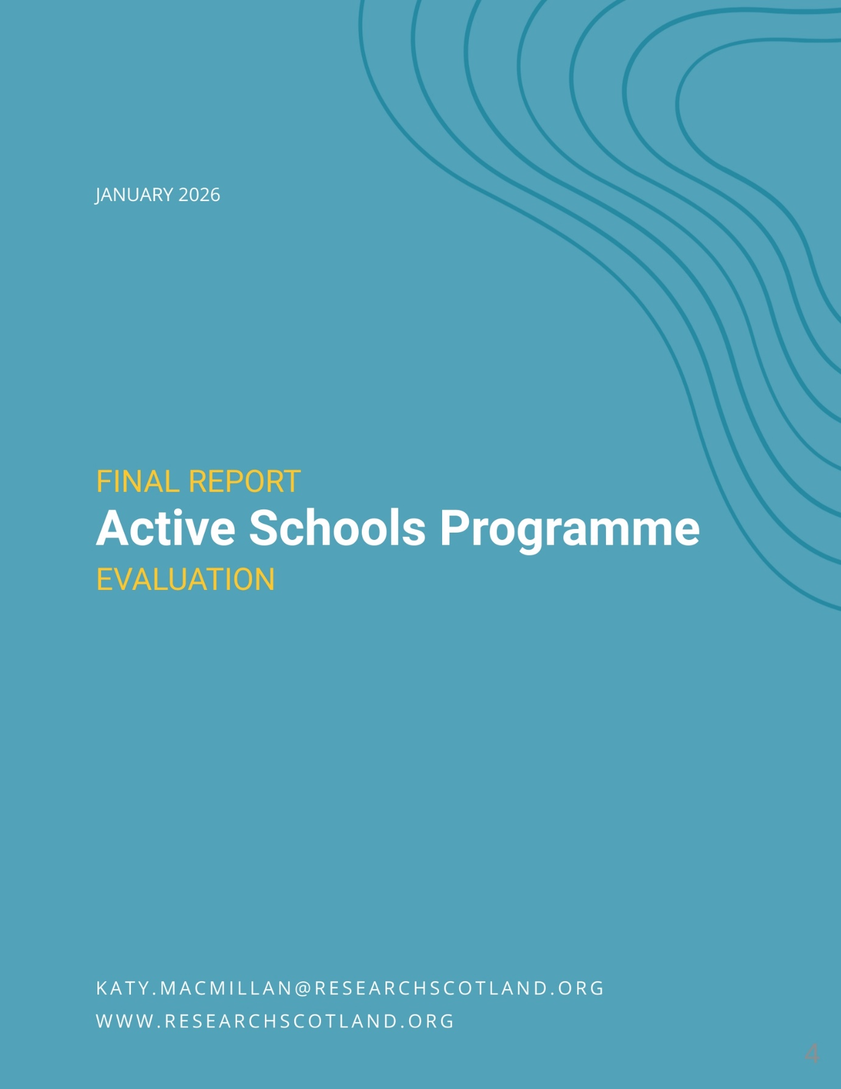

Contents

Summary i
1. Introduction 1
2. Active Schools delivery and participation 4
3. The difference Active Schools makes 14
4. The Active Schools model 29
5. Strengthening Active Schools 44

Summary

Key findings

Active Schools is getting young people more active. 280,000 young people were involved in 2024/25, and almost half of Active Schools participants say they would be less active without Active Schools. The health and wider benefits of being active are well researched and evidenced. However, Active Schools is not reaching everyone to the same extent – with under-representation and differing outcomes for girls and young women and young people with additional support needs (ASN). These groups are known to be less likely to be active.

Active Schools is contributing significantly to education and learning outcomes, including supporting attendance and engagement at school. This is highly valued by school staff, and is often happening through targeted activity with the least engaged pupils. Active Schools also supports inclusion, a sense of community, friendships and connections. Leadership activity is also having a significant impact on young people’s skills, qualifications, aspirations and opportunities. ASN schools are less positive about impact and the Active Schools model than other schools.

Developing the model

The Active Schools model is highly valued and respected. When schools were asked about priorities for the future for Active Schools, there were many mentions of ‘continue’, ‘more’ and ‘expand’. Schools, Active Schools teams, wider stakeholders, and those involved in the broader horizon scanning exercise, felt that Active Schools was an established, well respected and strongly supported programme which was highly regarded. Stakeholders felt that there were real opportunities to build on strengths in the Active Schools model around inclusion; leadership opportunities; supporting physical activity health and wellbeing; supporting learning outcomes; and community connection and reach.

To help Active Schools refine its model, stakeholders suggested:

- greater clarity of expectations around whether Active Schools is a universal offer for all children and young people, or whether support should be targeted at those most in need, most disengaged or most inactive
- considering development of the volunteer model to incorporate more direct delivery by paid, skilled staff (to support quality, range and inclusion); more training; and national support for engaging volunteers;
- building on highly valued leadership activity to clearly link it with skills development, recognised qualifications, inclusion, work experience and pathways to employment;
- better demonstrating the difference that Active Schools makes – moving from measuring participation and activity numbers, to outcomes; and
- sharing practice and ideas between Active Schools teams beyond Manager level, sharing ideas, training and recognising the success of teams, volunteers and participants at national level.

Introduction

1.1 About this report

This report sets out findings from an evaluation of the Active Schools programme, undertaken by Research Scotland for sportscotland in autumn 2025.

1.2 Evaluation aims

sportscotland commissioned an evaluation of the Active Schools programme, exploring the impacts and challenges of the current approach. The overarching aim of this evaluation report is to explore:

What are the impacts and challenges of the current Active Schools programme?

The report explores the five current Active Schools priority areas of:

- high quality opportunities
- pathways
- inclusive opportunities
- network of volunteers
- leadership opportunities.

It also explores evidence about impact in relation to key policy priorities including sport and physical activity; health and wellbeing; education and learning; and inclusion and community.

This – alongside a wider horizon scanning piece of research which explores key drivers for change – will inform exploration of the future focus of and models for Active Schools beyond 2027.

1.3 Method

This evaluation report involved:

- A desktop review – This included a review of monitoring information held by sportscotland, evidence submitted by Active Schools teams, existing qualitative data gathered through the Active Schools manager survey, and wider contextual reports, plans and strategies.

- Online surveys – Surveys were issued to all schools in Scotland, Active Schools Managers (ASMs), Active Schools Coordinators (ASCs), deliverers and sportscotland staff. Deliverers responding to the survey included club coaches, pupils, family members, teachers, students and others.

Responses were received from:

- Individual interviews – To gather more depth, we held 25 interviews with ASMs, ASCs, local authorities, leisure trusts, Scottish Governing Bodies for sport (SGBs), teachers and equalities organisations. We also held 25 wider horizon scanning interviews with strategic stakeholders not directly connected with Active Schools, which fed into this report.

- Focus group discussions – We held discussion groups with the Young People’s Sport Panel and equalities organisations.

1.4 Context

This is a timely stage to review the Active Schools programme. 2024/25 was the 20th year of Active Schools. Partnership agreements between sportscotland and local authorities, which include Active Schools delivery, currently run to 2027.

The context in which Active Schools is delivered is also changing. In late 2024, Scotland introduced a new Physical Activity for Health Framework. The Framework aims to build physical activity into the system and has an aim of ‘health in all policies’.

The overarching vision of the new Framework is “More People, More Active, More Often” – which is the same as the previous Active Scotland Outcomes Framework. However, it has a much clearer focus on inactivity – aiming to achieve a 15% reduction in the prevalence of physical activity by 2030.

The Framework also clearly recognises that levels of physical activity can be increased by people moving more in any way – whether through active travel, walking, cycling, dancing, playing or sport.

The Framework aims to prioritise funds to target the least active – which research shows includes women, older people, people living in the most deprived areas, disabled adults, people with mental health challenges and people from diverse ethnic communities.

Specifically in relation to schools, the Framework aims to create active places of learning using a ‘whole of school’ approach. This means supporting physical activity through the day (beyond physical education), including after school activities, active travel, and connecting to pathways of activity in local communities. This has clear connections to Active Schools, which is recognised within the Framework as making a contribution through providing a range of opportunities for children and young people to take part in sport and physical activity beyond the classroom.

In May 2025, sportscotland updated Sport for Life to take account of the new Framework.

Although this provides clear strategic context for Active Schools, much of this work has taken place within a very challenging environment. There have been intense pressures on public services, due to economic issues around inflation, cost of borrowing and global political instability. At the same time needs have been impacted by the cost of living crisis, demographic change and the effects of the Covid-19 pandemic.

Research has shown that these issues have had a clear impact on the sport and leisure sector. Financial challenges have resulted in declining local authority investment in leisure and culture services, due to the need to prioritise, make savings and create efficiencies.

This context means that all services, including Active Schools, increasingly require to be delivered in a way which is focused on needs, contributes to local and national priorities and clearly demonstrates impact. This will include the Physical Activity for Health Framework priorities, but also potential contributions to other priorities including tackling poverty, closing the poverty related attainment gap and tackling wider inequality and disadvantage.

A horizon scanning report exploring 15 trends likely to affect Active Schools over the next five years has been produced, and is available separately.

Active Schools delivery and participation

2.1 Introduction

This chapter explores the Active Schools programme, priorities, activities, participants and deliverers. It sets the context to exploring Active Schools impact, model and challenges later in the report.

2.2 Active Schools

The Active Schools programme aims to:

- create more and higher quality opportunities to participate in sports before school, during lunchtime and after school
- develop effective pathways between schools and clubs in the local community.

Active Schools is part funded by Scottish Government through sportscotland. Over £12 million is invested by Scottish Government and over £4 million by partners. Partnership agreements are in place with all 32 local authorities to March 2027.

Active Schools has five priority areas that are consistent across all 32 local authority teams. Active Schools:

- provides high quality opportunities for all young people to take part in sport & physical activity before school, at lunchtime and after school
- develops, leads and supports effective pathways to connect schools, clubs and communities
- provides inclusive opportunities by using targeted approaches to remove barriers to participation
- develops a network of volunteers to deliver activity sessions
- develops and supports leadership opportunities for young people

sportscotland works in partnership with all 32 local authorities to invest in and support the Active Schools network. The network consists of over 400 managers and coordinators dedicated to developing and supporting the delivery of quality sporting opportunities for children and young people.

Locally, Active Schools teams have their own priorities within the overarching aims of the programme. These priorities depend on local needs, issues and contexts, and include:

- target groups such as disabled young people, girls and young women, young people from diverse ethnic communities, those with care experience or experiencing poverty, LGBTQ young people or inactive young people
- themes such as leadership, community engagement, inclusion, equality, volunteering and skills development
- ways of working such as partnership, relationships and workforce development.

2.3 sportscotland priorities and Active Schools

sportscotland is the national agency for sport in Scotland. It is a public body funded by Scottish Government and the National Lottery. It aims to build an active Scotland where everyone benefits from sport, and increase the number and diversity of people participating, progressing and achieving in sport.

Sport for Life is sportscotland’s corporate strategy, launched in 2019 and updated in 2025 in line with Scotland’s new Physical Activity for Health Framework. It emphasises that sportscotland aims to support people to find ways to be physically active every day. An important part of this is making sport more accessible for people who don’t take part, and supporting people to progress to the level that they choose – whether this is walking, recreational activity, joining a club or competitive sport. A commitment to inclusion underpins everything sportscotland does.
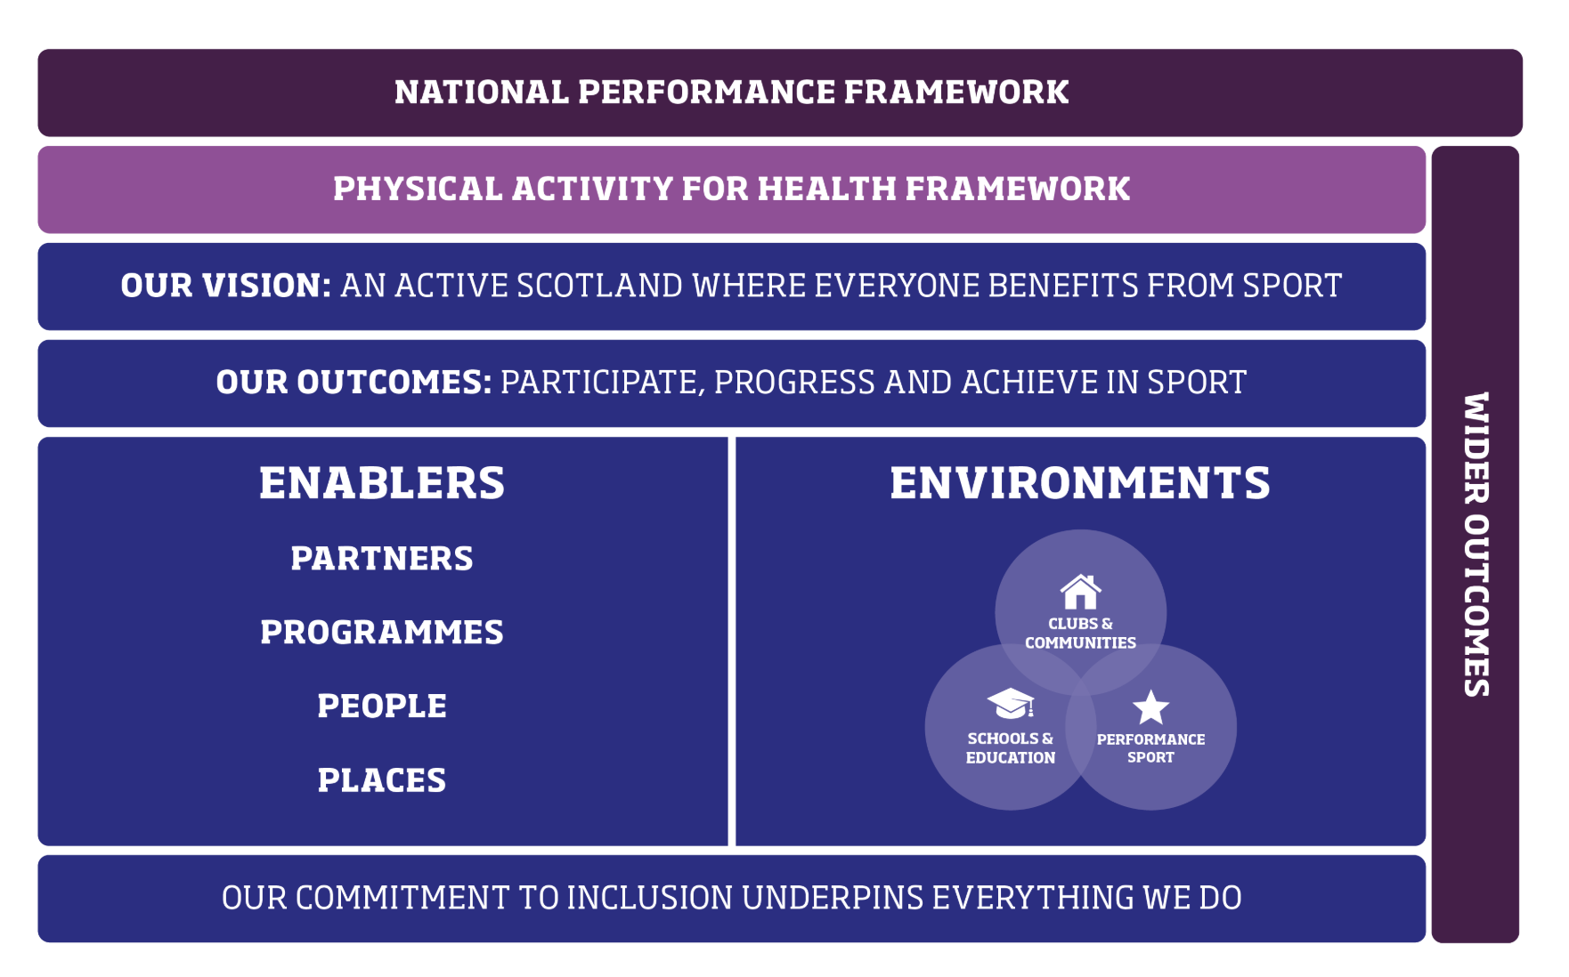

sportscotland works in three main environments – schools and education; clubs and communities; and performance sport. Within the schools and education environment, sportscotland aims to help build competence and confidence in sport by providing positive sporting experiences at schools, colleges and universities.

2.4 Local authority partnership agreements

sportscotland developed customised partnership agreements with each local authority from 2023 to 2027, to deliver national and local outcomes and priorities for sport and physical activity. These include work on a range of priorities including Active Schools, Community Sport Hubs, equality, diversity and inclusion, planning for sport strategically and taking an integrated approach to the school and sports facilities estate. Although the content of the partnership agreement varies, Active Schools is consistently referenced across all 32 partnership agreements.

The partnership agreements set out the national context – which in 2023 related to the Active Scotland Outcomes Framework, sportscotland’s corporate strategy Sport for Life and equality, diversity and inclusion priorities. Each partnership agreement also sets out the local strategic context, including:

- local authority corporate plans and Local Outcome Improvement Plans
- physical activity and sport strategies at local level
- education priorities and strategic outcomes.

The partnership agreements set out the overarching aim of Active Schools as increasing the number and diversity of children and young people taking part in sport and physical activity. Annual plans focus on a range of priorities related to Active Schools, linked to different local priorities. For example:

- in one area the agreement is strongly linked to reducing the experiential poverty related gap within the city
- in one area there is reference to targeted work with those with lowest activity levels, people living in poverty and people with a disability or additional support need (ASN)
- in one area there is strong reference to targeted work on inclusion
- in one area there is a strong focus on improving health and wellbeing
- in one area local priorities around anti-poverty support, physical and mental health and inclusion for disabled people and young people with care experience are woven through the partnership agreement and action plans.

The partnership agreements also set out how sportscotland will work together with each local authority. Each year, a formal review of the partnership agreement takes place. An annual action plan is also developed.

The duration of most partnership agreements is April 2023 to March 2027. In one authority the agreement was annual until a two year agreement was put in place for 2025 to March 2027.

2.5 Active Schools activities

The information in this section is based on data collected at national level. It is important to note that this data includes national level information about activities which take place out of school time – before school, during lunchtime and after school. Importantly, it does not include activity which happens during the school day. This means that some activity – for example some activity with young people with ASN, young people who are disengaged from school, young people who may benefit particularly from Active Schools school time engagement or activity out of the school term – is not included in this information. Patterns of activity and participation also vary considerably between local authority areas.

Number of sessions and visits
In 2024/25, Active Schools hosted at least 265,000 sessions and 5 million pupil visits. These figures increased each year from 2021/22, as Active Schools delivery recovered from the pandemic. Sessions mainly take place after-school (55%) and at lunchtime (34%).

 | 2021/22  (Covid recovery) | 2022/23 | 2023/24 | 2024/25
Sessions | 179,000 | 247,000 | 262,000 | 265,000
Visits | 3.5 million | 4.7 million | 4.9 million | 5 million
Average visitors per session | 20 | 19 | 19 | 19

Before the pandemic, the number of Active Schools sessions previously peaked at almost 398,000 in 2018/19. That year there were 7.3 million visits to Active Schools sessions – an average of 18 visitors per session.

Sessions and visits by activity
In 2024/25, more than a quarter of Active Schools sessions were football. The pattern of visits closely followed the activities offered.

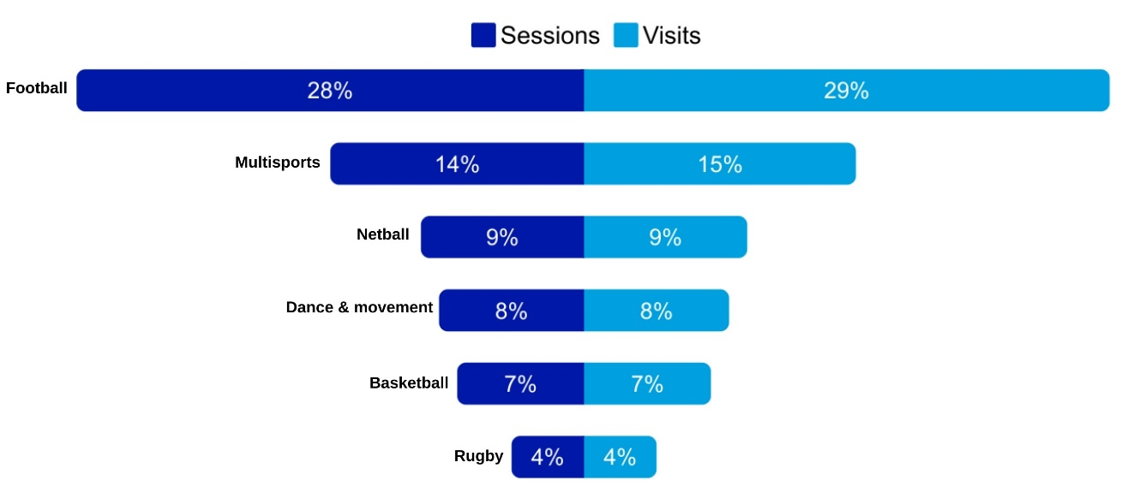

There were a wide range of other sessions including activities such as tennis, table tennis, volleyball, running, gymnastics, hockey and athletics.

2.6 Participants

Active Schools participants
A core aim of Active Schools is to increase the number and diversity of children and young people taking part in sport and physical activity.

In 2024/25, Active Schools engaged with 280,000 children and young people, supporting them to be more active. In 2024, there were just over 702,000 pupils in Scotland. Active Schools therefore engaged with 40% of all pupils in Scotland during 2024/25. This includes all pupils in primary, secondary and ASN schools.

Participation is higher in primary schools, compared to secondary and ASN schools. Participation in the four years to 2024/25 saw a clear peak at the primary 7 stage, and a sharp decline in secondary school settings.

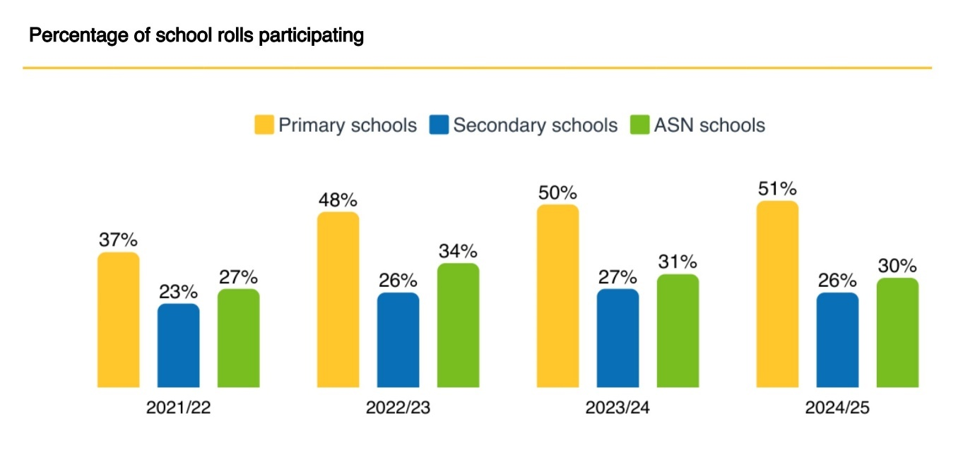

It is important to note that participants could have been engaged at any level – attending a session, participating in a block, or ongoing in-depth activity.

Trends in participation
Active Schools participation has increased since 2021, when participation levels were beginning to recover from the Covid-19 pandemic.

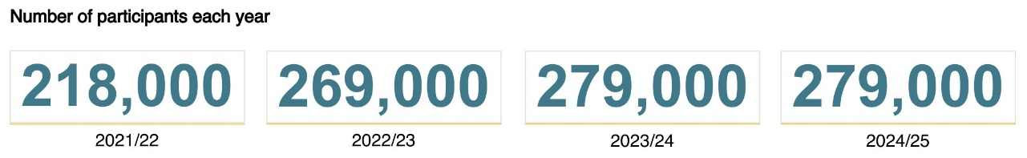

Data is not available for 2019/20 and 2020/21 due to the pandemic. However, data from pre-2020 shows that participation levels peaked in 2018/19 at 45% of the school roll with 313,000 young participants.

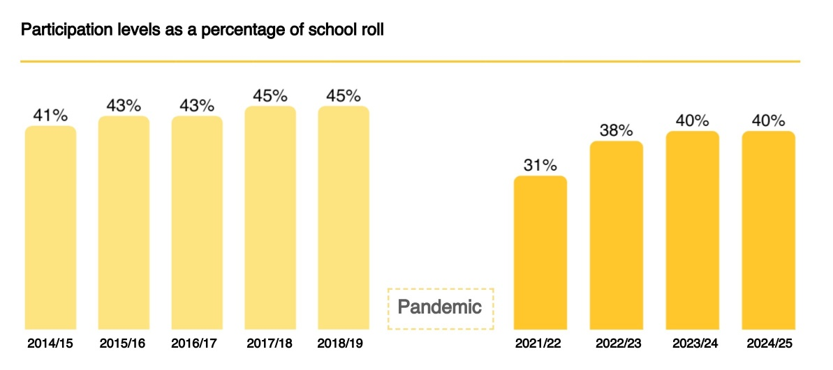

In 2024/25, the percentage of the school roll engaged in Active Schools differed between local authorities, ranging from 24% to 59%.

Participation of girls and young women
In 2024/25, 47% of participants were female, and 53% were male. This means that Active Schools was engaging 42% of the male school roll and 38% of the female school roll.

Boys and young men also attend more often. In 2024/25, 56% of visits were by males, and 44% by females. This trend is seen right back to 2014/15.

For primary schools, over the ten year period from 2014/15 to 2024/25, the proportion of participants who are female has remained at 48 to 49%, and the proportion male at 51 to 52%.

For secondary schools, the proportion of female participants increased over time from 2014/15 to 2018/19 – from 44% to 46%. However, after the pandemic the proportion of participants who are female decreased to 43% in 2021/22, and fell to 42% for 2023/24 and 2024/25.

This is a significant gap. For example, in 2024/25, there were more than 46,000 male secondary school participants in Active Schools, and less than 34,000 female participants. This is a gap of more than 12,000. The participation gap increases in older age groups.

Participation patterns mirror national data on physical activity levels in girls and young women. Males are more likely to meet physical activity guidelines, and participation levels in physical activity decline significantly at secondary school age for females.
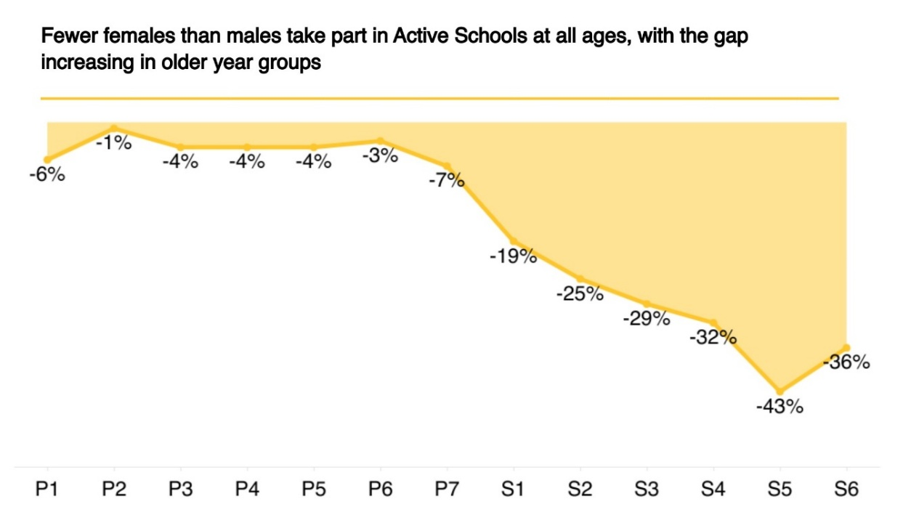

Males and females also attend different activities. Football was the most attended activity for boys, accounting for more than 1 million visits. For girls and young women, the most attended top activities included netball, football, multi-sports and dance and movement.

Male top 5 activities | Female top 5 activities
Football – 1,072,375 | Netball – 401,760
Multi-sports – 392,689 | Football – 374,237
Basketball – 264,993 | Multi-sports – 348,653
Rugby – 166,235 | Dance and movement – 327,789
Badminton – 147,254 | Basketball – 84,592

Detailed analysis shows that some local authority areas have a 50/50 split between males and females, or are close to this. Most of these areas have multi-sports making up a high proportion of sessions. Some of the areas with the lowest engagement of female participants have a very high percentage of visits to football sessions.

It is worth noting that the availability of volunteers skilled in relevant sports, to deliver sessions, will impact on this pattern.

Wider participation of under-represented groups
Pupils with ASN are under-represented in Active Schools participation. In 2024/25, although more than a third of school pupils had ASN, the proportion of Active Schools participants with ASN was lower, at just over a quarter. However, this proportion has increased since 2021/22 – from 20% to 27%.

Pupils from diverse ethnic communities are well represented in Active Schools participation. In 2024/25, 12% of school pupils were from diverse ethnic communities, while 14% of Active Schools participants were. This trend has been the same since 2021/22.

Pupils from the most deprived areas are equally represented in Active Schools participation. The proportion of school pupils from the 20% most deprived areas is roughly the same as the proportion of Active Schools participants from the most deprived areas, and has been since 2021/22. This figure was 22% in 2024/25.

These trends show the national picture for Active Schools, and will vary between local authorities.

2.7 Deliverers

In 2024/25, there were almost 20,000 people delivering Active Schools activities. The highest proportions of deliverers were secondary school pupils (31%) and teachers or school staff (31%). The number of deliverers has been increasing since the pandemic. Before 2020, the number of deliverers had been growing to a peak of 23,500 in 2018/19.

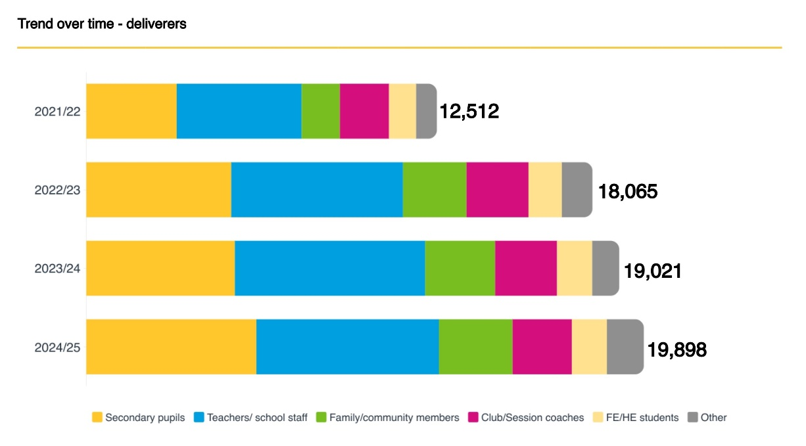

Local evidence also shows that primary school pupils are increasingly delivering Active Schools activity. For example, one area highlighted that 50% of its extra-curricular activities for p1 to p3 pupils was delivered by primary school pupils trained as playground leaders.

The proportion of deliverers who are voluntary has been increasing – to 92% in 2024/25. At the same time, the proportion of deliverers who are qualified (for example through SGBs, SQA, PE, further education, higher education or dance and fitness qualifications) has been decreasing.
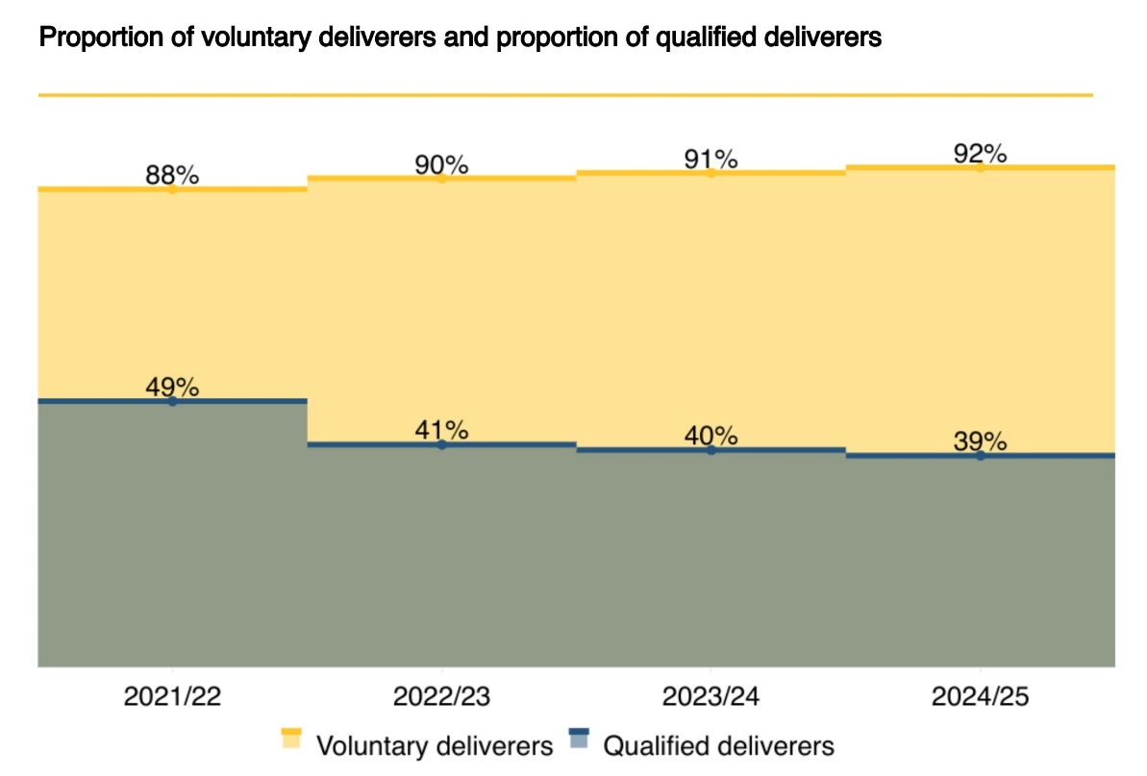

2.8 School to club links

Overall, in 2024/25, 9% of Active Schools sessions were delivered by clubs. This compares with 10% the two previous years, and 11% in 2021/22. More than 1,000 schools had at least one school to club link.

 | 2021/22 | 2022/23 | 2023/24 | 2024/25
School/ club links | 2,215 | 2,495 | 2,458 | 2,479
Clubs connecting with schools | 524 | 628 | 642 | 632
Schools connecting with at least 1 club | 1,003 | 1,164 | 1,158 | 1,092

In 2024/25, two thirds of school to club links related to football or rugby, and ten per cent related to multi-sports. A smaller proportion related to other sports such as basketball, dance, judo, tennis, golf, karate, cricket, running or badminton.

There were more school to club links for the activities most frequented by boys and young men, than girls and young women.

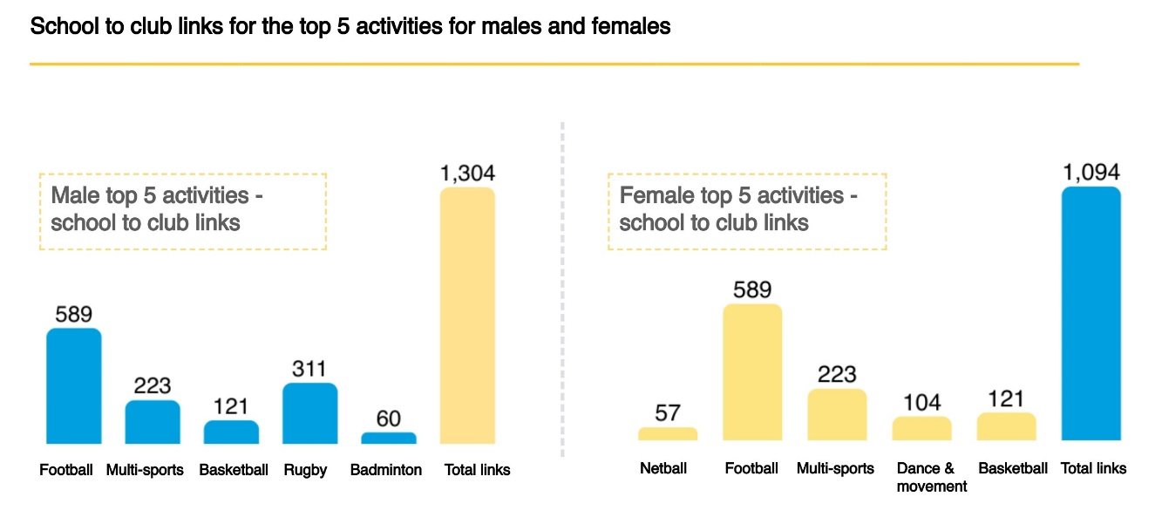

It is important to note that the links that can be made from schools to clubs depends on the infrastructure of clubs available locally. For example, Netball Scotland shows 38 clubs (junior and senior) across Scotland. In contrast, the Scottish Youth Football Association has approximately 4,000 registered teams for young players.

The quality of pathway for males and females within these clubs is not known here. For example, in football there are approximately 160,000 junior grassroots participants registered, of whom 15% are girls and young women.

  - Leadership programmes

A total of almost 27,000 young people were involved in local authority leadership programmes in 2024/25. This is higher than just over 24,000 involved in 2023/24 (when monitoring began for this indicator).

The leadership programmes involve a slightly different profile of young people than broader Active Schools participation. In 2024/25:

- more young women (52%) than young men took part – higher than broader Active Schools participation
- 27% of participants had ASN – (the same as in broader Active Schools participation but lower than the proportion of the national school roll with ASN)
- 10% were from diverse ethnic communities – lower than broader Active Schools participation
- 20% were from the 20% most deprived communities – lower than broader Active Schools participation.

The difference Active Schools makes

3.1 Introduction

This chapter explores the difference that the Active Schools programme makes, focusing on the themes of physical activity, health and wellbeing, education and learning and inclusion and community.

3.2 Participation in physical activity

Impact on physical activity through Active Schools
In 2024/25, Active Schools:

- engaged 280,000 children and young people in physical activity
- involved 40% of the total school roll in Scotland 2024/25.

In 2019/20, sportscotland undertook a major survey of Active Schools participants to explore the impact of taking part.

44% of pupils said that they would be less active without their Active Schools activity – with the remainder saying they would find another way to be active. Pupils from the most deprived areas and secondary pupils were most likely to say they would be less active without Active Schools.

67% of pupils said Active Schools helped them to be more active outside of school. This was lower for those in the most deprived areas, and for secondary school pupils.

94% of pupils said Active Schools made them want to keep being active as they grew up.

49% of pupils said Active Schools helped them get interested in other sports and clubs. This was lower for pupils in the most deprived areas, and for secondary pupils.

Figures from the 2019/20 survey suggest that Active Schools activity itself supported more participants to meet physical activity guidelines. The biggest change in inactivity was for pupils in the 20% most deprived areas and for females.

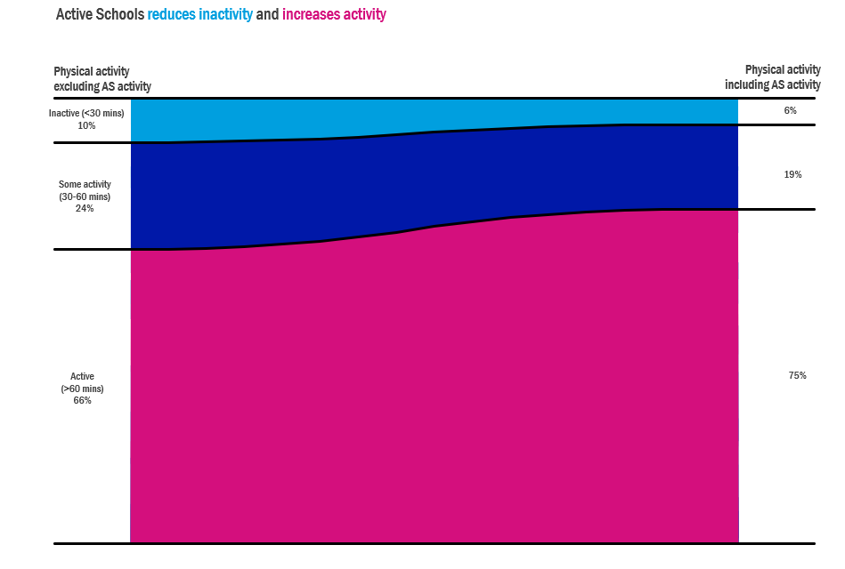
Note: Inactive (<30 mins per day, Some activity (30-60 mins per day), Active (>60 mins per day)

Stakeholder views on physical activity impact
Schools and the Active Schools network were positive about the impact Active Schools has on young people’s physical activity levels. Most schools were very clear that Active Schools helped to support physical activity levels among their pupils. Some said that without Active Schools there would be little or no sport or physical activity extra-curricular activities at their school.

“
There’s no way we’d have anything close to the number of kids we’ve got engaged in extra-curricular sport if it wasn’t for Active Schools.” Secondary school

“
Without free after school clubs in our school – the majority of our children would not participate/ try out any new sports or take part in physical activity.” Primary school

Active Schools teams also highlighted that the programme supported young people to be active in a way that suited them, in an inclusive, fun, safe and supportive environment. This helped increase physical activity levels and reduce inactivity.

“
Without Active Schools activities, the cluster inactivity levels would be huge.” Active Schools team member

Some Active Schools teams said activity was planned purposefully to get young people active, focusing on engaging those less likely to take part or who were not already involved. Many of the examples given of impact on physical activity levels for inactive young people related to targeted, small scale and in-depth work, rather than universal activity. Wider stakeholders also felt that Active Schools played an important role in building physical activity rates, and contributing to physical health.

Example: Supporting engagement with physical activity
In one area, Active Schools undertook specialist work which involved in-depth bespoke support to young people with care experience and young carers. A cohort of 10 to 15 young people was selected and received one to one support, and new social sessions with peer games were also introduced. Some of the young people taking part received a free leisure membership. Through the project, young people have achieved qualifications, started volunteering and achieved awards, found new passions and improved their wellbeing.

“I think its awesome I get to play sports cause I never did that before.” Young person

Example: Building physical activity habits
In one area, targeted inclusion work through the Active Schools team supported 56% of participants to transition into regular physical activity. The team prioritises support for those who have taken part in this programme, helping them to maintain consistent engagement with physical activity. Building strong, trusting relationships with young people is a crucial aspect of the approach.

A young person’s Active Schools journey
Ellee* first took part in Active Schools when she took part in an after school ski programme. At first, she struggled with confidence, often became upset and didn’t fully participate. Over time, she tried a wide range of Active Schools activities including athletics, badminton and netball. She took part in the Active Schools dance competition, joined the netball team and took part in a competitive Active Schools cross country event. Sport gave Ellee the chance to shine, and she feels included and motivated through sport.

“Oh my, sport has changed my life.” Young person

“The support of Active Schools and her family has clearly had an impact. She is engaging more in conversation – approaching staff to share her achievement.” Teacher
*Name changed to protect identity

Example: Active Schools support for pupils with ASN
In one area, Active Schools delivered inclusive community and school dance sessions for parents, carers and young people with additional support needs. Active Schools also supported pupils with additional support needs from enhanced learning resource classes to take part in other sessions within schools and the community.

The team found that almost all participants improved their mental health, confidence, physical health and overall wellbeing. For some, young people also saw improvements in their coordination, balance, flexibility, endurance and strength.

“I feel relaxed.” Young person

3.3 Impact on health and wellbeing

National evidence on health and wellbeing impact
sportscotland’s national survey in 2019/20 found that Active Schools made a significant difference to young people’s health and wellbeing.

- 97% said taking part in sport and physical activity helped them feel healthy
- 89% said it helped them feel confident
- 88% said it helped them feel happy.

There is very clear evidence and strong research that demonstrates that physical activity and sport can bring about positive change to people’s health and wellbeing.

There is a range of research which highlights the positive relationships between physical activity and various aspects of health. Across the life cycle, it can prevent premature death and chronic diseases; reduce blood pressure, osteoporosis, obesity and risk of stroke, colon cancer and cardiovascular disease; and improve psychological wellbeing, coronary blood flow and protect against post-menopausal breast cancer.

The UK Chief Medical Officer has highlighted that there are clear benefits of physical activity for children, for which there is moderate to strong evidence. These include improving bone health, cognitive function, cardiovascular fitness, muscle fitness, weight status and depression. Research has also found that children and young people taking part in sport have fewer mental health, emotional, behavioural and peer-relationship problems and demonstrate more positive social behaviours.

Evaluation evidence on health and wellbeing impact

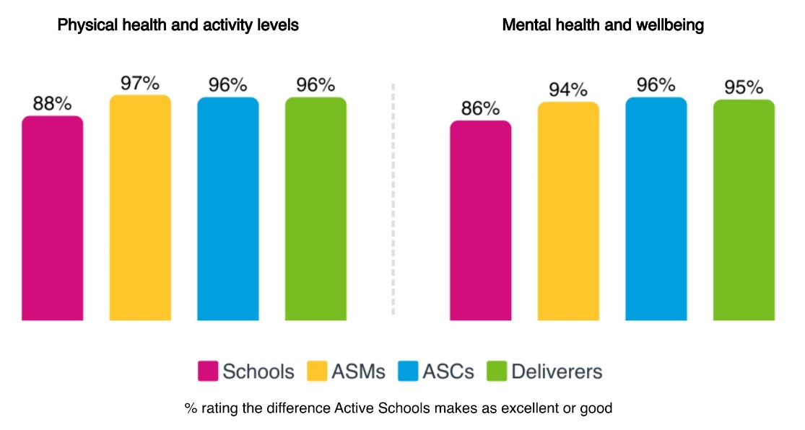
Schools felt that Active Schools supported physical and mental health, built positive relationships, supported emotional regulation, boosted positive mindsets, helped young people learn about healthy lifestyles, and built confidence and resilience. Schools also highlighted that being active helped young people with their mood, mindset and confidence. Schools in the 15% most deprived areas rated impact more highly and ASN schools rated impact more poorly.

“
Young people's physical, mental health and wellbeing is enhanced; their confidence and wellbeing is raised.” Secondary school

Active Schools teams highlighted that being active would have a significant impact on young people’s physical and mental wellbeing. This includes increased fitness, strength and coordination; reduced stress and anxiety; emotional regulation and feelings of being able to cope; and increased energy. Wider stakeholders also felt that Active Schools played an important role in building physical activity rates, and contributing to physical health.

Some young people talked about how Active Schools supports their mental health and emotional wellbeing, through being active or talking about emotions due to strong, trusting relationships developed as part of targeted work.

“
I feel calmer and more relaxed after my sessions.”
Young person

“
It made me feel so calm and happy.”
Young person

“
It is very fun, love the teacher. She is caring and loving, she also makes me feel at peace. I love dancing because it helps you express your feelings.” Young person

Example: Active Schools support for pupils with ASN
In one area, Active Schools delivered inclusive community and school dance sessions for parents, carers and young people with additional support needs. Active Schools also supported pupils with additional support needs from enhanced learning resource classes to take part in other sessions within schools and the community. The team found that almost all participants improved their mental health, confidence, physical health and overall wellbeing. Some young people also saw improvements in their coordination, balance, flexibility, endurance and strength.

“I feel relaxed.” Young person

Example: Exam support
In one area, Active Schools organised stress buster sessions for pupils. This included tennis, Hyrox and gym sessions and provided the opportunity for pupils to clear their heads and spend time with friends.

Example: Supporting mental health
In one area, Active Schools worked to empower young women aged 12 to 18 who were experiencing mild to moderate mental health challenges such as stress, anxiety or depression. Over six weeks, participants attended sessions combining movement and education. A physical activity segment was designed to be enjoyable and engaging, followed by a class based segment on coping strategies and life skills. Overall 100% of participants felt healthier, 100% expressed greater confidence to exercise and 66% reported increased energy.

“Felt like a break from school but still learning and trying new things. A lot more flexible and relaxed than learning in school.” Young person

Example: Targeting broader health and wellbeing
In one area, a pilot approach to upscaling Active Schools involved creating a Health and Wellbeing Assistant programme in 14 primary schools. Assistants worked directly with students to provide a mix of traditional sports, non-traditional activities and team building. The approach involved working with young people and their families – targeting young people with care experience, family clubs and young people with additional support needs.

“It was the best moment of my week and I am so happy I now attend a club in the school.” Young person

3.4 Impact on education and learning

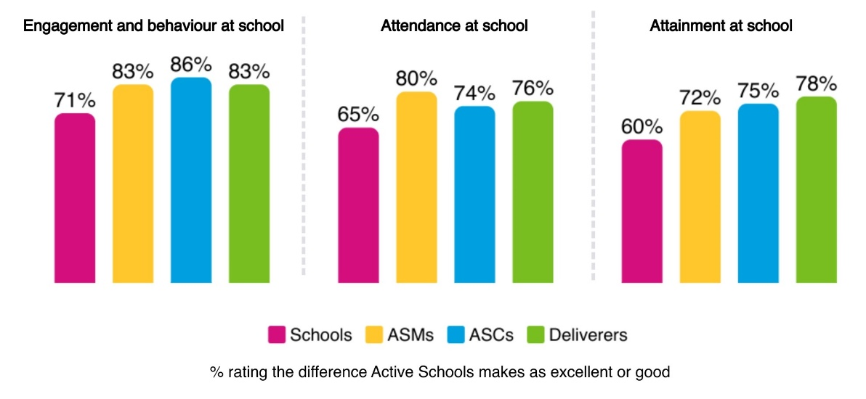

Schools were positive about the impact of Active Schools on engagement, behaviour, attendance and attainment. There were no major differences in response between primary, secondary and ASN schools and schools in the 15% most deprived areas.

In addition, most schools said that Active Schools aligned a lot with education outcomes (75%) and contributed a lot to school culture and ethos (78%). Schools indicated that Active Schools contributed to the experiences and outcomes in Curriculum for Excellence and aligned well with Getting it Right for Every Child, the United Nations Convention on the Rights of the Child and Pupil Equity Fund priorities. When talking about the difference that Active Schools made to their school, school staff often used words like ‘value’, ‘rely’ and ‘depend’.

“
They are a vital part of our school community.”
Primary school

“
They are involved in many aspects of the school life.”
Secondary school

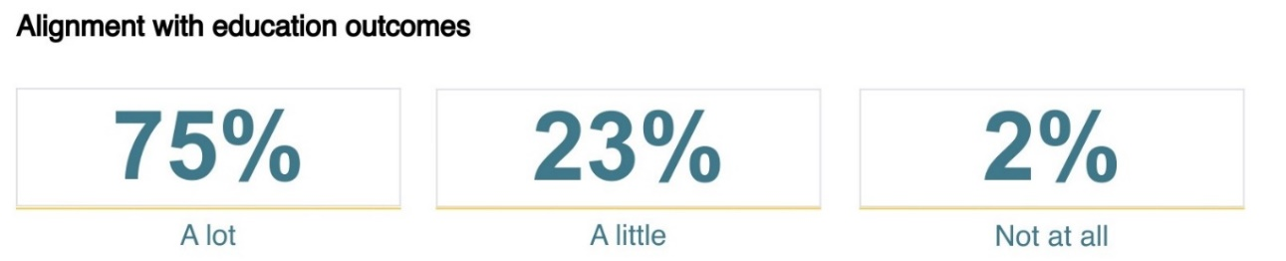

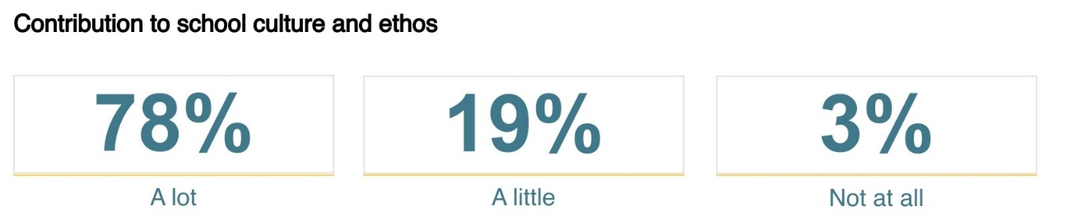

Engagement, behaviour and attendance
Schools were very clear that Active Schools was supporting:

- engagement with learning and positive behaviour – through movement breaks and physical release, building concentration levels and managing stress and mental wellbeing
- attendance at school – encouraging children and young people to come to school on days that Active Schools sessions are on.

“
We have noticed a marked improvement in overall wellbeing, attendance and engagement in school through participation with Active Schools provisions. Particularly targeted provision throughout the school day.” Primary school

“
We have also observed some improvements in behaviour within school, as pupils benefit from the structure, teamwork, and sense of achievement that these activities provide.” Primary school

Many schools mentioned that pupils who may not always attend school, attend better on days when Active Schools sessions run.

“
Pupils involved in Active Schools activities often show better attendance, as participation fosters a stronger connection to school life.” Secondary school

“
We have a few children who only come to school on the days that an Active School Club is on. It opens many opportunities for some children.” Primary school

Young people agreed that sport and physical activity could encourage them to attend school.

“
Sport can encourage people to stay in school.” Young People’s Sports Panel member

“
I’ve not been going to school as often recently, but knowing this is on a Friday makes me want to come in – I don’t want to miss it.” Young person

Example: Supporting attendance and inclusion
One Active Schools team talked about the introduction of Active Schools and Community Partnership Officers (ASCPOs) which aim to support and strengthen understanding of inclusion in and through sport. The work focuses on contributing to meeting priorities outlined in the council’s Children’s Services Plan, aiming to mitigate child poverty, and support children and young people experiencing poor mental health, disengaged or at risk of disengagement from education, and young people with care experience. This work involves intentionally using sport as a vehicle to promote attainment, inclusion, and school attendance, with work targeted in areas off high deprivation.

Example: Engaging disengaged Pupils
In one area, Active Schools engaged with a group of S2 and S3 pupils at one school for six weeks, working with them for two periods each week. The programme aimed to build relationships, boost motivation and guide students towards positive outcomes through physical activity, team building and role models.

By the end of the programme, several students showed marked improvements in attendance and engagement with school. One student moved into the local authority Leadership Academy, resulting in further increases in attendance and academic performance. Young people also felt more motivated and confident about their future.

Example: Breakfast club
In one area, a school breakfast club was introduced on a Friday morning, as this was a day with particularly poor attendance. This was provided by a local boxing fitness class, and pupils receive food and physical activity. This has ensured that pupils turn up at school and engage in positive activities – and has been successful.

Attainment, skills and achievement opportunities
Schools felt that Active Schools had an impact on the learning environment through:

- offering opportunities for children to achieve and do well in different aspects of school life
- developing new skills appropriate for learning – including confidence, resilience, teamwork, leadership skills, qualifications and accreditations and building a sense of responsibility
- supporting attainment – through developing skills for effective learning and offering further learning and qualification opportunities.

“
It has improved relationships between pupils and also given pupils an opportunity to achieve and feel successful outside the classroom setting.” Primary school

Schools highlighted that Active Schools provided young people with opportunities to gain further skills and qualifications out of normal class subject time, and could support achievement of awards such as Duke of Edinburgh awards. Schools felt that these skills and qualifications contributed to pupil attainment, and that the skills around motivation, perseverance, self-discipline, teamwork and leadership could be transferred into other areas of the curriculum.

“
Active Schools has supported our attainment with Young Leaders, SFA Coaching courses and lots of other opportunities for pupils.” Secondary school

“
The opportunities provided by ASC allows pupils in our school to develop their meta-skills further in various settings. These skills prepare the children for the world of work and are skills for life.” Primary school

A few secondary school staff mentioned that Active Schools opportunities supported PE learning in upper school, through providing opportunities to develop skills and try a wider range of sports.

“
The uptake of girls doing physical activity has increased massively, due to netball club & girls rugby. These girls are now all using these sports for their National 5/ Higher PE one off performances, which is worth 50% of their final grade.” Secondary school

Active Schools teams agreed that the programme provided opportunities for pupils to achieve, and build skills for learning – resilience, teamwork, motivation, discipline and confidence.

Example: Supporting literacy
In one area, Active Schools supported four pupils who were not engaging in literacy and reading tasks, and were below target for reading ages and literacy attainment. Active Schools staff held weekly quiet reading sessions, working 1-1 with each pupil, followed by 30 minutes of football activity outside, building teamwork and communication skills. This linked with wider school based activities. All four pupils saw an improvement in their reading age, with one increasing their reading age by nearly four years. All pupils went from saying they didn’t enjoy reading, to saying that they do enjoy it.

“The boys are motivated by being part of this group, helping them to build a positive relationships with reading.” Teacher

Young people were clear that they gained skills and qualifications through taking part in Active Schools.

“
Gives people a chance to gain qualifications and skills that they wouldn’t have.” Young People’s Sports Panel member

“
I have gained more confidence and I have also learned how to be more responsible and prepared.” Young person

Many highlighted how important these skills were for the future, thinking beyond school and to future learning and careers. Some talked about specific skills and qualifications for going into sports and physical activity related careers, while others mentioned transferrable skills that would be useful in different roles in the future.

“
Good way to make new skills and path ways for the future.”

It’s good for getting knowledge and practice with coaching.”

I now have confidence in my potential to be a good leader.”

I am gaining valuable leadership experience as I want to work in sport in the future.”

I feel more confident that the skills and knowledge gained will continue to help me throughout college and for future job opportunities.” Young people

Example: Positive destinations
In one area a Winter Leavers Active Schools programme was created to support young people who were planning on leaving school in the winter with low attendance or limited qualifications. One participant was leaving school with no qualifications, and was involved in the justice system. Through the programme, the young person gained 3 SCQF qualifications at level 4 and 5, tried new activities, developed self-confidence and started a college course.

“I enjoyed the qualifications I got, they are the first ones I have ever got. They have helped me get into college after Christmas… I want to take up some of the activities we done, like badminton and boxing, so I keep healthy.”

An Active Schools leadership journey
Evan* started volunteering with Active Schools in S1 following an I Can Lead training event. He regularly volunteered at holiday camps, after schools and supporting PE classes. In S5 he undertook more leadership training including Active Schools Play Leader Mentor Training.

Evan dedicated more than 40 hours annually to Active Schools. To recognise his volunteering efforts, he received a funded space on a National Pool Lifeguarding Qualification course, and passed. He went on to secure a full time job in the leisure and sport field. He also continues to volunteer at holiday programmes.

This example is part of a wider initiative, where volunteers dedicate at least 40 hours of volunteering and are then offered the opportunity to gain a lifeguarding qualification. This has supported skilled young people into local employment, in local leisure facilities.
*Name changed to protect identity

Active Schools teams agreed that their work motivated pupils to come to school to take part in enjoyable activities and provided an outlet for energy or emotions, supporting engagement with school and improved behaviour.

“
Being active helps children to be more motivated, learn better and achieve more at school.” Active Schools team member

“
Through our inclusion projects in schools, we have seen first-hand how the Active Schools programme supports attendance, attainment, and overall engagement in education.” Active Schools team member

A few said that this type of approach worked best when targeted at pupils that need it most, and taken forward as a whole school effort, working closely with teachers and other school staff.

“
Importantly, research shows that physically active children often demonstrate better concentration, improved behaviour, and higher academic performance, making Active Schools a key contributor to holistic child development.” Active Schools team member

An Active Schools leadership journey
Arianna* has been part of the Active Schools leadership programme for 3 years, as a dance leader. She wanted to provide young people with more opportunities to have fun taking part in dance.

“Arianna takes the responsibility of being a dance leader seriously… She has grown hugely in confidence emotionally and physically. She has developed the ability to be assertive and provide guidance and direction to younger children which will help her immensely in her choice of career.”
*Name changed to protect identity

An Active Schools leadership journey
Karis* initially worked with Active Schools through a tailored support plan to enhance engagement in physical activities. At 14, she became a Young Ambassador, coaching local primary pupils. Karis received further training and joined the Active Schools Coaching Academy, where she dedicated over 300 hours of volunteer work out of school hours. Karis found that as her engagement with sports grew, so did her academic performance. She achieved Higher and National 5 qualifications, which she never thought would be possible. Karis went on to secure a Modern Apprenticeship in a health and wellbeing role, completed an HNC in Sports Coaching and Development, and then became an Active Schools assistant.
*Name changed to protect identity

An Active Schools leadership journey
Jess* in S5 takes part in an Active Schools leadership academy.

“Working with the leadership academy is giving me the experience that I will need for in the future as I want to be a PE teacher… It makes me feel proud and I get along with the children and I am able to help them think of new ways to cope with anger and anxiety as that is the areas I struggled with while I was going through a hard time...I can support them to achieve the things I have done, or to make it through the hard times.”
*Name changed to protect identity

A few schools also talked about the difference that Active Schools can make in building confidence and skills to deliver PE session among primary class teachers.

“
As a class teacher PE lessons can be challenging at times and the continued support of Active Schools means that I feel more confident and enthusiastic to push my own boundaries and try out new activities and sports with the children that I may never have tried without them.” Primary school

When talking about the difference that Active Schools made to their school, school staff often used words like ‘value’, ‘rely’ and ‘depend’.

School staff who rated the alignment and contribution lower often said that Active Schools had limited input in their school, their Active Schools team was spread too thinly, that they weren’t sure what Active Schools did in their school, or that it was hard to measure or understand the contribution Active Schools made due to lack of evidence.

School staff emphasised that Active Schools was part of a wider effort to support learning and attainment, and while it contributed, it was not the only or main driver. A few schools said that they didn’t have any evidence to understand the impact of Active Schools, and the measurement currently focused on numbers rather than outcomes. A few schools would like an impact report from Active Schools to understand outcomes for young people.

Many in the Active Schools network also said that it was hard to gauge the impact of Active Schools on attendance, attainment and engagement with school, due to the complexity of the environment with many contributing factors. A few said that this wasn’t the main focus of their activity, and while it might contribute to attendance and attainment at school, this wasn’t something they measured or aimed to achieve.

Wider stakeholders felt that Active Schools could contribute positively to the school experience, particularly through leadership activities, but that data didn’t currently fully capture or evidence the full impact.

3.5 Impact on inclusion and networks

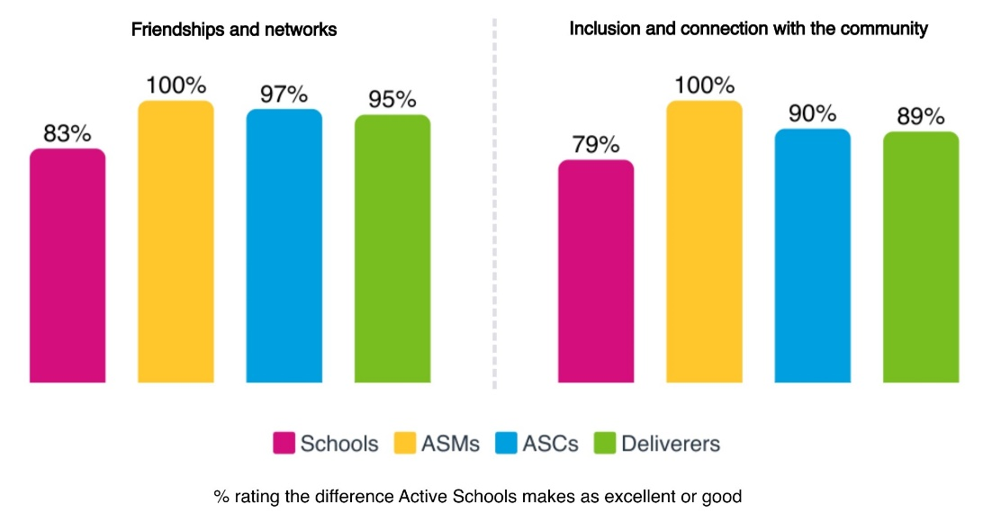

Schools were positive about the impact Active Schools has on young people’s friendships, networks and inclusion within the community.

- Primaries, secondaries and schools in the 15% most deprived areas gave similar ratings.
- ASN schools rated impact on friendships and networks and inclusion within the community lower than other schools.

The sportscotland Active Schools survey from 2019/20 also found that Active Schools participants said taking part in sport and physical activity helped them to:

- make friends – 82%
- feel included – 82%.

Friendships and networks
School staff said that Active Schools:

- supports connections, friendships and networks across stages and ages
- creates a sense of fun in the school environment
- builds safer and more inclusive play at break and lunch for primary pupils.
- helps primary pupils to play well together in the playground and support those who may struggle in these environments
- supports transitions between primary and secondary school.

“
It’s really good for connecting primary and secondary schools and means there’s a familiar face for pupils when they go to high school.” Young People’s Sports Panel member

“
The young play leaders have definitely helped to make playtimes (with no PSA or adult support) much more enjoyable and safe.” Primary school

Young people agreed that they made friends and talked to people through Active Schools.

“
I am more proud that I tried something new and now I am out of my shell more. I am less shy because I have been talking to people I wouldn’t normally talk to.” Young person

“
I made new friendships, and feel more safe and happy after being anxious about coming.” Young person

“
I played with people I don’t usually play with.” Young person

Example: Supporting play
In one area, Active Schools created a new pilot programme which supported good choices around playing together well at break and lunchtime. Pupils who would benefit from support to make positive choices were selected for participation.

Example: Transition support
Active Schools often supports transitions from primary to secondary school. In one area, a P7 targeted transition club was designed for pupils who needed additional support when moving from primary to secondary. The activity involved sports, fitness, gender violence input and wider activities like science. Participants gained new skills around making new friends, team work and confidence. In another, young people reported clear benefits in feeling more excited and less nervous, scared and worried about transition. In addition, more pupils became interested in joining extra-curricular clubs, and became more interested in the chance to learn different subjects at high school.

“I just want to go to high school now.”

“The staff really helped me and I can’t wait for school to start back.”

Inclusion and community connection
School staff said that Active Schools:

- fosters a sense of belonging and connection to the community
- contributes to the nurturing environment in the school, providing positive role models and positive, trusting relationships
- empowers young people and provides opportunities for pupil voice
- helps young people work together and deal with conflict
- build a culture of young people helping other young people
- promotes inclusion and equity in the school
- provides opportunities for family engagement
- provides opportunities that people would not otherwise have access to.

“
I think it gives the children a sense of belonging in school.”
Primary school
“
Helps to encourage a community feel among the school, promoting Health & Wellbeing among children and their families.” Primary school

Young people agreed that Active Schools helped them feel included and connected.

“
It’s been so good to have opportunities that keep me busy because usually I would just be in the house worrying, now I have lots to do and feel like I’ve learned so much.” Young person

Active Schools teams emphasised the connections built within schools, and out to the wider community, through volunteers coming in to deliver, and connections out to clubs, community groups and leisure facilities.

Example: Whole family support
In one area, Active Schools has worked with Family First forums, which take a joined up, whole family approach to supporting vulnerable young people. Active Schools supports young people and their families to access sport during the school day, within Active Communities sessions, or in local sports clubs.

In this area, the Active Schools team also piloted a project to take a small number of pupils who struggled with social confidence to a local sheltered housing community to undertake low intensity activities such as boccia, table tennis, soft archery and golf. The activities built interaction between the young people and older adults, building relationships and role models.

Example: Routine and independence
One Active Schools team ran a summer inclusion programme for young people with ASN. More than 100 young people took part, attending multiple times over the summer. Families felt that the activities provided routine, respite and a safe environment for young people to play, learn, become more independent, develop their social skills and have fun.

Example: An intentional, change focused approach
In one area, the Active Schools team embedded an intentional, change focused approach across its work, using sport and physical activity as an intentional tool to create positive social change for targeted groups. This provided the team with a more focused approach on tackling inequalities locally. This approach has led to targeted initiatives, for example with pupils with ASN.

One approach involved three festivals with secondary school pupils with ASN. Pupils tried out new sports, and 90% reported that they felt healthier and more confident, and 60% found it helped them to make friends.

Example: Inclusion and respect
In one area, targeted Active Schools activity supported young people with care experience. 80% felt more included as a result, 75% felt more respected, 73% were more active, 67% felt more responsible and 60% were in a position to achieve/ had achieved qualifications.

The Active Schools model

4.1 Introduction

This chapter explores the current Active Schools model, in relation to the five priority areas which are consistent across all 32 local authorities in Scotland:

- providing high quality opportunities for all young people to take part in sport and physical activity – before school, at lunchtime and after school
- providing inclusive approaches using targeted methods to remove barriers to participation
- developing, leading and supporting effective pathways to connect schools, clubs and communities
- developing a network of volunteers to deliver activity sessions
- developing and supporting leadership opportunities for young people.

4.2 High quality opportunities

The quality of Active Schools activities was rated highly.

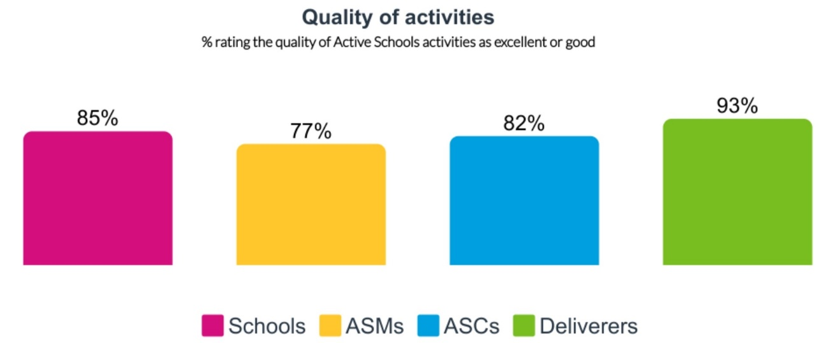

Schools – views on high quality opportunities
School staff generally rated the quality of Active Schools highly and also felt there was a good range of activities available.

- Most school staff said the quality and range was excellent or good.
- A small proportion rated the quality (5%) and range (8%) poor or very poor.
- ASN school staff rated the quality and range of activities lowest.
- Secondary school staff were more likely to rate the range of activities highly.
- School staff in the 15% most deprived areas were more likely to rate the quality and range of activities as excellent.
“
We could not run the comprehensive programme of activities and extra-curricular clubs that we do without Active Schools support and input. Active Schools are irreplaceable and an invaluable service that we currently have to support wellbeing and engagement at all levels.” Primary school

School staff said that Active Schools staff worked well jointly with them, in a knowledgeable, proactive, passionate, solution focused, caring and well organised way. They felt that Active Schools teams built positive relationships with schools and young people, communicated well and listened to and acted on the needs of schools.

“
Our Active School Team are fantastic and are able to offer our pupils a range of experiences, both in and out of school. Without them our pupils would not have the opportunities and experiences that they do.” Primary school

“
Active Schools has become an integral part of the school community and they provide so many fantastic opportunities for the children.” Primary school

Some schools said that without Active Schools there would be no sport or physical activity extra-curricular activities at their school.

“
There’s no way we’d have anything close to the number of kids we’ve got engaged in extra-curricular sport if it wasn’t for Active Schools. The numbers would drop off massively.” Secondary school

“
Active Schools very much provides our activity programme. Without it the children wouldn’t have the chance to be involved in any of those activities.” Primary school

Some school staff also identified challenges with quality and range of activities:

Quality | Range
A few felt that Active Schools teams had very large remits, and had limited capacity, and that this could limit the depth of their support. | A few said that Active Schools activities were quite traditional, limited in range and at times football focused, partly due to the facilities and equipment available.
A few said they weren’t sure of Active Schools remit, and there could be a bit of lack of clarity about what schools should expect. | A few said that activities were very dependent on volunteer availability, meaning the same activities were offered regularly.
A few said that the focus on volunteers meant that Active Schools couldn’t pay skilled coaches to deliver sessions. This was felt to limit both quality and range of activities, particularly for pupils with ASN. | A few mentioned particular challenges in rural and small schools, placing limits on Active Schools activity due to barriers including transport limits, travel to competitions or events, challenges attracting volunteers and lack of available facilities within the school.

Some schools suggested there should be a focus on play and recreational activity as well as sport, helping young people have fun and be active. A few suggested more longer term activity rather than taster sessions to ensure that impact could be higher.

A few schools said that they felt sometimes Active Schools activities were being done just to get the number of participants up, rather than thinking carefully about the quality and nature of activity. A few said it was important to focus on the difference Active Schools could make, not the number of participants.

A few school staff felt that the quality and range had declined in recent years, due to lack of funding and capacity.

“
Their service is spread so thin that we do not get any quality time to benefit from Active Schools.” Primary school

Active Schools network – views on high quality opportunities
Active Schools teams generally felt that the quality of Active Schools activity was good. Some Active Schools deliverers highlighted that activities were high quality because they were specifically planned based on what young people wanted.

“
I feel that the children and staff at my school are listened to – the children have a high involvement in which activities are on offer.” Active Schools deliverer

Some Active Schools team members highlighted that quality was realistically quite mixed and varied, due to:

- the range of deliverers and reliance on volunteers
- increasing reliance on young people as volunteers, with limited experience
- reduced levels of qualifications among deliverers due to the changing profile
- increasing costs and decreasing or static budgets.

“
As we’re working with volunteers and young leaders, we cannot always guarantee that the coaching content is high in quality.” Active Schools team member

However, some suggested that even with variations in quality, it didn’t impact on outcomes for young people – who got active, gained new skills and made friendships. A few cautioned that focusing too much on quality of coaching risked a distraction from the need to get as many children active in school as possible. A few said they now focused on creating a fun and safe environment, with well-planned and organised activities.

Others talked of a different approach, where they had reduced the number of experiences, focusing on high quality experiences reaching the most disadvantaged or excluded young people. This meant that the number of participants had reduced, but the quality of experience had increased.

“
Now we look at which children aren’t engaging, and it’s OK if there’s only six coming along because it’s about why are they there and what are they getting.” Active Schools team member
In terms of range of activities, some Active Schools teams indicated that it could be challenging to match the preferences of children and young people with capacity among volunteers to deliver particular sports or activities. In particular, some Coordinators highlighted that relying on volunteer delivery led to some gaps in sports – often those that are most appealing to girls such as dance, yoga, Pilates, netball and gymnastics. A few deliverers also said they would like to see a wider range of sports, for example those that appealed to teenagers, being offered through Active Schools.

Wider stakeholders – views on high quality opportunities
Wider sportscotland staff said that there was definitely more activity taking place than would be the case without Active Schools. However, there were concerns that:

- physical activity patterns may not be sustained long term
- quantity could sometimes be prioritised over quality
- there was significant variation between areas.

4.3 Inclusive and targeted approaches
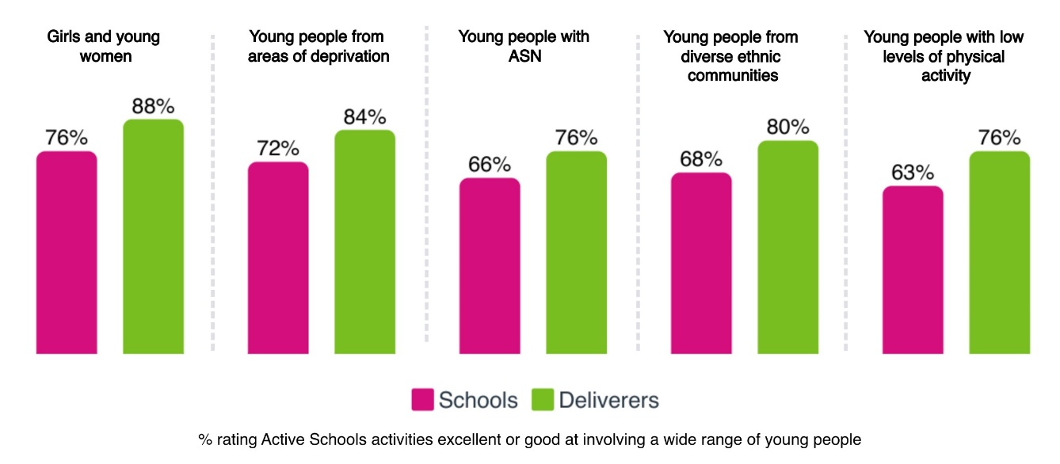

Schools – views on inclusive approaches
Schools generally felt that Active Schools was been good including a wide range of young people. Schools in the 15% most deprived areas rated performance in these areas higher across all five markers, than other schools.

Reflecting on what works well, schools felt that:

- Active Schools was responsive to the needs of young people and worked closely with schools and pupils to explore needs.
- A lot of thought went into inclusion in Active Schools - with Active Schools tracking engagement, identifying gaps, discussing targeted activities, considering needs and then developing activity in line with this.
- It was positive that Active Schools activities were free to pupils. Schools felt this supported initiatives around cost of the school day and tackling poverty.

“
We love the ethos of our Active Schools team – so inclusive and strive to accommodate for as wide a range of children as possible.” Primary school

Many schools talked about inclusion of young people with ASN. There were examples of some good work with pupils with ASN, and examples of this work still being developed through joint work with schools.

“
Our young people in a complex needs secondary school get an excellent experience, opportunities in a range of lunchtime and after school activities.” ASN school

However, ASN schools were more likely to rate performance at engaging young people with ASN poorly. Some schools said that there were not always a range of Active Schools activities to meet different needs, and a few said that at times activity was not inclusive and was geared towards able bodied participation. Schools recognised this was challenging as deliverers were volunteers and may not have the skills to deliver or may require extra adults supporting inclusive delivery.

“
We get limited involvement in comparison to our mainstream schools. The sessions we do are rarely fit for purpose or tailored to the needs of our pupils.” ASN school

“
The offer cannot always meet the needs of children with more complex needs where additional staffing would be required to be fully inclusive.” Primary school

A few schools said that they felt that Active Schools engaged those who were already sporty, and there wasn’t much evidence of them reaching the most inactive. Some schools suggested that there should be more targeted activity prioritising inclusion, and engaging pupils less likely to take part in physical activity.

Secondary schools suggested more targeted work with girls and young women, and many suggested more focus on support for pupils with ASN. Some schools pointed to intersectionality compounding challenges and barriers – for example people in areas of social deprivation, from diverse ethnic communities, with low physical activity levels.

Example: Girls leadership activities
One school talked about its girls group which is for girls who have disengaged from education, learning or sport. Active Schools team members work with the girls weekly to develop their confidence, leadership and skills. The school felt that this had been effective with girls going on to be successful leaders, leading clubs and visiting local primaries.

Active Schools network – views on inclusive approaches
Active Schools teams emphasised that all activities were designed to be inclusive and reduce barriers to participation. Many said that there had been a real focus on inclusion in recent years, and that targeted activity now formed a key part of their work.

In sportscotland’s survey of Active Schools Managers, many identified inclusion, equality and diversity as a key focus for the upcoming year. Many were working to enhance their understanding of needs, identifying inactive pupils, profiling and exploring needs, working to develop opportunities and interrogating health and wellbeing data to drive activities in schools.

Many Active Schools teams talked about engagement with young people with ASN in relation to inclusion, and this was reported as an area of success for many. A few said that it could be challenging to connect the extra-curricular model of support with ASN schools – as pupils often are not able to stay after school, either due to transport or wider needs.

In some areas, having additional capacity in the network through Active School Assistant roles who are able to deliver activity to targeted groups was felt to be instrumental in involving those who may be less likely to participate. Some mentioned that this had worked particularly well for engaging girls and young women and pupils with ASN.

Example: Inclusive activity
At one high school, a weekly lunchtime multi-sport club was delivered in partnership with the PE department and Pupil Support Base. This targeted pupils from both mainstream education and the support unit, offering them a chance for physical activity in a relaxed setting. Targeted clubs were established in primary schools for pupils with specific needs.

Example: Inclusive activity
In one area, the Active Schools team supported more than 240 young people with additional support needs to take part in a range of experiential activities including water sports, dance sessions and swimming sessions. Many (60%) of these participants live within the most disadvantaged areas (SIMD 1 and 2). Most (90%) of the young people have been supported to attend regular activity within their school or community network.

Many said that there was more that could be done to build inclusion and targeting within the Active Schools programme. Some suggested that a more targeted approach would be helpful. This would recognise that there is a need for a more intentional focus for those most in need of support – and a focus on getting inactive people active.

However, some were unsure whether it was realistic to deliver skilled inclusion work using a pool of volunteers. Teams recognised that while volunteers were vital to Active Schools, they often lack the training, consistency and capacity to deliver targeted, inclusive programmes. Active Schools teams pointed to the need for:

- paid and skilled deliverers to support targeted work, supported by accessible and high quality training
- funding to enable more resource intensive targeted work – involving relationship building, community engagement, partnership building and co-design
- flexibility to support young people during school time
- a focus on developing a more diverse Active Schools network, to ensure role models are within the system
- a shift in how performance of Active Schools teams is measured – to recognise and empower teams to invest in in-depth approaches, take a long term approach, focus on quality over quantity, change focus away from mass participation, and value curricular as well as extra-curricular work.

“
Meeting the needs of young people with additional support requirements is difficult without specialist staff or trained volunteers.” Active Schools team member

Wider stakeholders – views on inclusive approaches
Wider stakeholders indicated that approaches to inclusion varied significantly across the Active Schools network. There were examples of good practice, but some indicated that skills around inclusion, identifying community needs, working with pupils with ASN, and taking an intersectional approach needed to be developed across parts of the network, including staff and volunteers.

School, club and community pathways

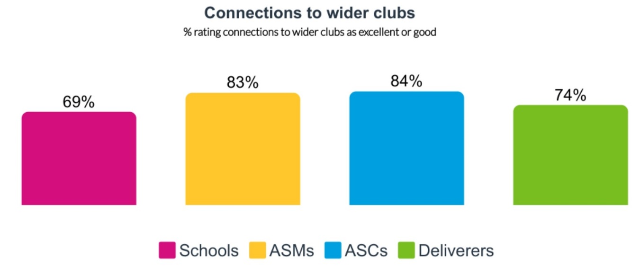

Schools – views on pathways
School staff generally felt that Active Schools connected schools well to wider clubs in the community. Overall, most school staff rated the connections excellent or good. ASN school staff rated connections more poorly than other types of school.

“
Active Schools are very proactive in offering opportunities and promoting pathways.” Secondary school

“
Links with sports clubs in the community have been beneficial for pupils and provide regular high-quality input from rugby, tennis and golf clubs.” Primary school

School staff also identified challenges with pathways, including:

- gaps in links to clubs with opportunities for young people with ASN
- taster sessions not leading to a pathway into sport or activity locally
- challenges in rural areas and communities where there are few or no clubs
- issues with the cost of club activity, proving a barrier to moving from Active Schools to club based activity
- challenges asking local clubs to volunteer in Active Schools delivery.

“
Due to the sports provision in the local community it is often difficult to create more new opportunities.” Primary school

“
Links to local clubs more limited than they used to be as organisations are less willing to give up their time freely.” Primary school

Some schools talked about the fragility of local club and community sport organisations, meaning that they don’t have time or capacity to engage in outreach work with school pupils. Schools recognised that often local clubs and groups are run by volunteers, who are very stretched.

Active Schools teams – views on pathways
Active Schools teams generally rated pathways to clubs and communities highly. Active Schools was felt to be a key programme connecting schools and clubs, and strengthening the participation pathway.

“
From my perspective we have a great feeder system for getting kids into running and it is excellent to see them transition into the main running club sessions.” Active schools deliverer

Some Active Schools teams talked about work undertaken to build strong pathways, including:

- Ensuring all Active Schools participating organisations must have a considered pathway – so that all activity whether a taster, session, block or a festival has onward opportunities.
- Quality assurance within the pathway – checking all clubs in the pathway meet governing body standards, or are visited and approved by the Active Schools team.
- A few areas indicated that they had undertaken work to build connections with community and youth work organisations to continue physical activity, as well as traditional sports clubs.

Example: Free lets for clubs
One Active Schools team talked about an arrangement where if community clubs offer a free Active Schools session, they can stay on in the space and access facilities rent free for an hour afterward to run their own club session, with some free places available for Active Schools participants. This has helped to recruit new local clubs to the programme.

Active Schools teams highlighted that it could be very difficult to create pathways in areas without a strong network. This was reported as an issue in many areas, where it was felt that since the pandemic the community club network and sports development structures had reduced in capacity. In particular, remote and rural areas reported that there may be fewer clubs in existence, and not all governing bodies for sport have regional development officers. This could make it particularly difficult to connect with new trends and emerging sports such as pickleball or padel, as the wider structures were not yet in place.

Active Schools teams also highlighted that it was getting harder to encourage club coaches to volunteer because Active Schools is unable to pay for high quality coaches, and there is little incentive to volunteer if clubs are already at capacity.

Some Active Schools teams highlighted that there could be barriers in the clubs and community environment which made it hard to connect young people such as:

- financial barriers and cost of participation
- clubs not always being inclusive or accessible
- a lack of pathways for young people with ASN
- limited capacity of clubs and volunteer fatigue
- clubs being isolated from their sports governing bodies.

Wider stakeholders – views on pathways
Wider sportscotland staff and other stakeholders said that there were challenges with the Active Schools programme in terms of pathways. Challenges included:

- pathways are weaker in the system due to reduced resources in club and community sport, local authorities and leisure trusts
- clubs are not always inclusive
- pathways for young people with ASN are not well developed, leading to gaps
- there is usually a barrier – cost, time, location, transport or equipment
- a need for better coordination between Active Schools, Community Sports Hubs and Governing Bodies for Sport.

Some SGBs felt that Active Schools was not good at connecting pupils with external club sessions, and that school to club connections were often weak. Some reported clubs bypassing Active Schools to deliver in schools in a more flexible way.

4.5 Network of volunteers

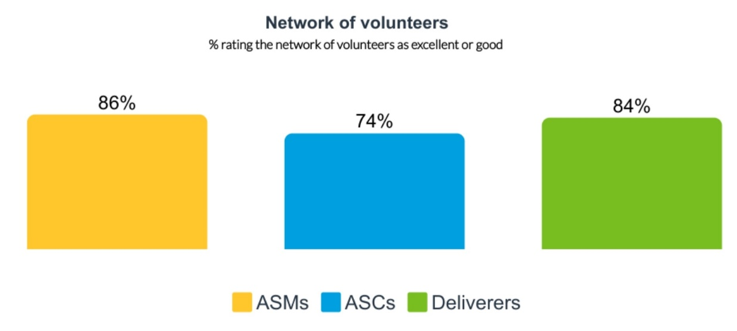
Deliverers – views on support as a deliverer
Deliverers rated the support they had been provided with as an Active Schools deliverer highly. Most (67%) said the support was excellent. Deliverers praised:

- the advice, guidance and support offered by ASCs
- the passion and commitment ASCs had
- ASC communication
- support with registration, first aid equipment and incident report documentation
- support with induction, introductions and building confidence running sessions
- support with planning, and accessing facilities and equipment
- access to training, shadowing and delivery ideas.

“
Active Schools have been excellent, consistent and extremely helpful in allowing me to coach and gain more experience within sport. Over the past 2 years they have been able to give me many experiences that have benefited me massively as a University student.” Active Schools deliverer

“
Their expertise and extensive knowledge in sports and community engagement are invaluable resources that not only provide guidance but also inspire me to be a more effective leader.” Active Schools deliverer

A few deliverers said that access to training and support had been limited, but good quality, and that they would welcome more courses to improve skills. A few said that practicalities of managing attendance at sessions could be streamlined.

Schools – views on network of volunteers
Most school staff highly valued the leadership opportunities that delivering Active Schools offered for their pupils. However, they highlighted that adult volunteers were also required. A few school staff highlighted that Active Schools placed significant additional workloads on teachers – including volunteering, coordinating last minute cancellations, being an adult present at a young person led club, and ensuring access to facilities. A few said that the model could mean that one or two very keen teachers had to take on the role of coordinating activity, as they felt there had been a noticeable change with fewer teachers willing to lead extracurricular activities or take on additional responsibilities (in the context of wider workload pressures).

A few school staff questioned whether the volunteer model for delivering Active Schools worked. There were concerns about:

- the quality of sessions delivered by volunteer young people or parents
- challenges attracting parent volunteers – as parents are busy, working, caring for other children or have other responsibilities
- inconsistency in delivery if young deliverers, who have other responsibilities and demands, don’t turn up to run sessions
- whether young people or parent volunteers had skills to manage behaviour at Active Schools sessions
- relying on goodwill of teachers to give up their time to run or supervise sessions
- the capacity of club coaches to volunteer their time for free
- limited pools of volunteers available in small schools and rural areas
- the skills of volunteer deliverers in relation to inclusion, particularly supporting young people with ASN.

Some schools felt that the model of volunteers should be reconsidered, and that Active Schools teams should deliver activity directly, be more present in schools and be part of the school community. Schools with ACSs or other team members based in their school for part or all of the week highly valued this.

Active Schools teams – views on network of volunteers
Broadly Active Schools teams were positive about delivery through a network of volunteers. Approaches that worked well included:

- partnering with further and higher education institutions to offer formal student placements
- working with newly qualified teachers
- primary pupils leading play sessions at break and lunchtime
- secondary school pupils leading activities, developing leadership skills and gaining qualifications and recognition.

“
We simply wouldn't have a programme without our volunteers.” Active Schools team member

“
The recruitment and supporting of volunteers is a great success in Active Schools
and results in large, varied programmes running across cluster schools and locations, often being the only provision for young people in rural communities.” Active Schools team member

Challenges included:

- capacity and burnout among teachers as volunteers
- young leaders require an adult presence and mentoring opportunities, which can be increasingly difficult to identify
- PVG requirements and associated paperwork and costs
- undertaking inclusive and targeted work using volunteers
- access for training for volunteers, including through SGB qualifications.

Some felt that it would be useful to have e-learning opportunities for volunteers. A few emphasised the importance of recognising volunteer time through small recognition schemes or thank you gifts.

Some suggested that while volunteers were important, and provided locally based people to run activities, relying solely on volunteers to deliver the whole Active Schools programme was not sustainable. Some suggested that it was important to recognise that quality delivery comes at a cost. Some sought flexibility and budgets to pay coaches, or receive funding for delivery roles such as Active Schools Assistants. However some felt that Active Schools teams getting involved in direct delivery did not help clearly explain the role of Active Schools teams as coordinators of activity, rather than deliverers.

Examples: Ways of working
In one area, the Active Schools team works with many newly qualified teachers, and felt that this resulted in well engaged volunteers, while also helping to increase the quality of primary PE sessions.

Wider stakeholders – views on network of volunteers
Some wider sportscotland staff also questioned how sustainable the volunteer model was, particularly as schools and teachers are now more stretched than ever. Some wider stakeholders wondered about the reliance on volunteers to deliver activities, and emphasised the need for skilled and trained volunteers to support inclusion.

Colleges explained that Active Schools played a key role in supporting students to get real life experience of delivery.

Example: Student volunteering pathway
One college works with Active Schools teams across three local authority areas to find placements for their students. More than 300 students on sports development courses work with over 30 primary schools to run after-school clubs, support Active Schools led events and complete placements in schools, including placements in ASN schools focusing on disability inclusion.
Active Schools offer award schemes to recognise students’ volunteering hours. Students who engage with clubs through Active Schools may also be offered coach education qualifications.

Active Schools provides training workshops at the college before placements begin. This covers expectations for working in primary and secondary schools. Students also receive disability awareness training, provided in collaboration with Disability Scotland. Specialist ASCs also support disability placements.

These placements help students see a range of career paths, and helps to broaden students’ understanding of the opportunities in the wider sports and community sector.

In addition to school placements, all students must complete an external placement during the year in clubs or community settings. Active Schools plays a key role in helping place students who aren’t already affiliated with a club. They help connect students to clubs, schools, and community sports hubs.

4.6 Leadership opportunities

Almost all local authorities (94%) offer an Active Schools pathway or programme for young people as leaders. This includes developing young people as volunteers, coaches and deliverers of Active Schools, programmes such as Young Ambassadors or Event Organisers, and young people being panel or committee members. Local authorities run these opportunities in a range of ways including Coaching Academies, Leadership Academies and other leadership pathways.

Young people are supported to gain qualifications through leadership programmes, including SGB sports specific awards, Sports Leaders UK, local Sports Leaders qualifications, first aid, safeguarding, Dynamic Youth Awards, Saltire Awards and others such as disability awareness.

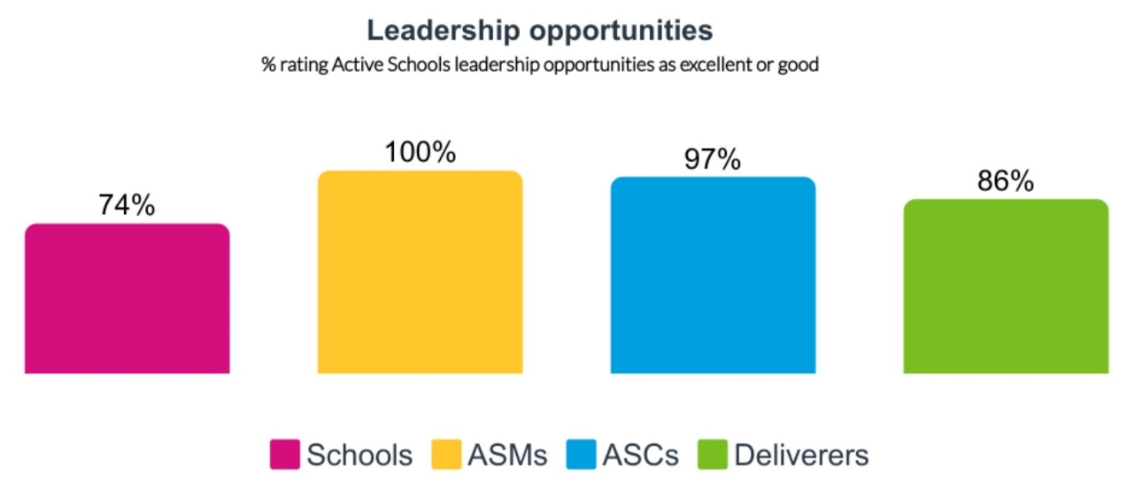

Schools – views on leadership opportunities
Schools generally rated the Active Schools leadership opportunities highly.

- Secondary schools rated leadership opportunities the highest.
- ASN schools rated leadership opportunities the lowest.
- Schools from the 15% most deprived areas rated leadership opportunities broadly the same as other schools.

Schools said that Active Schools offered good leadership opportunities which allow young people in primary and secondary school to develop their skills. Some schools liked that leadership opportunities started in primary and linked into secondary school, providing a leadership pathway.

Schools said that through leadership opportunities young people learned skills such as resilience, initiative, planning, supporting others, and working as a team. Some highlighted that children and young people could gain qualifications through leadership programmes, to recognise their input.

“
This was transformative to our P6s last year and allowed learners the chance to both keep active, develop teamwork and also enhance their leadership skills.” Primary school

“
Secondary school pupils run lunchtime clubs for our children, it is always great to see them in that leadership role and our younger learners greatly enjoy interacting with them as peer role models.” Primary school

“
I have so many former pupils who have taken leadership activities through PEPASS and used it as springboard into their adult life.” Primary school

Active Schools network – views on leadership opportunities
Active Schools teams felt that developing young leaders was a core aspect of Active Schools, and took up a considerable part of their role. Active Schools teams often commented that leadership opportunities were excellent, worked well, built skills and were particularly effective for senior pupils when connected with qualifications.

“
I think the leadership provision is also making a big difference, in terms of getting senior pupils qualified, giving them experiencing of volunteering and leadership.” Active Schools team

Active Schools teams noted that leadership opportunities provided a route into careers – including as lifeguards, gym instructors, hall keepers, Modern Apprenticeship opportunities, Active Schools Assistants and ASCs. Some felt that this fit well with school priorities, developing skills for life, and wider trends of more pupils being interested in vocational pathways.

“
We have many success stories of pupils and young people progressing through our pathways into full-time work in sport and beyond.” Active Schools team member

Some Active Schools teams highlighted how their leadership work supported their inclusion priorities, including:

- Some sports leadership programmes are developed to help with attendance, behaviour and attainment – working closely with schools.
- In some areas there is a deliberate focus on engaging a wide range of people in leadership – for example young people with care experience – so they can go on to coach or mentor young people with similar lived experience.
- Fit for Girls was felt to work well, encouraging senior girls to lead sport.

A few challenges to leadership work were highlighted, including:

- Because so many deliverers are volunteers, it could be hard to place young people in high quality mentoring environments.
- Leadership can be quite a busy landscape, with other PE and sports leadership courses taking place in schools.

A few Active Schools teams mentioned that they were disappointed that the Young Ambassadors conference was online in 2025, and that they had organised their own local in-person events to coincide with this. A few suggested a national leadership programme, with an accredited programme which could be delivered locally, to build consistency.

Example: Building leadership skills
In one area a Sports Leadership Academy initiative offers pupils aged 14+ a week long holiday camp of certificated and non-certificated leadership courses spread between different venues. This is developed in partnership with governing bodies for sport, and has been well supported by secondary schools, some of whom have paid pupil fees or arranged transport.

Example: Targeted leadership approaches
One area launched a new leadership programme for S5/6 pupils, targeting those less likely to be going on to university. This focuses on football, basketball and netball. Young leaders get their entry level first qualifications for free in exchange for 25 hours volunteering, either with Active Schools in school or through local community clubs.

Wider stakeholders – views on leadership opportunities
Wider sportscotland staff rated leadership opportunities highly, feeling that most local areas had well established leadership programmes which built skills, connected with Curriculum for Excellence and Scotland’s national outcomes, and provided young people the opportunity to gain qualifications.

Some SGBs were positive about Active Schools leadership programmes, feeling the work helped develop young people’s skills and provide access to qualifications and leadership awards. Some also felt this helped enhance the volunteer pipeline in the community.

However, a few stakeholders were concerned that young leaders were being used as substitutes for adult volunteers. A few felt that approaches to leadership programmes should be more inclusive, supporting young people beyond those who are the most sporty and active, and offering meaningful opportunities for young people with ASN. Some wider stakeholders also felt that more standardisation in leadership programmes would be helpful.

Young people – views on leadership opportunities
Young people involved in leadership opportunities indicated that these were rewarding, built a sense of achievement and community, and were an important aspect of Active Schools programmes locally. Young people said that the rewards systems worked well (for example recognition through hoodies or other rewards locally) and qualification opportunities were important for skills development.

“
Gives people a chance to gain qualifications and skills that they wouldn’t have.” Young People’s Sports Panel member

Young people also said that the leadership opportunities helped with the transition between primary and secondary school. More on the impact of leadership opportunities for young people is available in Chapter 3.

“
It’s really good for connecting primary and secondary schools and means there’s a familiar face for pupils when they go to high school.” Young People’s Sports Panel member

Strengthening Active Schools

5.1 Introduction

This chapter explores the views of schools, Active Schools teams and wider stakeholders on the challenges to the Active Schools programme in its current model and the opportunities available.

5.2 Key findings

Active Schools is getting young people more active. 280,000 young people were involved in 2024/25, and almost half of Active Schools participants say they would be less active without Active Schools. The health and wider benefits of being active are well researched and evidenced. However, Active Schools is not reaching everyone to the same extent – with under-representation and differing outcomes for girls and young women and young people with additional support needs (ASN). These groups are known to be less likely to be active.

Active Schools is contributing significantly to education and learning outcomes, including supporting attendance and engagement at school. This is highly valued by school staff, and is often happening through targeted activity with the least engaged pupils. Active Schools also supports inclusion, a sense of community, friendships and connections. Leadership activity is also having a significant impact on young people’s skills, qualifications, aspirations and opportunities. ASN schools are less positive about impact and Active Schools model than other schools.

5.3 Building on a strong and respected model

When schools were asked about priorities for the future for Active Schools, there were many mentions of ‘continue’, ‘more’ and ‘expand’. Overall, many schools suggested more funding, more staffing, more activities, more people taking part, more training for volunteers and deliverers, and more direct delivery by Active Schools teams.

“
I would hope that Active Schools and the service they provide continues. It has been invaluable to my school and ASN service.” Primary school

Schools, Active Schools teams, wider stakeholders, and those involved in the broader horizon scanning exercise, felt that Active Schools was an established, well respected and strongly supported programme which was highly regarded. Stakeholders felt that there were real opportunities to build on strengths around:

- inclusion, equality and tackling deprivation
- leadership and skills development, role models and qualifications
- physical activity, health and wellbeing
- supporting learning outcomes
- community engagement, connections and reach into schools across Scotland.

“
Active Schools is well placed to engage with schools, engage with local communities, engage with local organisations and also engage with young people.” Horizon scanning stakeholder

5.4 Clarifying expectations

Some Active Schools teams had developed systems to include targeted and universal provision in their offer, and were comfortable with this balance. However, many felt that in the current programme, using resources which were increasingly under pressure and in an environment of increasing needs, there was an expectation that they could both:

- deliver a universal programme, with perceived pressure to increase participation numbers and proportion of school roll participating (as this is what is being measured at national level)
- deliver targeted, in-depth work with the most vulnerable, excluded or inactive young people, which required intensive resources and relationship building.
Many said that it wasn’t possible to deliver on both of these areas well using existing resources. A few mentioned that additional inclusion funding from sportscotland had helped with this, but without this the capacity of Active Schools teams would reduce.

Some felt that this meant that in times of limited funding, there may be a need to shift from universal provision to more targeted interventions for the most inactive or disengaged groups. Many were comfortable with the concept of a focus on more support for those with greater needs or facing more disadvantage. However, a few felt that continuing the universal offer was also important.

Reflecting on the need for targeted support, some Active Schools teams were clear that the model used to support universal provision would be quite different to that used to support targeted work. Most felt that targeted work with young people experiencing mental health issues, trauma, adverse childhood experiences, ASN and other issues could not be delivered using a model of volunteers.

Wider stakeholders were very clear that community needs were increasing, health inequalities were widening and there were ongoing high levels of child poverty and inequality. Many felt that there was a need for an approach which ensured that the people least able to take part in physical activity received the most support, taking an intersectional approach recognising that a range of factors can compound inequality and disadvantage.

Some stakeholders felt that there needed to be a shift away from getting all children more active more often, to a stronger emphasis on those least engaged and most excluded. A few said that the current Active Schools model stifled the development of inclusive approaches and did not support inclusive, long term participation for all young people. Importantly, stakeholders saw Active Schools as part of the system to address inequalities, working jointly with others – and not in isolation.

Some ways stakeholders suggested adapting to this challenge included:

- recognition of both the value and the resource intensive nature of targeted work
- a clear decision about whether the programme is about universal or targeted work, or needs to balance both
- a clear national directive about inclusion, intersectionality and targeted work
- enabling Active Schools work to happen in curriculum time (which happens in some areas but not others)
- high quality inclusion training across the network – for staff and volunteers
- building capacity of Active Schools teams to effectively target their work
- a reduced focus on measuring participation and activities, and an increased focus on impact.

5.5 The volunteer network

Many Active Schools teams reported challenges with delivering the programme through volunteers. The adult pool of volunteers was declining for many, due to:

- patterns of reduced volunteering generally in Scotland
- more people needing paid work rather than volunteering opportunities
- severe pressures on school staff workloads – recognised nationally
- increasing behaviour issues which impact those willing to deliver.

At the same time, there was some concern that the proportion of qualified deliverers was declining. In some areas, a very high proportion of activity is delivered by pupils, which is valued for leadership and skills development, but is not seen by many to be sustainable in delivering quality and inclusive activity (particularly for young people with ASN) long term.

Active Schools teams highlighted that for some sports, it was not possible to attract deliverers if they were not paid – particularly for sports like dance, Pilates, yoga, parkour, athletics and basketball. Some also said it was harder to attract volunteers for targeted work, which often required particular skills and had to happen during school hours. Active Schools teams felt that paid coaches offered consistency, expertise and ability to deliver targeted interventions during school hours.

Some ways stakeholders suggested adapting to this challenge included:

- considering more direct delivery through Active Schools Assistants and Modern Apprenticeships (and perhaps fewer ASCs)
- funding to pay for coaches to deliver some activities
- affordable and accessible training for volunteers to gain appropriate qualifications
- a national, sportscotland led approach to engaging volunteers.

5.6 Leadership activity

Schools, Active Schools teams and wider stakeholders highly valued the leadership aspect of Active Schools. It was felt that there were opportunities to:

- recognise, value and celebrate leadership activities at national level
- clearly link leadership programmes with skills development, developing the young workforce and employability outcomes
- focus on recognised leadership qualifications that can be used as alternative entry routes into further education
- develop further opportunities for leadership at primary schools, in some areas
- develop the concept of ‘targeted leadership’ for pupils facing barriers or disadvantage, including pupils with ASN
- simplify, streamline and share learning from leadership opportunities between local authority level
- provide greater opportunities for work experience for young people through Active Schools
- build strong pathways from leading and volunteering through to entry level opportunities as coaches, Active Schools Assistants, Modern Apprentices and other roles in sport and physical activity.

5.7 Demonstrating impact

Many stakeholders felt that the data and evidence relating to the impact of Active Schools nationally was not strong and did not demonstrate the difference the programme made. Key challenges identified were:

- a strong focus on number of participants in national monitoring systems
- limited information nationally about outcomes, impact and change
- a focus on quantitative information about activities rather than qualitative evidence about impact and change achieved
- a focus on measuring and counting extra-curricular activity, while targeted and leadership activity often took part during the school day.

Some wider stakeholders and schools said that the current monitoring framework made it feel as though Active Schools was focused on boosting participation numbers, rather than offering diverse, quality opportunities in a range of different sports. In particular, it is felt to under-value the in-depth inclusion work that takes place, often within curriculum time, and not fully recognise the impact of leadership programmes.

Stakeholders were clear that it was very important to effectively communicate the value and impact of Active Schools in the future. Some suggested there was a need for a robust platform which could demonstrate impact effectively at both local and national level.

Some ways stakeholders suggested adapting to this challenge included:

- focusing on impact and outcomes rather than activities
- gathering stories and qualitative evidence about the difference Active Schools makes
- adopting a community needs based approach to Active Schools work – including further skills development for Active Schools teams on this
- adopting a continuous improvement and tests of change approach.

5.8 Sharing practice and ideas

Stakeholders valued the experience and skills within the Active Schools network, and many suggested opportunities for further sharing of practice. Opportunities included:

- creating more chances for ASCs to network and share practice
- creating more informal online connections between Active Schools teams to build innovation and share approaches
- more training for ASMS and ASCs including a formal induction and continuing professional development process, and regular refresher training on topics such as child protection, first aid, sport specific updates, trauma informed approaches and mental health first practice
- more recognition of the success of Active Schools volunteers and participants at national level.

5.9 Developing the model

In summary, the Active Schools model is highly valued and respected. When schools were asked about priorities for the future for Active Schools, there were many mentions of ‘continue’, ‘more’ and ‘expand’. Schools, Active Schools teams, wider stakeholders, and those involved in the broader horizon scanning exercise, felt that Active Schools was an established, well respected and strongly supported programme which was highly regarded. Stakeholders felt that there were real opportunities to build on strengths in the Active Schools model around inclusion; leadership opportunities; supporting physical activity health and wellbeing; supporting learning outcomes; and community connection and reach.

To help Active Schools refine its model, stakeholders suggested:

- greater clarity of expectations around whether Active Schools is a universal offer for all children and young people, or whether support should be targeted at those most in need, most disengaged or most inactive
- considering development of the volunteer model to incorporate more direct delivery by paid, skilled staff (to support quality, range and inclusion); more training; and national support for engaging volunteers;
- building on highly valued leadership activity to clearly link it with skills development, recognised qualifications, inclusion, work experience and pathways to employment;
- better demonstrating the difference that Active Schools makes – moving from measuring participation and activity numbers, to outcomes; and
- sharing practice and ideas between Active Schools teams beyond Manager level, sharing ideas, training and recognising the success of teams, volunteers and participants at national level.

sportscotland staff responses are not shown as a separate group in the charts throughout the report, due to the sample size. Key sportscotland staff input through horizon scanning and evaluation interviews and group discussions.
Physical Activity For Health: Framework, Scottish Government, October 2024
https://audit.scot/strategic-risks-and-issues-affecting-the-scottish-public-sector
https://sportscotland.org.uk/about-us/our-publications/review-of-leisure-and-culture-services-in-scotland
Sport for Life, sportscotland, 2025 - https://sportscotland.org.uk/about-us/sport-for-life#intro
Physical Activity for Health: Framework, Scottish Government, October 2024 - https://www.gov.scot/publications/physical-activity-health-framework/
https://www.gov.scot/publications/summary-statistics-for-schools-in-scotland-2024/pages/key-points/
Scottish Health Survey 2024: Volume 1: Main Report, Scottish Government, 2025
https://www.scotpho.org.uk/risk-factors/physical-activity/data/children/
Prescribing Exercise as Preventive Therapy, Warburton DER, Nicol CW and Bredin SSD, Canadian Medical Association Journal, vol. 174, issue 7, 2006
The Social Benefits of Sport, sportscotland, 2010 and Prescribing Exercise as Preventive Therapy, Warburton DER, Nicol CW and Bredin SSD (2006), Canadian Medical Association Journal, vol. 174
UK Chief Medical Officers’ Physical Activity Guidelines, 2019
A Review of the Social Impacts of Culture and Sport, Sheffield Hallam Sport Industry Research Centre, 2015
Feedback in Active Schools and Communities Partnership Officer Progress Report, 2021
85% of schools rated the quality as excellent and 74% rated the range of activities as excellent.
Overall, 48% of all schools rated quality of activities as excellent and 39% rated range as excellent – increasing to 58% and 47% for schools in the 15% most deprived areas.

