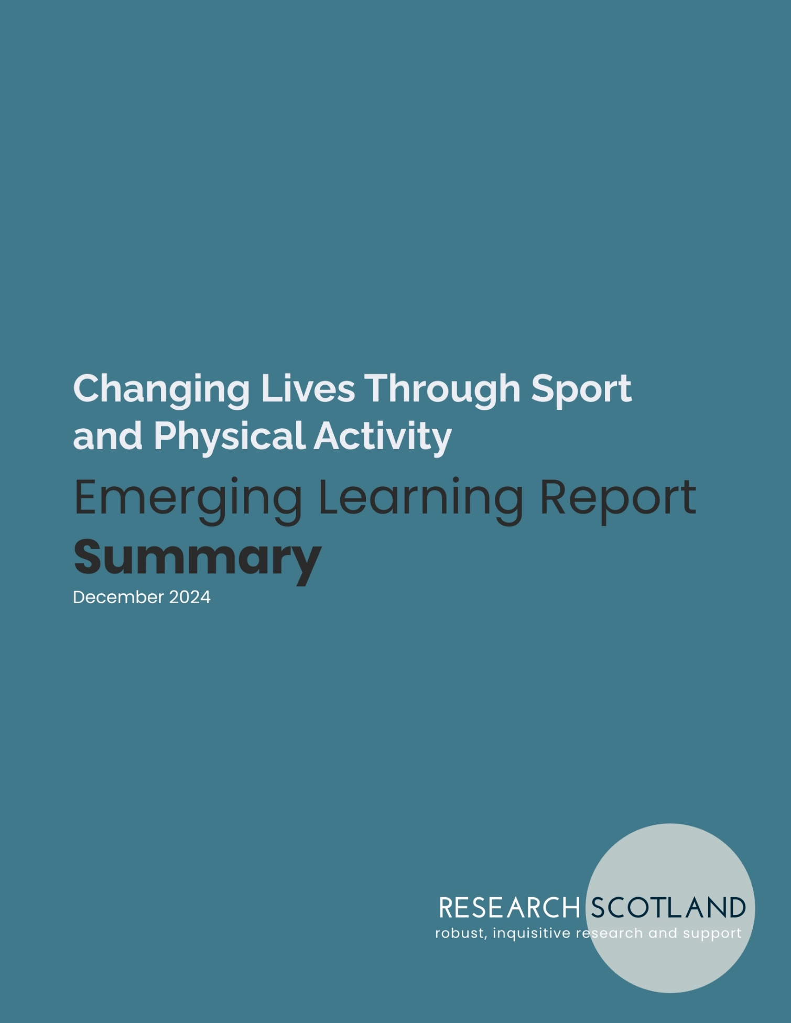

Summary

What is Changing Lives?
Changing Lives is an approach, mindset and way of using sport and physical activity to intentionally bring about positive change for people and communities. There is very good evidence that physical activity and sport, by its very nature, impacts positively on individuals and communities. However, the Changing Lives approach is about intentionally bringing about positive change by building this into thinking, planning and delivery.

The potential impact of Changing Lives
The benefits that physical activity can inherently bring to health are well documented. There is strong evidence that moving your body can prevent disease, build health, reduce falls, improve mental health and benefit the NHS. Through Changing Lives, programmes can maximise the benefits of physical activity, sport and active recreation through deliberately and purposefully:

- focusing activity on the least active
- focusing activity on those with the most needs in the community
- addressing barriers to taking part
- designing activity to sustain interest and participation.

The Changing Lives approach is particularly relevant as Scotland moves to a systems based approach to Physical Activity for Health. This approach recognises that all policy areas – like education, transport and planning - have an impact on physical activity and health, not just sport and health. This potentially opens up new areas of partnership between the NHS, schools, other key organisations and sport and physical activity organisations – focused on increasing physical activity for the most inactive.

There is also good evidence that if used intentionally and purposefully, physical activity and sport can bring about wider benefits including learning and skills development, social connectedness, inclusion and positive decision making. These benefits are less likely to be naturally brought about through sport and physical activity, but sport and physical activity can be a useful tool through which to achieve these outcomes. This requires a clear focus on intended outcomes, and design of programmes to achieve specific change. For example, intended change could include increasing attendance at school; reducing isolation, fostering inclusion, or building employability skills. Here, physical activity brings value by:

- being a hook to attract participants
- providing a mechanism for engagement and conversations
- creating an environment of positive behaviour and decision making
- being a way of bringing people together
- providing a reward or incentive for taking part in other activity.

Changing Lives ingredients
There is clear evidence that using physical activity and sport intentionally to achieve positive outcomes increases its impact – how it is delivered matters. The Changing Lives approach involves:

- A skilled staff and volunteer team – Staff and volunteers are likely to be an organisation’s biggest resource in making Changing Lives work successful. Staff can be powerful role models, and having staff with lived experience can be very valuable. Staff need support, training and leadership to take a Changing Lives approach.

- A Changing Lives organisational ethos – Organisations need to be strong and willing to learn to use a Changing Lives approach. There needs to be a culture of trying new ideas, learning and not being scared to take risks.

- Collaboration – Changing Lives involves joint working between sporting and non-sporting partners, actively seeking out partners with specific expertise, having a shared vision and clarity of roles for each partner.

- Intentionality – Rather than starting with the premise that sport is inherently good, intentionally and purposefully looking at the issues that communities face and how sport and physical activity can play a role in providing a solution.

- Community need – Starting with an understanding of the needs of people and communities, with the aim of working to reduce inequality, disadvantage and challenges in society. This involves building relationships, spending time in communities, and prioritising and focusing on greatest need.

- Co-production – Working with potential participants to design approaches that meet needs, working with communities and empowering people to co-create and co-produce plans and activities.

- Measuring impact – Self-evaluation, learning and evidence about the difference Changing Lives work is making should be built in from the start. This can be simple, focused on intended outcomes, and aim to hear participant voices and learn from this.

- Person-centred approach – Building relationships with participants, tailoring activity to what works for individuals, and working at smaller scale but more in-depth to secure long term change and deeper impact.

- Fun and social activities – Fun and social aspects are often the main focus of Changing Lives approaches, with activity for all abilities, social opportunities, drop-ins and reduced competition to take the seriousness out of sport.

- An inclusive approach – Focusing on reducing inequalities, identifying the needs of the most disadvantaged or disengaged communities and designing programmes to meet their needs. This will involve prioritising activity, and targeting communities most in need in a proactive way.

Changing Lives challenges
The Changing Lives approach can bring about positive change, but adopting the approach can be challenging too.

- Changing the mindset – Although many in Scotland are very committed to the Changing Lives approach, there remain many who are unsure or do not understand it. For many organisations in the sporting system, creating good athletes and winning has been the main focus. There can be a lack of understanding of how sport can be used to bring about change and why this might be important.

- Organisation strength and capacity – It can be harder to introduce a Changing Lives approach where clubs are small, led by volunteers, stretched their capacity or facing financial challenges. The Changing Lives approach is more in-depth, resource intensive and time consuming.

- Funding environment – The current funding environment means it can be challenging to access resources, when there is a strong focus on making savings, and investment is often reactive rather than proactive.

- Systemic focus on participation and performance – Targets, aims and reports within the sporting system often focus on number of members and participants. Changing Lives is not felt to be reflected in measures for how sporting organisations are performing. It can be hard for organisations to adopt a Changing Lives approach if this work is not recognised within the system.

Changing Lives learning resources
To support a Changing Lives approach in Scotland, there are already a wide range of learning programmes and resources available. These are rated highly by those who use them, and have had a positive impact on practice. However, resources are:

- mainly focused on practitioners using a Changing Lives approach
- accessed through a range of different routes – not always easy to find
- not well sorted or signposted – meaning it is time consuming to understand what is available and how they are relevant.

There is some demand for:

- resources to help embed a Changing Lives approach across the system, including to help leaders, managers, funders and decision makers to understand the approach
- resources to help explain the Changing Lives approach to those at coaching and club level, and demonstrate that the approach is possible and valuable
- resources to introduce junior staff or students to the approach
- guidance for those using a Changing Lives approach – for example on evaluation processes, collaboration and partnership, how to have conversations and build relationships
- resources that connect with the new Physical Activity for Health Framework, and demonstrate the potential of Changing Lives in working with people who are very inactive (doing less than 30 minutes per week)
- resources that help people to negotiate the complexities of taking a Changing Lives approach, manage difficult conversations, tackle conflicting views, balance needs, prioritise resources and gain support from line managers.

There was clear agreement that resources should be simple, bite-sized, accessible on phones, practical and quick to use.

